Blindata Release Note 1.9.4-5 

30 May 2005

Bug Fixes and Enhancements

382. Administration > Parameters > Quotation Print (Letterhead)

There is a new quotation print option called Quotation Print (Letterhead). This is designed for clients who do not want to enter detail lines in the quotation – all text is entered in the ‘contract text’ box in the totals tab.

394. Reports > Sales Analysis

Sales Analysis by Rep by Customer YTD (Invoice).

Each Rep is now starting on a new page. The current ytd, last year mtd and last year ytd figures are now calculating properly.

415. Order Processing > Quotations

‘Customer reference’ field now appears on the grid.

416. Order Processing > Orders

Order detail line drilldown (+ to show detail lines) is now back in the order amend enquiry screen.

420. Invoice Print and Post > Create Invoices

The ‘carriage over amount’ is now held against the currency record instead of in the Parameters table. When the carriage calculation is done in the ‘Create Invoices’ routine, the program now checks the currency table instead of the Parameters table. This makes the carriage calculation more flexible.

422. Order Processing > Orders

The currency rate was being shown with too many decimal places. It now shows the same number as was entered in Administration > System Tables > Currency Types.

423. Label Print – 200x24mm

- Order date was overlapping ‘Drop’ slightly.
- No. of vanes is now being displayed properly – was hidden behind text.
- No. of metres of fabric is now being displayed.
- Head. Cut size calculation is now correct (should be man. Width – rail cut size).

428. Order Processing > Orders

We have one client who does not price blinds individually – they only enter a total amount, so an order can look like this:

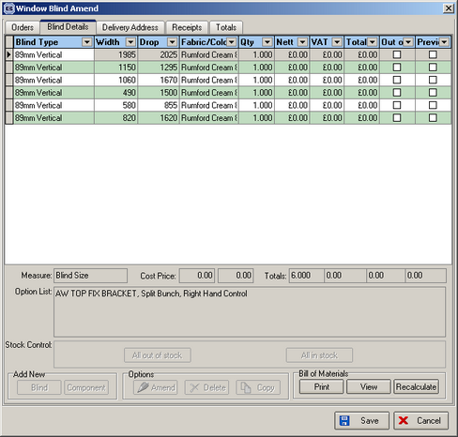

They then enter an amount in the actual nett field in the totals screen. It is then not possible to update this invoice into Sage because the program looks at the figures in the detail line. When the actual nett is entered, the figures in the detail lines should be back calculated even if the detail lines had zero amounts. This would then solve the Sage update problem. However, this is a very complicated procedure.

We have therefore decided that the client should enter the full amount for the order in the first detail line. Providing the sales nominal code is the same for all the detail lines in the order, the update to Sage will work perfectly.

430. Order Processing > Quotations

Quote e-mail now working for addresses over 30 chars. This was the same problems as in orders.

431. Order Processing > Quality Control

There is now a ‘Save’ button on quality control screen – now has the same convention as ‘Orders On Hold’ screen.

433. Order Processing > Production Lists > Order Control Report

This report has been speeded up by a factor of 7.

436. Works Order - label 2

The department is now printing to the right of 'Department' text on the address label.

Vanes Only works order - No. of Vanes now on large label and 2 small labels (was OK in previous releases).

437. Order Processing > Orders > Add

"This customer does not exist in Line50" message no longer displays when entering a RETAIL order when parameter "Post Retail Orders" is not selected.

439. Order Acknowledgement Laser Print (Letterhead)

Delivery company name now prints in 'Deliver To' address.

441. Invoice – Laser Print (Letterhead)

Vanes Only - No. of Vanes now printing.

442. Financials > Post Invoices to Sage Line50

Batch posting by Date range now working.

443. Financials > Posting invoices to Line50

There is now a validation routine for posting invoices to Sage Line 50. The order of events should be as follows:

- Run validation.
- Correct errors.
- Print audit trail.
- Post invoices.

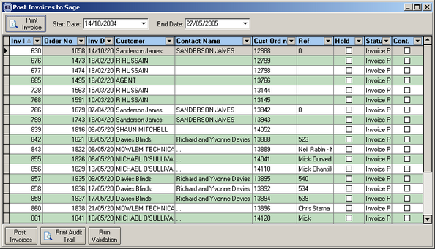

440. Delivery Docket Laser Print (Letterhead)

Vanes Only - No. of Vanes now printing.

444. Invoice – Laser Print

The contact name now appears on the invoice address for a retail customer. ‘Retail Sales’ does not appear.

445. Financials > Invoice Print and Post

Form should default to being in order id order.

446. Order Processing > Orders

‘Custumer’ is now spelt ‘Customer’!

Copy button gave an error message – now fixed.

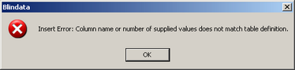

447. Financials > Post Invoices to Sage

Run Validation

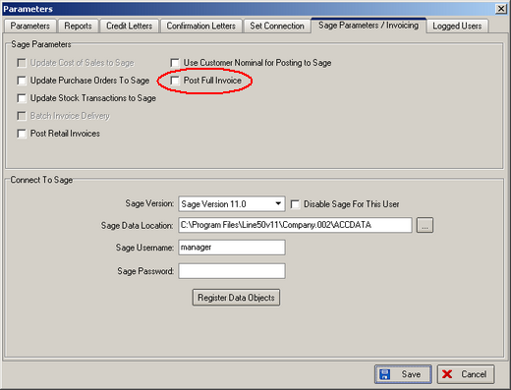

If ‘Post Full Invoice’ is switched off, the validation was too strict. It was trying to validate stock items, when it should only have validated customer account codes and nominal codes. Fixed.

448. Acknowledgement Laser Print (and all other similar reports)

All reports now print contact name for a retail customer order.

449. Invoice – Sage Laser Print

The detail line information was missing from this report. Now fixed.

450. Invoice – Sage Tractor Feed

Totals were missing from the bottom right. Now fixed.

New Work and Customer Requests

20. Multiple Bought In Suppliers

Some clients wanted the ability to choose which supplier they purchase manufactured blinds from. The system has been altered to do this, and also select the correct cost price for those blinds.

There is now a facility to have multiple suppliers for blind types in Blind Details > Blind Types.

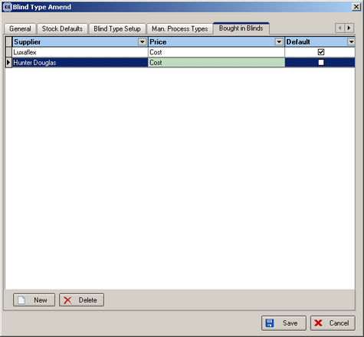

As well as defining the various suppliers, we can select a default supplier and also the cost price table that relates to that supplier and that blind type.

Cost prices for these supplier are held in Pricing > Price Tables in exactly the same manner as a selling price table:

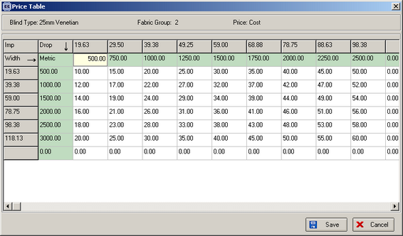

When we enter an order detail line, if the blind type entered = bought in, it is now possible to select the correct supplier. This, in turn, will find the correct cost price for the blind.

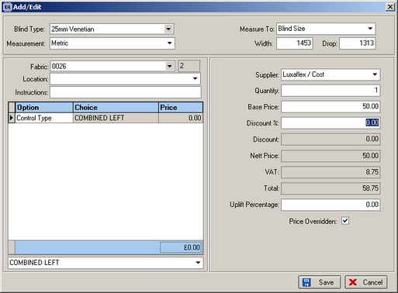

The supplier will only be displayed if the blind type = bought in, and will default to the default supplier. If no supplier has been set up in the blind type record, a message appears saying ‘Please set up supplier in blind type record.’

