Blindata Release Note 1.9.3 

23 May 2005

Bug Fixes and Enhancements

381. Order Processing > Orders > Create PO

It is no longer possible to create a bought in PO if a sales order is on credit hold or customer hold.

413. Order Processing > Quotations

After entering the first detail line in a quote, these buttons were greyed out – now fixed.

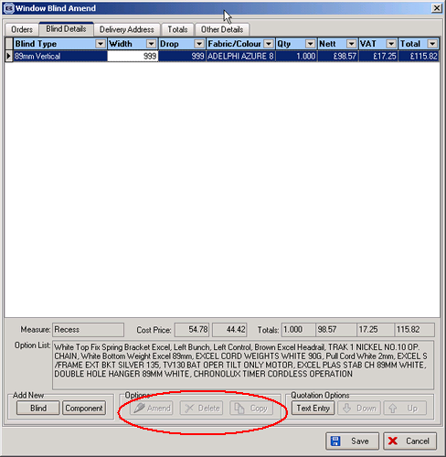

417. Order Processing > Orders

In the following screen, the second blind was entered without entering a fabric. It then saved the fabric from the first blind, but the fabric cannot be used in the second blind. This can no longer happen.
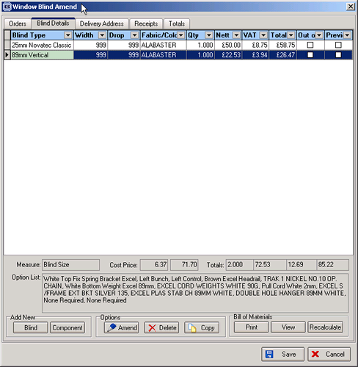

418. Invoice - Bespoke 1

In all these invoice prints ‘Velux Code’ now only says ‘Code’.

424. Order Processing > Orders / Quotations etc

The grid header descriptions were wrong.

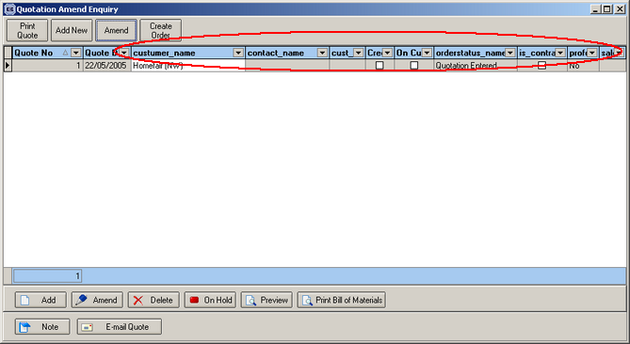

425. Order Processing > Emailing Orders

It is now possible to email to an email address that is over 30 characters.

426. Reports > Sales Analysis > All reports

We have removed the condition to exclude carriage on Sales Analysis reports.

427. Invoice Bespoke 1

Invoice Bespoke 1 - When the detail lines of the invoice total to more that £1000.00 then it only displayed 1 of the pence fields – this is now fixed.

New Work and Customer Requests

