Blindata Release Note 1.9.2 

20 May 2005

We have now reworked the structure in the Order form to speed it up and optimized the sql query. The form opens and refreshes approximately 30-50% faster now. Please let us know the results on your system

We have also optimized the sql query on Archive Enquiry form.

Bug Fixes and Enhancements

287. Invoice Bespoke 1

If there is a log number for a remake, the invoice now prints ‘MEF No: [Log Number] on same line as carrier but 35mm to right on this invoice.

358. Financials > Daily Sales Report

This report is now grouped by transaction type (ie invoices and credit notes) with separate totals for invoices and credit notes.

392. Order Processing > Quotes

Once you enter a quote onto the system and save the quote, then if you went back into the quote you could not change the Width, Drop, Fabric or Quantity of a Blind, but when you print the quote and the status changes to Quotation Printed then you could changes these detail line fields. Fixed.

377. Stock Setup > Purchase Order Enquiry > Generate PO > Add

Can now tab through grid in correct order.

404. InstallShield

This message now says ‘Please enter’, not ‘Please, enter’.

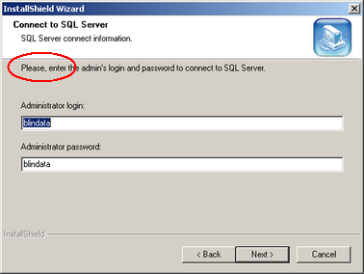

405. Order Processing > Archive Enquiry

There are now options to reprint Delivery Docket and Order Acknowledgement from the Archive Enquiry Screen.

406. Delivery Docket - Laser Print

There is now a parameter to not show any totals on delivery docket. This is in Administration > Parameters > Reports.

We don’t show option prices if a ‘component’ line has been entered. Also, we have removed background colour.

412. Works Order – Label 1

There is now enough room to print out the Cust. Ref. field properly on the top part of the label.

414. Order Processing > Quotations / Orders

The totals fields now display to 2 decimal places (temporary bug).

419. Financials > Create Invoices

The delivery date should not now be altered by running this routine.

New Work and Customer Requests

39. Order Processing > Sales Leads (Client 9)

It is now possible to make diary entries for non domestic (trade type = trade) customers. Previously you could not convert a sales lead into an order for a trade customer, because the ‘Change’ option in Fitters Sheet / Sales Lead only shows customers with trade type = retail. There is now a new parameter to allow trade customers to be displayed here. The parameter (in Administration > Parameters) is called ‘Allow Trade Sales Leads’.

76. Archive Enquiry

We have added the date filter, which now displays only the last month of invoices by default.

It is now possible to filter by invoice date ie only show the last month of orders that have status invoice posted, but also be able to change the filter to any date range.

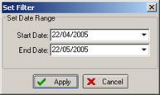

78. Pricing Per Metre Width

We have a new client who calculates selling prices differently. They have price tables in the following format:

Drop | Fabric Group | Price per metre width
400 | A | 23.66
600 | A | 25.03
900 | A | 27.29
1200 | A | 29.74
1500 | A | 32.42
1800 | A | 35.34
2100 | A | 38.52
2400 | A | 41.98
2700 | A | 45.76
3000 | A | 49.66

Therefore if we have a blind with width = 1560 and drop = 1956, the price is calculated as follows:

Look for the first price drop >= blind drop. In this case it is 2100, so the price per metre width = 38.52. The price of the blind is therefore 38.52 * 1560/1000 = 60.09.

The prices can be held in the vanes price table. We have changed the criteria for the blind type lookup so you can enter a blind type record for blind identifier = vanes only or blind type ‘pricing per metre width’ = true.

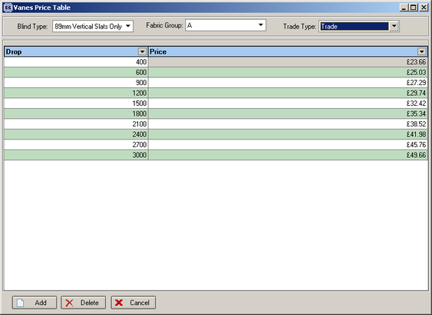

In order detail entry, if blind type ‘pricing per metre width’ = true, the price should be calculated by finding the drop price in the vanes price table, and then multiplying by the width of the blind. The following field should be set up in Blind Details > Blind Types

