Blindata Release Note 1.9.1 

21 June 2004

Bug Fixes and Enhancements

392. Order Processing > Quotes

Once you enter a quote onto the system and save the quote, then if you go back into the quote you cannot change the Width, Drop, Fabric or Quantity of a Blind, but when you print the quote and the status changes to Quotation Printed then you can changes these detail line fields.

Gavs

377. Stock Setup > Purchase Order Enquiry > Generate PO > Add

Should be able to tab through grid.

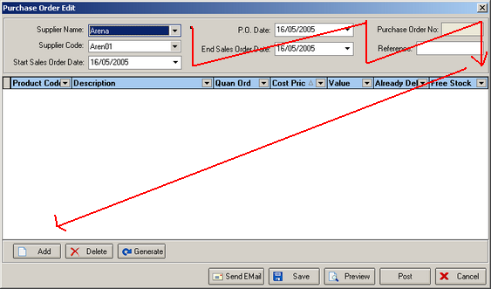

Shulc

404. InstallShield

This should say ‘Please enter’, not ‘Please, enter’.

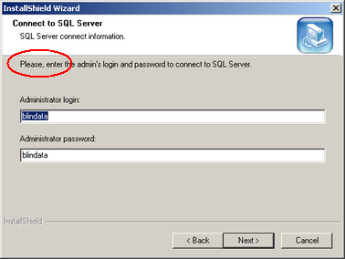

New Work and Customer Requests

