Blindata Release Note 1.8.6 

11 May 2005

Bug Fixes and Enhancements

369. Fitters Sheet > General Report

Correct balance is now showing for fitting appointment.

384. Stock Setup > Purchase Order Enquiry

System is now picking up next purchase order number in properly.

386. Order Processing > Quotations

It is now possible to enter a text detail line first because the ‘text entry’ button is no longer greyed out until a normal detail line has been entered.

390. Order Processing > Orders

No Delivery Address was being displayed for 50% of Orders which were on the system before the update (1.8.4).

We have inserted the update script to the new version (1.8.6), it fixes the problem.

393. Reports > Sales Analysis

There is now a Sales Analysis by Rep by Customer by Blind Type report. Each Rep starts on a new page.

395. Sales Files > Customers

Can now Double Click on a customer to amend the customer.

396. Order Processing > Archive Enquiry.

The invoice date is now on this screen.

397. Order Processing > Orders

This message should no longer appear:
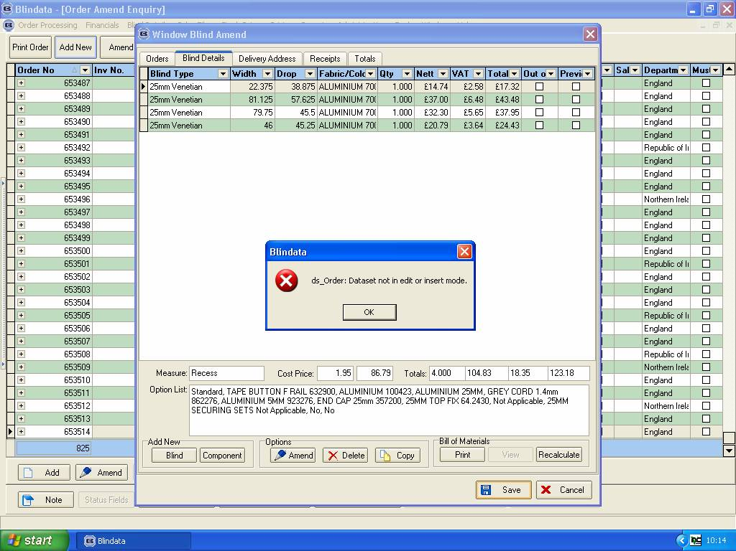
399. Production List by Blind Type

This report is no longer moving fields across the page like this:
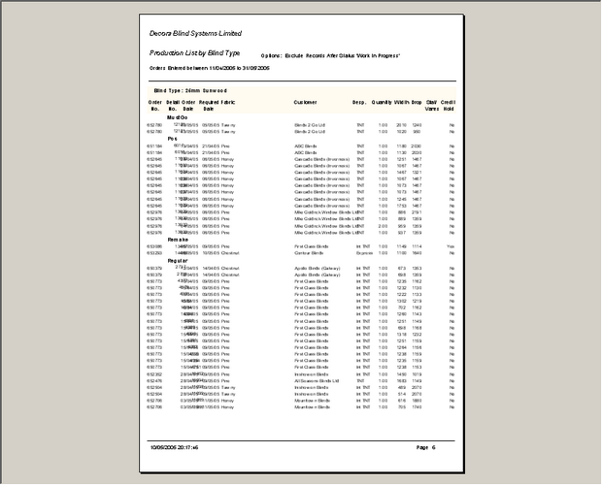

400. Production Documentation > Works Order – Label 1

For the last two weeks this was printing out 2 sets of labels per page instead of 3. Now needs testing on client printer.

New Work and Customer Requests

