Blindata Release Note 1.8.3/1.8.4/1.8.5 

11 May 2005

Bug Fixes and Enhancements

275. Financials > Updating Customers on Stop

This program updates all customer records and places some customers on stop. Once this has been done, there is a routine to set all orders for ‘on stop’ customers to on credit hold if order status <= order manufactured.

344. Production Lists > Production List by Blind Type etc

The ‘Exclude after’ option was choosing a specific status instead of excluding records after that status. It works for ‘Order Control Report’, and now for production list reports.

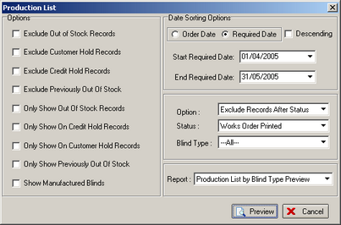

348. Pricing > Option Price Enquiry
Sort order was incorrect when sorting by Blind Type and by Product Code. Fixed.

353. Order Processing > Quotations

When converting a quote to an order the Original Required Date is now being completed.

356. Financials > Post Credits to Sage

There is now a header line in the csv export file. A Nominal Code is now appearing in the export file.

357. Reports > Cancelled Orders

The title of the column Sage Account Ref has been changed to Account Code.

358. Financials > Daily Sales Report

This report is now grouped by transaction type (ie invoices and credit notes) with separate totals for invoices and credit notes.

361. Order Processing > Orders

When entering a new order, the following error occured if you selected a proforma customer and then changed immediately to another customer. Fixed.

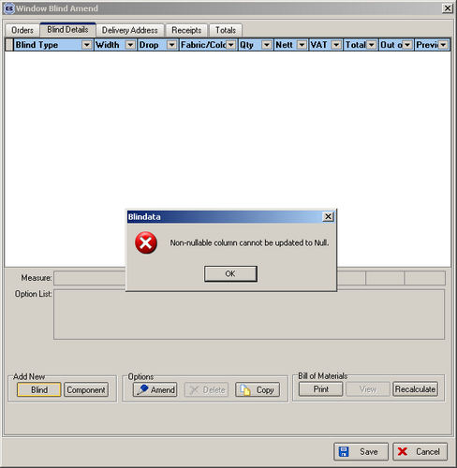

362. Stock Setup > Stock Items > Product Blind Types

The blind type column now sorts in the correct order.

‘BlindType’ says ‘Blind Type’. ‘Fabric Group’ says ‘Fabric Group’.

363. Delivery Docket – Laser Print (Letterhead)

- Company address line 3 is now printing – it showed company address line 2 instead.
- Order contact name was missing for retail customer.
- Discount percentage is now not showing if detail line prices are not shown
- Carriage description is now being shown.
- Delivery date was missing.

364. Order Acknowledgement (Letterhead)

The delivery name is now the contact name for a retail sale. The same problem existed in the invoice print (letterhead).

366. Administration > Holidays/Weekend

The form was not storing dates properly, and the same date was appearing for each year. Fixed.

367. Administration > Company Details

Tab order was incorrect

Postcode is not required for non UK companies so is no longer mandatory.

368. Order Processing > Orders

A message appeared saying ‘Sage is not installed’ even if it is set to ‘Not Installed’ in Administration > Parameters > Sage Parameters / Invoicing. Fixed.

369. Fitters Sheet > General Report

Correct balance is now showing for fitting appointment.

370. Order Acknowledgement – Laser Print

‘Dispatch’ is now spelt ‘Despatch’

Delivery address prints contact name, not company name.

372. Administration > Users

When you go into the screen, it now defaults to the User Information tab, not Advanced Permissions.

373. Report Label Blind Size

The same rules for printing works order label 1 and works order label 2 now apply to this works order, that is it checks to see if there is a record in Blind Details > Blind Types > Blind Type Setup for production labels.

Choice ‘Entered size – metric and imperial’ was only showing imperial sizes – it now shows both metric and imperial.

374. Order Processing > Fitters Sheet / Sales Leads

Sales lead sheet now only prints out sales lead records, not fittings.

375. Order Processing > Quotations

When you converted a quotation that is in Euros into an order, the currency amount was being picked up as 1 instead of the correct ratio according to the currency set for that customer. Fixed.

New Work and Customer Requests

71. Administration > Parameters

There is a new tab to show who is logged in.

77. Filter Orders by Department

A new feature was written that enabled you to restrict users to entering orders for only customers that were set up with departments that matched the departments set up against users. The following had to be set:

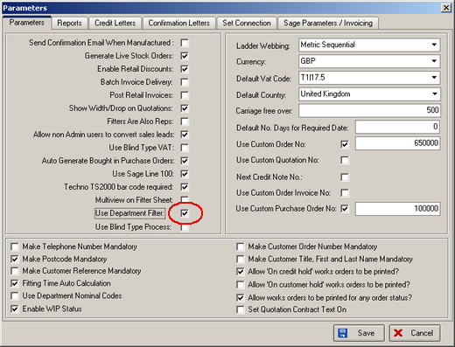

This works well and means that the user can only enter orders for certain customers. There is now an enhancement to this so the user can only see orders for the departments he is entitled to see – in other words filter by department in order amend enquiry.

