Blindata Release Note 1.8.2 

29 April 2005

Bug Fixes and Enhancements

326. Sage Integration > Create/Update Customer Records from Sage

This was not importing data correctly into Blindata from Sage – addresses were wrong, credit limit was wrong. This is now working.

328. Order Processing > Orders > > Add New Blind (Client 9)

As soon as a choice is selected for a blind option, the grid is now updated.

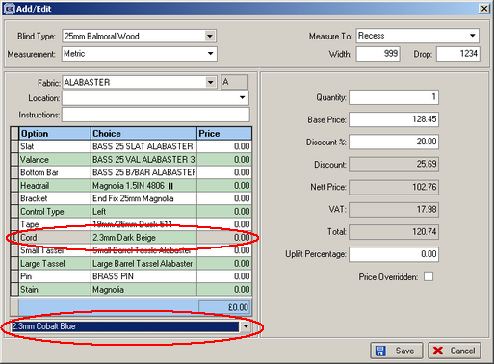

341. Archive Enquiry

Within the Archive enquiry the component to expand an order is now applied so that the detail lines for that order can be viewed.

343. Order Processing > Archive Enquiry

‘Works order – Label 1’ is now printing out from this screen when clicking on ‘Print Works Order’ button.
344. Production Lists > Production List by Blind Type etc

The ‘Exclude after’ option was choosing a specific status instead of excluding records after that status. It works for ‘Order Control Report’, and now works for production reports as well.

345. Order Processing > Total No Of Blinds Outstanding Report

The print preview now shows the same totals as the screen.

346. Reports > Lead Times

The ‘Exclude Out of Stock’ option was now working. This is now fixed.

347. Administration > Sage Utilities > Create/Update Customer Details from Sage

This error is now fixed.
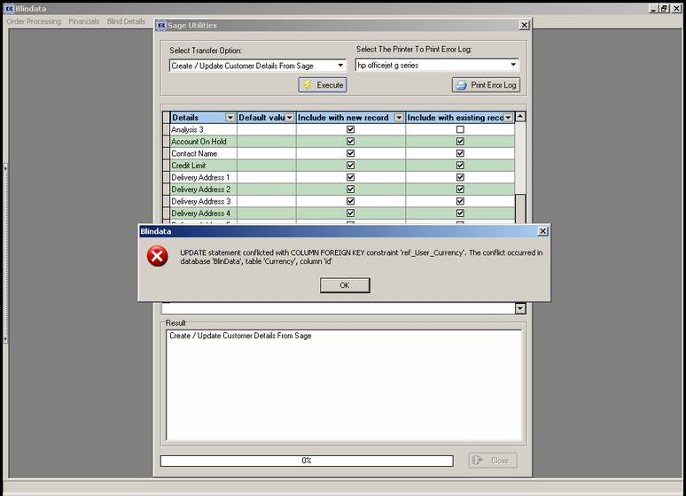
349. Stock Setup > Purchase Order Enquiry > Generate PO (regular) > Purchase Order Edit

Quantity now only display to 2 decimal places on screen.

"Value" now calculates whilst in this screen. Also the value amount displays to 2 decimal places

350. Stock Setup > Purchase Order Enquiry

Purchase Order status now changes to "Delivered" when goods are delivered.

352. Order Processing > Quotations

When converting a quotation into an order, the delivery company name is now being brought across.

354. Order Processing > Orders / Quotations

The tab order in order entry and quotation entry is now correct – this happened after ‘Delivery Company’ was added.

355. Order Processing > Archive Enquiry

We have added a column to signify if the order was a remake similar to the remake column within Order Processing > Orders.

365. Delivery Docket – Laser Print (Special)

Two company names were being printed for trade customers – is now only delivery company name.

New Work and Customer Requests

58. Height field for External Blinds

There is a new field in the detail line entry for blind types with blind identifier = External. This is called Height and appears where number of vanes appears for vanes only blind types. It is only used for ‘External’ blinds and has no effect on pricing.

