Blindata Release Note 1.7.7 

19 April 2005

Bug Fixes and Enhancements

279. Pricing > Discount Management

The discount file can now be opened by more than one person at a time.

293. Pricing > Discounts

Record locking is now working.

296. Order Processing > Orders

The calculation of the add/deduct slat amounts for wood box blinds is now correct. It should also select the correct box blind stock item, dependent on data set up in Administration > System Tables > Box Blind Slat.

317. Order Processing > Quotations

When converting a quote to an order, the required date is now calculated according to the existing order entry rules.

319. Financials > Invoice Print and Post

This screen now shows Invoices at Invoice Created and Invoice Printed statuses. When the posting has been completed, the invoice posted records appear only in the archive screen.

320. Production Lists > Production List Summary by Required Date

"Exclude After Status" was not working properly. It now only shows the status selected prior to the status selected.

This has now been fixed for "With Status" WIP and "Exclude After Status" WIP.

323. Production Lists
This sporadic problem occurs - "Timeout Expired" error messages on some of the Production list reports.
We have now increased the timeout to 5 minutes. The logic in the stored procedure cannot be simplified any further, so we need to look at other options.
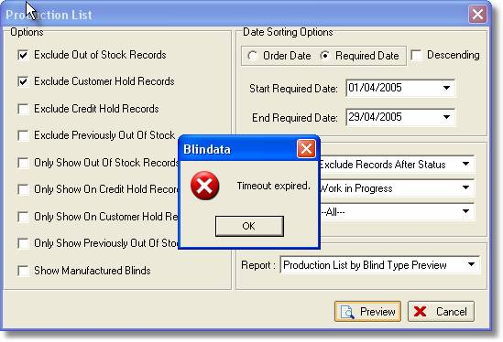
New Work and Customer Requests

