Blindata Release Note 1.7.6 

18 April 2005

Bug Fixes and Enhancements

274. Order Processing > Orders

The tabbing now goes right through order, so we have minimised the use of the mouse. This means when you go to add an order, the cursor is already on customer and then you can tab right through.

311. Order Processing > Production List > Production List by Blind Type with Fabric Total

On the later pages of the report, the customer reference had moved right and was overlapping the Despatch field. This has been fixed.
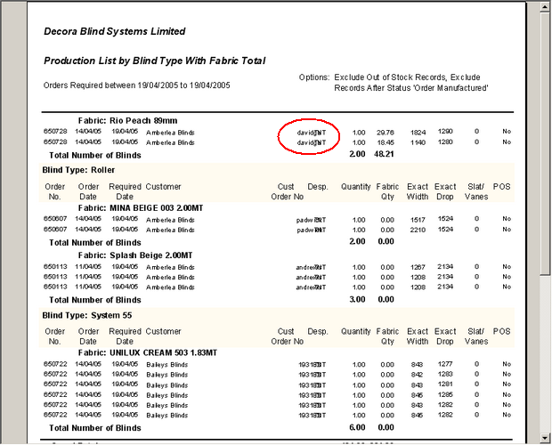

312. Total of Outstanding Orders Report

This was incorrect if you select order status = works order printed. It gave a larger figure than for all orders. This is now correct.

316. Order Processing > Orders

The following error message occured when you try to delete a detail line.

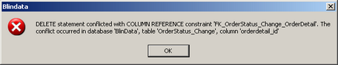

We think this may have been a one off message as we have not been able to repeat it on other detail lines.

321. Order Processing > Orders

The roller fabric calculation is working properly for fabrics where calculator = width or drop. There is an issue with setup.

322. Order Processing > Quotations

When sending out an e-mail quotation, the subject text now starts with ‘Quotation…’, not ‘Order…’.

324. Credit Hold

Some orders were not being put on credit hold, despite the fact they are over their credit limit. This has been resolved.

323. Production Lists
This problem started last week, we are getting "Timeout Expired" error messages on some of the Production list reports.
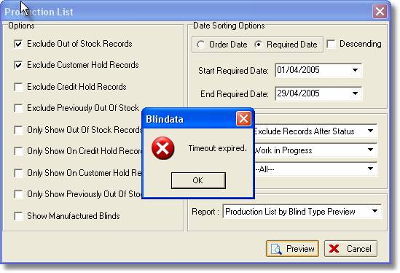
For the time being we have set the timeout to 120 seconds. But we will also work on the optimization of the stored procedure used for these reports.
New Work and Customer Requests

