Blindata Release Note 1.7.2 

13 April 2005

Bug Fixes and Enhancements

267. Works Order – Label 1

Number of slats now appears on the top small labels for Venetian and wood blind identifiers

270. Delivery Docket Laser Print (Special)

Moved order date 15mm to left and carrier 20mm to left.

271. Invoice Bespoke 1

Moved totals at bottom down 1.5mm.

276. Works Order – Label 1 (CRITICAL)

If you enter a quantity of more than one Venetian blind on an order detail line, the number of slats shown was the total of the slats for all the blinds in the order detail line. It now only shows the number of slats for that blind.

283. Order Processing > Orders On Hold

If you click on ‘Taken off credit hold’ when ‘On credit hold’ is true, the ‘On Credit Hold’ field is set to false. But if you try to click ‘On Credit hold’ as true when ‘Taken off credit hold’ is true, it doesn’t work. ‘On credit hold’ remains as false and ‘Taken off credit hold’ remains true. This has been fixed.

284. Order Processing > Orders

If an order is put on customer hold, when it is taken off customer hold, the required date is now calculated from the current date, not the order date.

295. Works Order – Label 1

If order is a remake, the word REMAKE now appears above the label on the right hand label. If it is a must go, the words MUST GO now appear on the same label.

281. Sales Leads / Fitters Sheet

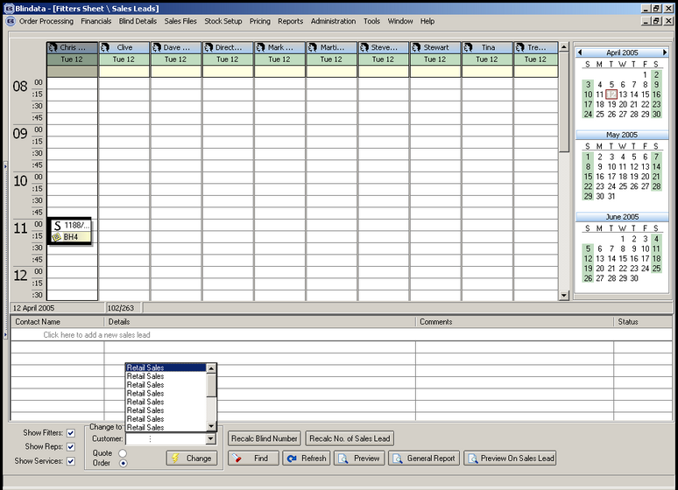

When you click on ‘Change To’, the retail sales account appeared many times. This has been fixed

282. Sales Leads / Fitters Sheet

When you convert a sales lead to an order, the address is put into the delivery address. It now also goes into the invoice address.

289. Works Order – Label 1 (Critical)

Box blinds were not printing deductions and no. of slats properly. If you entere a Venetian blind on an order and then a box blind, it printed number of slats and cord spacing for box blinds This has been fixed.

New Work and Customer Requests

