Blindata Release Note 1.7.1 

12 April 2005

Bug Fixes and Enhancements

171. Order Processing > Order Enquiry

We have removed the Out of Stock an In Stock buttons from the blind detail entry screen put them on the ‘Order Enquiry’ form instead.

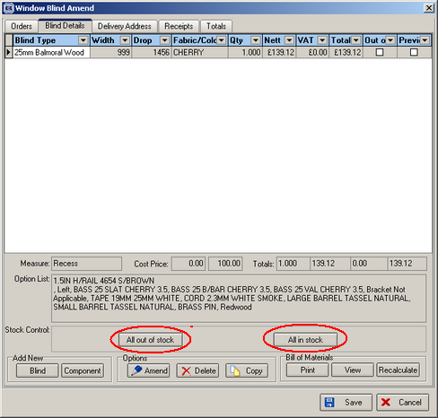

215. Order Processing > works Order – Label 2

We now print the number of pleats on the works order. The number of pleats is calculated by looking at the ‘Pleat Table’ that is held against the pleated blind type. The cord spacing is also printed.

261. Administration > Parameters

Every time a new version is installed, the printer settings got changed in Administration > Parameters. The printer settings are now held as names, not numbers. Please note the printers must be reset here before processing continues.

264. Sage Export File

The headings fields now have the exact same names as those on sageexport.csv.

265. Cord Spacing

Cord spacing calculation was wrong if you entered a blind, size width 1422. It gave 152-374-373-373-152, which adds up to 1424. It should add up to 1422. Fixed.

266. Production Lists > Production List Summary by Required Date

Not grouping blind types problem has been fixed.

Exclude After Status was not working properly. It now only shows the status selected prior to the status selected.

272. Works Order – Label 1

For box wood blinds, we now show slat add/deduct, not number of slats or cord spacing. This was correct until we added in number of slats for wood and Venetians.

277. Order Processing > Total Of Orders Outstanding

The following error was appearing and is now fixed.

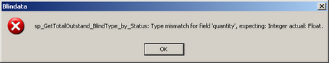

278. Order Acknowlwdgement (Laser Print)

The text ‘Velux Code’ now says ‘Code:’.

280. Acknowledgements, Invoices and quotations

For retail customers, order acknowledgements were showing the company name and not the contact name in the invoice address. Invoices and quotations were the same. This has been fixed.

New Work and Customer Requests

