Blindata Release Note 1.6.9 

9 April 2005

Bug Fixes and Enhancements

241. Orders > Order Processing

There is a new field to store the works order printed date in the orders table. This gets updated when the works order label is printed.
246. Order Processing > Orders
The following debug message was appearing either when you save a detail line or when you save an order.
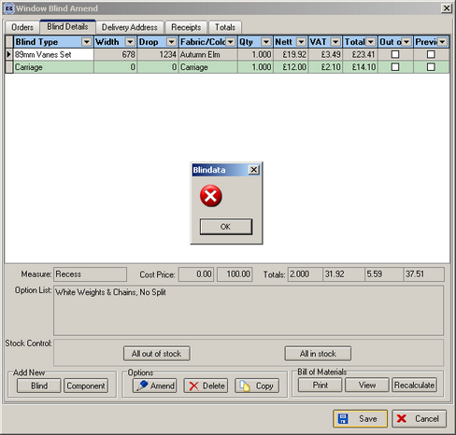

This was caused by switching on the Sage line 100 parameter by not relogging in. It has been resolved.
247. Order Processing > Orders

The following error can occur if an option is not set up properly:

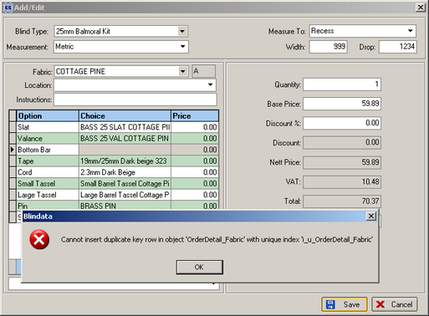

You can see that there is no option set up for ‘Bottom Bar’. This is because a particular bottom bar size has been selected but that product code was not set up for the correct product blind type.

248. Orders > Order Processing > Works Order – Label 1

For vanes only blinds, we now display the fabric cut size and the number of vanes in the same way it is shown for normal vertical blinds.

249. Orders > Order Processing

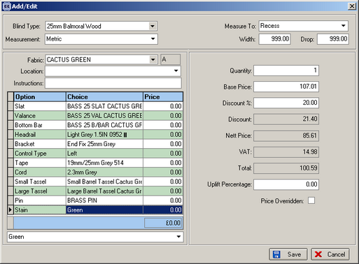

When you add a detail line, the tabbing is now correct in the grid. The focus goes from Instructions to the first grid entry.

250. Orders > Order Processing

If you enter an order for a company without a postcode, the following error occurred:

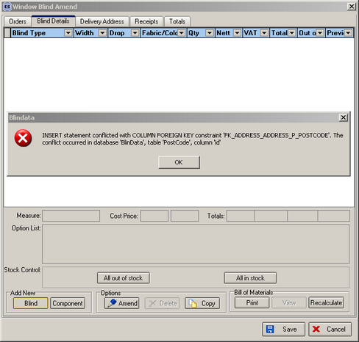
This was caused by the new address routine and has been fixed.

New Work and Customer Requests

