Blindata Release Note 1.6.8 

8 April 2005

Bug Fixes and Enhancements

197. Order Processing > Orders

If entry type is changed to Invoice, the order status now changes to ‘Invoice Created’ after the invoice number has been updated.

202. Order Processing > Orders

‘Timeout expired’ messages were sometimes occurring when going into the Order Amend Enquiry screen and when printing sales analysis reports. This has been fixed.

204. Order Processing > Quotations

When converting quotes to orders, carriage is no longer left in a quote and the quotation is removed if there are no other detail lines left unselected.

209. Order Processing > Orders (CLIENT 9)

When adding an order, customer lookup was showing multiple customers, but the account code lookup was ok. This is fixed.

210. Order Processing > Order Acknowledgement (Letterhead)

Totals are now printing on first copy of order ack. Department prints as prefix in front of order id.

If despatch method is Collection, do not print delivery address. We are not going to do this – it is too complicated.

Naming convention for name in delivery address is now correct.

Special instructions are now wrapping round. ‘Spec Ins’ does not appear for misc. detail lines.

For a vanes only blind, the number of vanes now displays.

If there is discount on a detail line and ‘hide detail line totals’ is true, discount % is no longer shown.

214. Order Processing > Orders

Vanes only was not pricing properly according to vanes price table rules. It is now picking up prices from the Vanes Price table. Also, if the vanes only blind type record is set to ‘calc width from vanes’ = false, the user can enter the number of vanes and not worry about the blind width.

The logic for vanes only is as follows:

If ‘calc width from vanes’ = false, enter vanes (width is then entered but is not mandatory), price is calculated by looking at vanes price table.

If ‘calc width from vanes’ = true, enter vanes and the width is calculated from the number of vanes multiplied by the vanes multiplier in the blind type record. The price is calculated by looking at the normal price table.

219a. Send Mail

When sending e-mail (different reports), the e-mails were not displaying detail lines correctly. This was caused by . (dots) being placed in addresses. This has been fixed by inserting a space after the dot.

224. Order Processing > Orders

There was a bug entering vanes only blinds. If ‘calc width from vanes’ is switched on, the width is now calculated from the number of vanes in order detail entry.

226. Order Processing > Orders

One client ha a particular problem. For some retail customer sales they do not enter prices in detail lines – they only enter totals. The order of events is as follows:

Sales lead is converted to order.

Total and deposit is entered manually against order in sales office.

Detail lines are then entered against the order in production office. Once this is done, the totals get zeroised because they have no prices set up in price tables. This means the totals have to be entered again.

Solution: we now have a flag that is set up against a customer called ‘Disable total recalculation’? If this flag is set to true, detail lines can be entered for an order and no change gets made to the amounts on the totals tab of the order.

228. Order Processing > Order Acknowledgement

For a trade order the deliver to name is now the company name, not the contact name.

229. Delivery Docket Print – Laser Print (Special)

We have removed totals from delivery docket.

Delivery docket date was incorrect – showing 31/12/1899. This was showing the invoice date (which was null) and has now been corrected to show the delivery date.

230. Order Acknowledgement – Laser Print

Order acknowledgement – laser print no longer shows department before order id.

232. Order Processing > Orders > Works Order – Label 1

If order was entered in inches, cord spacing calculation did not work – it should convert to metric before calculation is made. This has been fixed.

233. Order Processing > Orders > Works Order – Label 1

The number of slats is now on the ‘works order – label 1’ for Venetian and wood blinds.

234. Order Processing > Orders

The default values are now being picked up from default options when the fabric is entered in a detail line.

235. Invoice – Bespoke 1

The layout has now been altered slightly to the right and down (5mm and 3mm).

236. Delivery Docket Laser Special

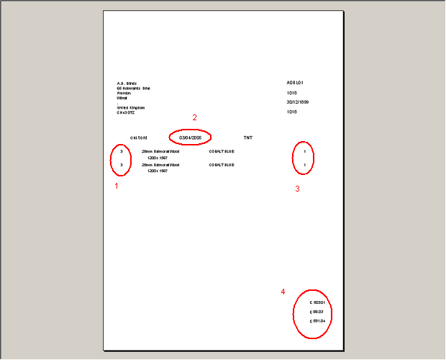

- This now shows fabric code.
- Moved 20mm to right.
- Moved 20mm to left.
- Removed totals and replaced with despatch employee name.

237.Orders > Order Enquiry

The ‘Deliver Scan’ button stores the employee in the Orders table. The ‘Deliver’ button now does the same thing.

238.Financials > Posted Invoices Report

This client uses the order no. as the invoice number – therefore invoice number column now also displays order id instead of invoice number.

239.Financials > Post Invoices to Sage

When we create the file SALINV.csv, we now have the field names in the first line.

240. Order Processing > Order Enquiry

When the ‘WIP Status’ scan is done, the field dat_startmanuf in the Orders table is now filled with the current date.

243. Order Processing > Order Enquiry (Minor Bug)

The typing search isn't working on the order No, if you click on the little downward arrow and type the number it just goes to the first record but if you do the same on the Blind ID it will go to the specific record. This is related to the speed of typing in the order number. If you do it quickly, it will work.

245. Order Processing > Orders

Tabbing through the grid on the order detail line is now functioning, and is in the correct order.

New Work and Customer Requests

13. Order Processing > Orders > Order Entry

We have made an alteration to the way the addresses work. Previously there were two sets of rules, for trade and retail customers. Trade was straightforward and works. Retail was more complicated and required a small modification.

Normally retail sales are all held against one customer account, and when quotations, order acknowledgements, delivery dockets and invoices are printed, the delivery address is used as the invoice address. However, there are occasions when, for a retail customer, the delivery address and invoice address are different. So we can now hold two addresses for the order, one for delivery and one for invoice.

Solution:

We allow the user to amend the invoice address against the order:
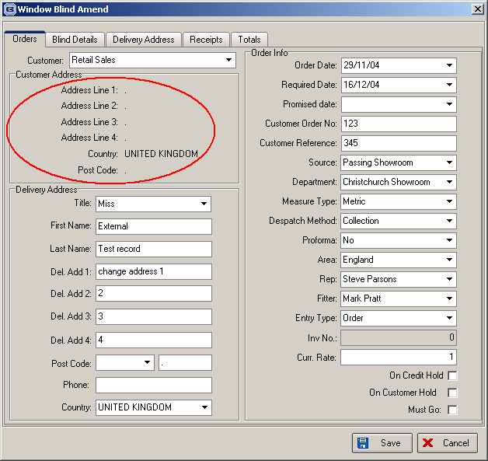

But it is only possible to change this address if the customer trade type = retail.

43. Order Processing > Quotation Print (Client 9)

The above work has also been applied to quotations and we can now show a second address for retail quotations. This is because we could have a separate invoice and fitting address. The print layout adheres to the same layout rules as order acknowledgements.

57. Order Fax Number

It is now possible to hold a fax number against an order in order entry.

