Blindata Release Note 1.6.7 

4 April 2005

Bug Fixes and Enhancements

169. Order Processing > Orders

This problem occurred whenever we had two customers with similar names. When going to input an order eg. ABC Blinds it will bring up the first ABC but if this customer is on stop it would not let you choose another ABC. We have altered this so that if we enter ABC it does not automatically come up that the customer is on stop if that customer is not being selected. However you must now press the tab key to fill in the customer details in the order.

190. Order Processing > Orders > Detail Line Entry

Tabbing in grid in detail entry – it is now possible to be able to tab through the entries in the option grid

200. Order Processing > Orders

If a blind is entered and it has no options and no price is found in the price table, the nett price, VAT and totals did not get calculated properly when the price is overridden. This has been fixed.

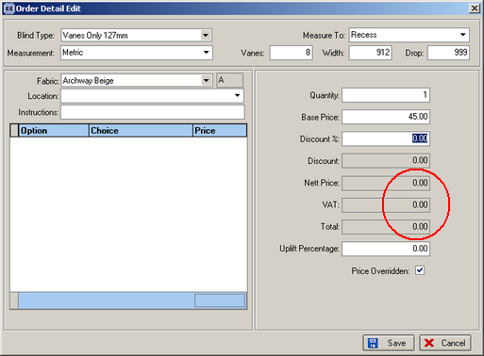

205. Order Processing > Orders

Not displaying e-mail address for trade order amend. E-mail address is not being stored in Orders table for trade orders - we have implemented new rules. If there is no e-mail address in the Order (it looks for the e-mail in the order first of all), a script checks for the e-mail in Customer’s record, no matter what Customer type it is. If the script does not find the address there, you will get a message that the address is empty.

Also the e-mailed order acknowledgement now shows all detail lines properly.

206. Order Processing > Orders

127mm vanes only – no. of slats were not being calculated properly. Fixed

212. Order Processing > Quotations

There is now a parameter to set contract text button = true in quote entry. See Administration > Parameters.

213. Order Processing > Quotations / Orders

If retail customer, ‘hide detail line totals’ now defaults to true.

216. Pricing > Price Table Enquiry

If you sort by blind type description, the fields got sorted by record id. This was wrong – they now sort by blind type description.

217. Order Processing > Orders

Caption on order detail amend screen now says ‘Add/Edit’…

218. Pricing > Price Table Enquiry

There is now a warning message if you are going to delete a price table ‘Are you sure you want to delete this price table?’

220. Order Processing > Quotations

Credit limit messages no longer appear when entering quotations, only on orders or when converting a quote to an order.

221. Order Processing > Quotations

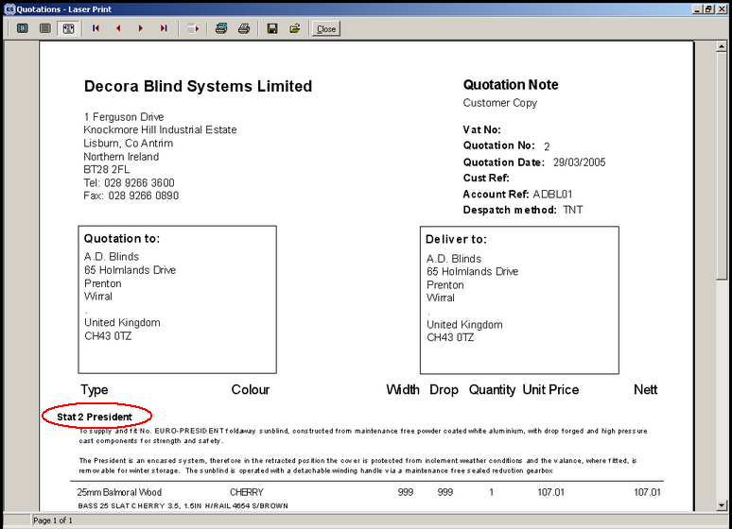

This quotation text line had been entered with the header text set to Centred but it moved it to the extreme left on the quotation print. It is ok on the screen. This is now fixed.

222. Sales Files > Customers

There is now a ‘Proforma’ column on the Customers Enquiry form.

223. Reports > System Reports

There is a new report in the same format as Customers list by Area, called Customers List by Rep.

225. Blind Details > Cord Spacing

There was a bug entering a new cord spacing record – it wouldn’t let you select a blind type. Fixed.

New Work and Customer Requests

44. Financials > Retail Balances (Client 9)

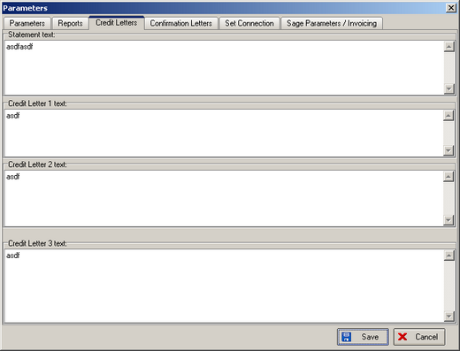

In Administration > Parameters > Credit Letters, we can hold four different sets of text for putting in letters to retail customers. We want to send reminder letters to retail customers who do not pay their outstanding balances.

There are two new fields in the Orders table, ‘Letter Sent Status’ and ‘Last Letter Date’. ‘Letter Sent’ will be one of 5 possibilities – No Letter Sent, Statement Sent, Letter 1 Sent, Letter 2 Sent, Letter 3 Sent.

There is a new menu option in Financials called Retail Balances. The screen grid shows order number, customer order number, contact name, total, balance, order status, despatch date, department, letter sent status, last letter date. Only retail orders will be shown on this screen and the record display defaults to those with balance > 0. There is a button to print out the appropriate letter according to the following rules:

Statement letter – can only be sent if balance is > 0, despatch date + 7 days < current date, Letter Sent Status = No Letter Sent.

Credit Letter 1 – can only be sent if balance > 0, last letter date + 7 days < current date, letter sent status = Statement Sent.

Credit Letter 2 – can only be sent if balance > 0, last letter date + 7 days < current date, letter sent status = Letter 1 Sent.

Credit Letter 3 – can only be sent if balance > 0, last letter date + 7 days < current date, letter sent status = Letter 2 Sent.

After each letter is sent, the last letter date is updated.

54. Credit Limit 2

There is another field in the customer record, ‘Credit Limit 2’. This is an additional credit limit that is used for manufacturing only. It is placed in the Options tab of the Customers form.

The field is used for calculating if a customer is over their credit limit. At the moment balances + Sage order amounts + outstanding orders are compared against the credit limit. With this new field introduced, the comparison is made against the combined credit limit total (credit limit + credit limit 2).

