Blindata Release Note 1.6.4/1.6.5 

21 March 2005

Bug Fixes and Enhancements

79. Order Processing > Orders > Order Made

When order was flagged as ‘’Order Made’, it was being changed to ‘Despatched’ instead of ‘Order Manufactured’. Data issue at only one site. Now fixed.

136. Order Processing > Order Enquiry

The normal deliver button now applies the same rules to consolidated deliveries as the ‘Deliver scan’ button does. It also asks for employee and delivery date.

146. Stock Setup > Purchase Order Enquiry

When you invoice a regular PO, it is possible to post the invoice into Sage many times. It should only be possible to do this once. This has now been fixed.

When PO window is opened you can post to Sage (if the button is active); after the information is posted, you’ll get a message that the information has posted successfully. But if you try to post again without closing the window, you’ll get the following message:

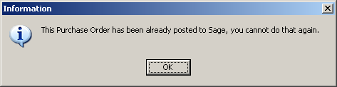

149. Order Processing > Quotations

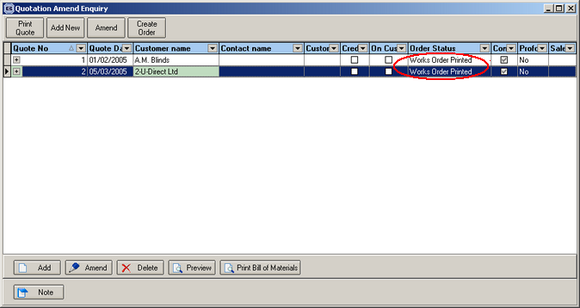

Status now says ‘Quotation Printed’ instead of ‘Works Order Printed’.

150. Order Processing > Quotations

Quotation text lines now print properly on the quotation. Also the totals print on the quote if a text line has been entered.

151. Order Processing > Quotations

The quote entry screen needs the following changes:

- ‘Credit Note Date’ now sasy ‘Quote Date’.
- The other dates have been removed.
- Must Go, On Customer Hold etc have been removed.
- ‘Quot. Entered by’ now says ‘Quote Entered by’ and there is more space for the operator name.

153. Reports > Sales Analysis

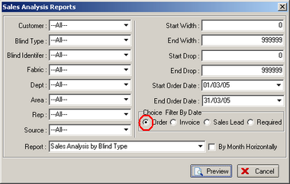

If you select sales analysis by order date, it now selects records regardless of their status (except cancelled – it ignores those). The purpose of this report is to show all orders between two dates, even if they have been invoiced.

158. Order Processing > Production Lists

Now the reports work when the following box is ticked:

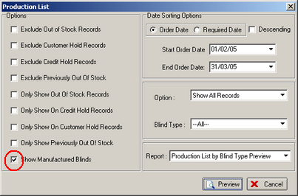

This is the purpose of the ‘Show Manufactured Blinds’ criteria. Here are the rules:

It is not used in the order control report, only production reports.

In the production reports, it only comes into play if some of the blinds in an order have been manufactured and some haven’t. Because the status choice is limited to order statuses, we needed some way of working out which blinds had been made.

159. Financials > Invoice Batch Print > Invoice – Bespoke 1

If blind identifier = X (Velux), the Velux code now appears on the invoice instead of width and drop.

160. Order Processing > Quotations > Quotations – Laser Print

We now display dispatch method below ‘Sage Account Reference’ on quote print report.

161. Order Processing > Quotations

When updating a quotation into an order it was not changing the order date to the date the quote was updated. Eg if quote date was 02/03/05, but the quote was converted to an order on 07/03/05, the order date should be 07/03/05 and the required date calculated from 07/03/05. This is now fixed.

164. Financials > Invoice Batch Print > Invoice – Bespoke 1 (HIGH PRIORITY)

Invoices were slightly off line. Move everything down 3mm and left by 5mm. Cust. Ord. No, order date and dispatch method are now printing.

168. Order Processing > Order Enquiry

Order Enquiry Screen - Now showing WIP status on records.

173. Order Processing > Orders

If the ‘All out of stock’ button was flagged, the previously out of stock button was flagged. This should not have happened. It now only flags ‘previously out of stock’ when the ‘In Stock’ button is flagged.

177. Order Processing > Orders

Can now e-mail order for trade customers.

178. Order Processing > Production List > Order Control Report

We now show blind type code instead of blind identifier code.

180. Reports > System Reports

Blind Type Ordered report date criteria was not finding anything for one day. This is now fixed.

181. Order Processing > Orders > Del. Docket Print

Can now reprint delivery docket. Should also validate department to make sure this prints.

182. Reports > Lead Times

‘Exclude out of stock’ criteria is now working.

183. Order Processing > Order Enquiry

Manufacturing date now appears on this screen.

184. Order Processing > Orders on hold

Record locking was not working properly – could not deliver record straight after taking off hold.

187. Order Processing > Consolidated Orders

Occasionally a consolidated order customer will want an order to be dispatched immediately. It is now possible to override this option if ‘must go’ = true on order and apply carriage charges if necessary.

189. Order Processing > Production Lists > Order Control Report

The order control report now shows the on credit hold field (Yes/No).

192. Blind Details > Cord Spacing

Cord spacing form – now displays records where blind identifier = Wood.

193. Order Processing > Order Enquiry > Deliver Scan

We have changed the order of the fields on the form. When the form appears, the first active field is “Despatch Employee”, then “Date” and finally Scan Edit. We have added verification to make Despatch Employee selection required.

Delivery docket is now printing.

We have switched off e-mailing of delivery dockets for time being.

194. Order Processing > Orders > Status Fields button

We have double checked that changing order status changes the underlying detail line status.
Please see the table below to see which order detail status corresponds to each Order status.

Order Status | Order Detail Status
Order Entered | Order Entered
Work In Progress | Work In Progress
Order Manufactured | Fully Manufactured
Despatched | Despatched
Invoice Created | Invoiced
Invoice Printed | Invoiced
Invoice Posted | Invoiced
Credit Note Created | Order Entered
Credit Note Printed | Awaiting Manufacture
Credit Note Posted | Invoiced
Quotation Entered | Order Entered
Make Into Order | Order Entered
Made Into Order | Order Entered
Order Printed | Awaiting Manufacture

195. Blind Details > Blind Types > Option Setup

Printing options for delivery dockets have now been included.

196. Order Processing > Production List > Order Control Report

Blind types field (1 WO5, 1 L127, 1R, 2 WO2 etc) was overlapping into fields to right. This has been fixed.

198. Order Enquiry > Deliver/Deliver Scan > Delivery Docket – laser print (Special)

Minor changes have been made to the layout.

New Work and Customer Requests

51. Administration > Users > Advanced Permissions

Previously, a user may have had permission to access Order Processing > Orders (and Order Processing > Order Enquiry), and be able to use all the buttons on the screen. There is now an option to restrict access to certain buttons. This can be done in Administration > Users > Advanced Permission as follows:

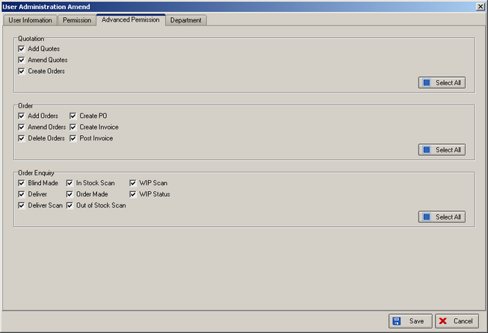

If any of the above boxes are not ticked, the buttons will be greyed out on the relevant screen for that user.

