Blindata Release Note 1.6.2/1.6.3 

14 March 2005

Bug Fixes and Enhancements

33b. Order Processing > Orders

We no longer show the ‘proforma’ column on the order amend enquiry screen. The ‘Remake’ field is displayed instead.

76. Order Processing > Orders > Component Detail Entry

In component detail entry, you can now enter quantity to 3 decimal places.

100. Order Processing > Order Enquiry

The order enquiry screen can be refreshed by clicking F5.

130. Order Processing > Order Enquiry > Despatch Scan

It is now possible to record employee who despatched the goods – please use service employees for time being but we will want to lookup by ‘Despatch’ employee in future.

It is also possible to e-mail the delivery docket at end of the despatch scan.

131. Order Processing > Orders (HIGH PRIORITY)

The order detail entry form has been speeded up by a factor of 2 – 2.5.

139. Order Processing > Orders > E-mail Order Acknowledgement

The following problem no longer occurs. Virus checking messages will be tagged to the end of the order acknowledgement.

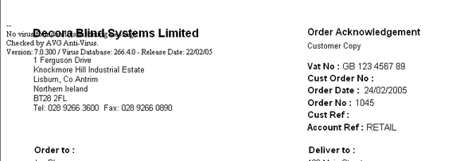

144. Order Processing > Orders

When orders were filtered by ‘Order Date’, only one record was shown, when there may be more. This has been fixed.

154. Order Processing > Orders > Acknowledgement – Laser Print

The text ‘Spec. Ins:’ now appears in front of the special instructions.

‘Despatch method’ appears below ‘Account Ref:’.

Order contact name appears on top right.

Measurement (recess/blind type) appears on detail line.

Additional option prices appear separately.

If the detail line is for a velux blind, it should show the velux code instead of the width and drop.

On the bottom, carriage has been removed and the totals right justified.

156. Order Processing > Production Documentation > Works Order – Label 1

The blind type is now being displayed properly on the label for a Cassette blind.

Also, for box blinds, ‘Trim Amounts:’ now say ‘Deduct Each End’. It is now including ‘number of slats’ for box blinds. This now says ‘Slat Add’ or ‘Slat Deduct’ depending on whether the answer is positive or negative.

162. Order Processing > Production List > Production List by Blind Type

Within groups (blind type and must go/remake etc), orders are now sorted by order date or required date, depending on the date that has been chosen, and then by order id sequence.

163. Order Processing > Order Enquiry

Orders are now displayed in order id order and within that by blind id order.

165. Order Processing > Production Documentation > Works Order – Label 1 (HIGH PRIORITY)

The customer name was missing (it was a trade order – retail is ok) and the delivery day has been fixed.

166. Order Processing > Order Enquiry

WIP scanning - if scanned accidentally more than once, a message ‘Already Changed to WIP’ appears.

167. Order Processing > Production Documentation > Works Order – Label 1

The required date is now on the two small tickets.

172. Order Processing > Production Documentation > Works Order – Label 1

On right hand large label, there is a lot more room for special instructions and bar code has been moved down.

174a. Order Processing > Production List > Production List by Blind Type

Exclude previously out of stock condition is now working, exclude on customer hold condition is now working, only show previously out of stock and only show on customer hold are correct way round.

174b. Order Processing > Production List > Order Control Report

The same record was appearing twice on the order control report:

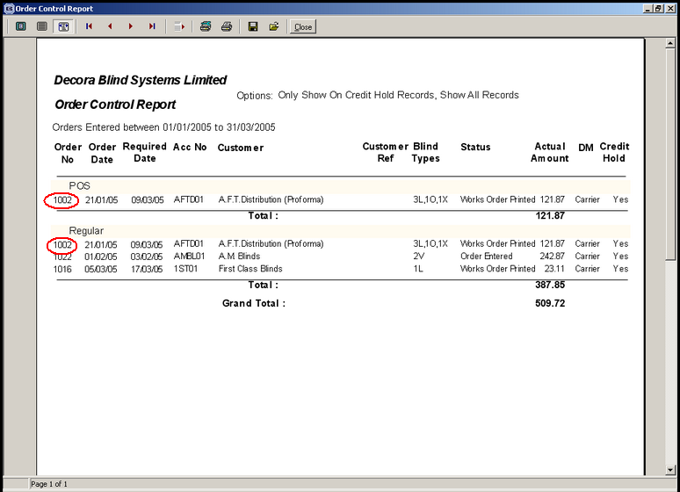

This is now fixed.

176. Order Processing > Production List

The order status fields are now displaying properly.

179. Order Processing > Production Documentation > Works Order – Label 1

‘Recess’ has replaced ‘Entered’. ‘Recess / Blind Size’ has been spaced out, Width fields, drop fields are also spaced out.

186. Order Processing > Orders

It is no longer possible to put an order on customer hold if the order has status of WIP or greater. A message appears saying ‘This order is already at the work in progress stage. It cannot be placed on customer hold’.

It is also no longer possible to scan for WIP if an order is on customer hold. A message appears saying ‘This order is on customer hold and cannot be changed to work in progress’.

New Work and Customer Requests

48. Blind Details > Blind Types > Option Setup (Client 1757)

We can now define what options get printed on various reports – for quotes, order acknowledgements, delivery dockets, works orders, labels, invoices, credit notes, purchase orders.

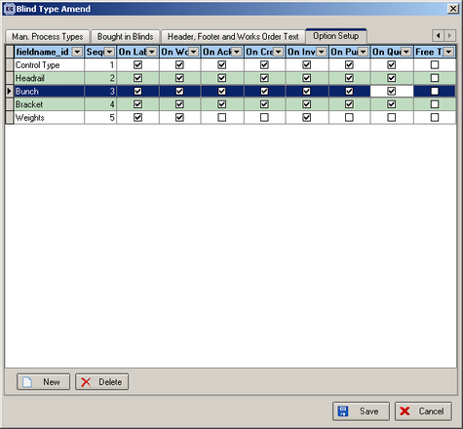
When we print out the various reports, the reports now check Blind Details > Blind Types > Option Setup to see if the option is flagged to appear on the report. If an option is ticked for a particular report, then that option will print out in the option list line of the report.

