Blindata Release Note 1.5.8 

24 February 2005

Bug Fixes and Enhancements

99. Financials > Create Invoices

After creating invoices, form now closes.

109. Order Processing > Orders

When entering an order detail line for a bought in blind, the cost price is now being found.

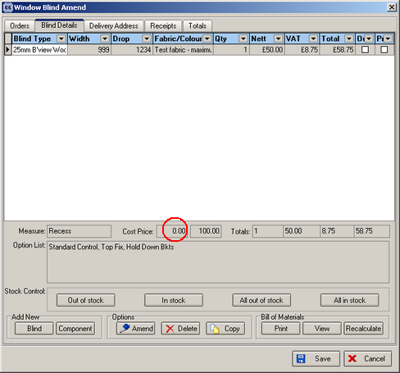

There is a cost price set up for this blind here:

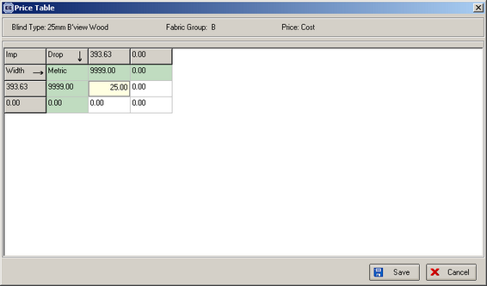

110. Pricing > Vanes Price Table

The price can now be entered to 2 decimal places.

111. Order Processing > Orders > Window Blind Amend

Automatically generated carriage detail lines now appear as the last detail line in an order.

116. Sales Files > Customers

The e-mail address field has been expanded.

117. Financials > Invoice Batch Print > Invoice – Bespoke 1

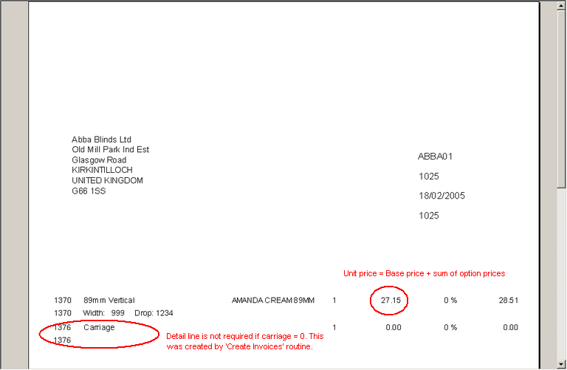

In the invoice detail line, the unit price of 27.15 is only the base price. It it is now base price + sum of option prices.

122. Stock Setup > Purchase Order Enquiry > Generate PO

It is now possible to save a bought in purchase order. The detail line did not save properly. This was a bug.

123. Order Processing > Orders > Detail Line Entry

If you are entering a vanes only blind, the width calculation now displays correctly.

Then when you save the record, it previously zeroised the number of vanes and the width. This is fixed.

124. Order Processing > Orders > Acknowledgement – Laser Print

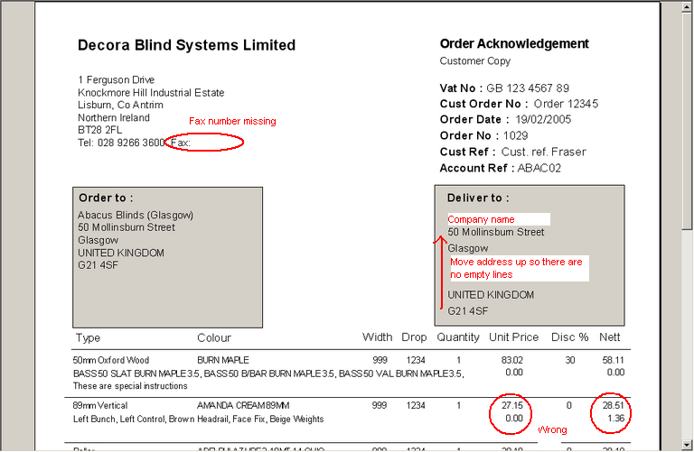
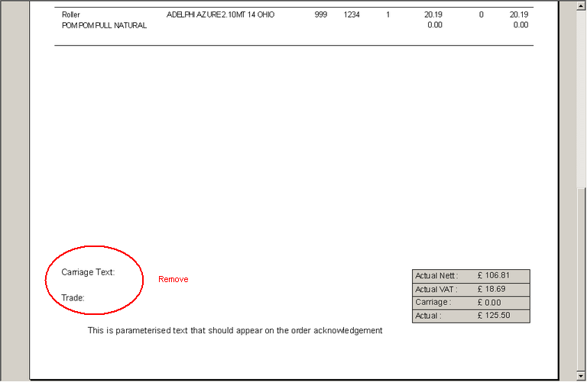

This has been tidied up.

126. Order Processing > Production Lists > Production List by Blind Type

The records are now printing out in the correct order – it is Must Go, Delivery Day, Previously Out of Stock, Remake, Regular (all others).

Dates now show in format 21/02/05, not 21/02/2005. This will save space and make more room for fabric.

129. Order Processing > Production Documentation > Work Order – Label 1

On small labels we have removed blind size width and drop

‘No. of Vanes’ now says ‘Vanes’

We have removed department concatenated with order id in top labels.

‘Spec Inc’ now says ‘Spec Ins’. Special instructions have been moved down a line.

Del Day now says day (Mon, Tue) not 0,1. If no del day, now says N/A on ticket.

We have spaced out width and drop on large label.

H’rail cut figure is now calculating properly.

Now prints tube cut size for rollers. Tube cut size = man width – tube cut difference. This appears beneath ‘Operator’.

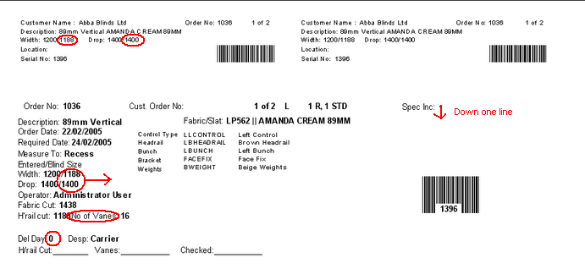

New Work and Customer Requests

A new feature is now available in Order Processing > Orders > Order Amend Enquiry. The user can now view the detail lines for an order by clicking on the + plus sign beside an order id. This will then display the detail lines for that order. The detail lines can then be hidden again by pressing the – sign.
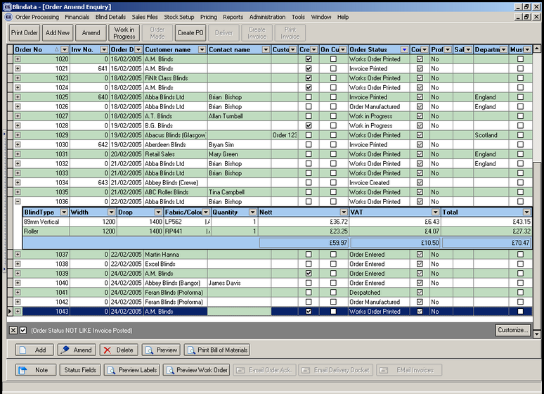

11. Sales Lead Amendments (Client 1665)

We have replaced the postcode selection component on the Order Amend Screen.
The new field allows selecting and filtering.

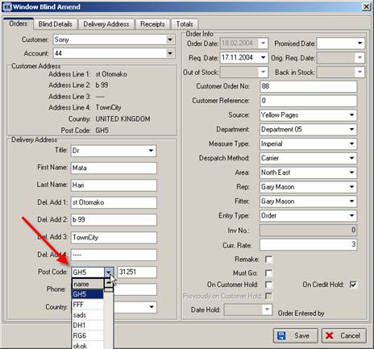

29b. Financials > Create Invoices (Client 1757)

Particular customers get orders held until their value is over £500 and then orders are sent together. Need to allow for consolidated despatch. This means that the ‘normal deliver routine should miss out these customers when orders are being delivered. We will need a separate routine to handle delivery for these customers.

Consolidated Deliveries Specification

There is a new field in the customers table called ‘Consolidated Delivery’.

There is a new field on Order Processing > Order Enquiry to show ‘Consolidated Delivery’. This will be picked up from the customer table.

When the Deliver button is pressed or ‘Deliver Scan’ is used in Order Processing > Order Enquiry, it now checks the record to see if ‘Consolidated Delivery’ is true. If it is, then a message appears saying ‘This is a consolidated delivery customer – please use alternative option.’

There is a ‘Consolidated Delivery’ button on the Order Enquiry screen, called ‘Con. Del.’ This will then display another screen with all the orders for the selected customer with blind detail lines = order manufactured. The operator will be able to check selected records and see if the total of these orders comes to more than £500 (Carriage Free Over). If so, they can then click on a ‘Deliver’ button. No carriage will therefore be charged.

33. Financials > Post Credits to Sage (Client 1757)

Credit notes can now be updated to Sage Line 100 in the same way as invoices are at the moment.

47. Sales Files > Customers (Client 1757)

A new tab is available on the customers screen. This will show all existing live orders for the customer.

