Blindata Release Note 1.5.6 

14 February 2005

Bug Fixes and Enhancements

8. Blind Details > Blind Types

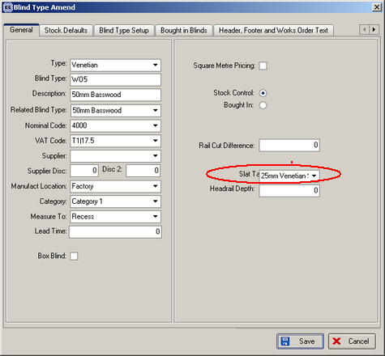

This screen has been tidied up.

Also, the fields for slat table and headrail depth now appear for blind identifier = W (wood venetians).

9. Order Processing > Orders

Less info required on the delivery docket - do not need the special instructions displayed. A new delivery docket layout has been created: Delivery Docket Laser print (Special).

23. Blind Details > Blind Types

Vanes multiplier field is now rounding to 2 decimal places.
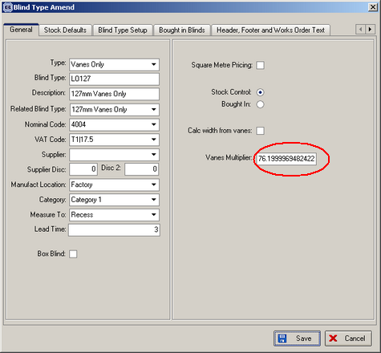

24. Order Processing > Orders

There was a bug in entering vanes only blinds. If the ‘calc width from vanes’ field is ticked, the blind did not calculate the width properly. It now multiplies the number of vanes by the vanes multiplier field and use this ‘width’ to look up the normal price table.

Extra: we have make a slight change to the order entry program, so the following can be done. If a blind type = vanes only, the detail line entry should be as follows:

The screen now displays Vanes, Width and Drop. Width and Drop are where they were previously and Vanes is to the left of Width (previously displayed instead of Width).

The operator now has the option of entering the number of vanes. If they do this, the number of vanes will be multiplied by the vanes multiplier in the blind type record and the width field will then be filled. If the number of vanes field is not entered by the operator, they can then enter the width of the blind instead. The program now calculates the number of vanes based on the width of the blind. To do this, we need to hold the slat table against blind types = vanes only in the blind type record.

28. Order Processing > Orders > Receipts tab
After entering a receipt amount, the balance figure in the Totals tab is now updated properly.
33a. Order Processing > Orders

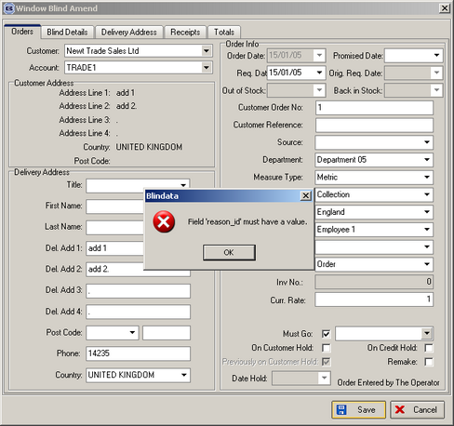

As soon as the ‘Must go’ box is ticked, the must go lookup now appears.

48. Order Processing > Orders > Order Entry

‘Original Required Date’ is now only be filled if there are detail lines. This is because an operator may enter the header order record, save it and then enter the detail lines later. We have set a rule that ‘Original Required Date’ can only be updated once.

49. Sales Files > Customers

There is a new field in the Customers table called ‘FOC Carriage’. This is ‘free of charge carriage’. When we calculate the amount of carriage that must be applied to orders, the customers with FOC Carriage = true are not included.

66. Order Processing > Quotations

The following message no longer appears when you flag a proforma quotation as Paid. The payment of proformas is now handled differently.

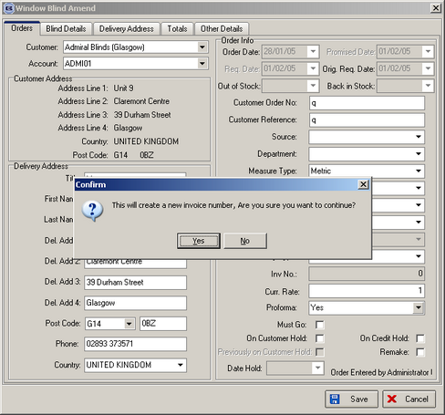

70. Order Processing > Quotations

You can now enter a quotation for a customer that has ‘is proforma’ = true. But now it is not possible to convert this quotation to an order, unless it has been set to paid.

80a. Order Processing > Orders > Order Entry (LOW PRIORITY)

When ‘Promised Date’ is changed, it is only saved if ‘Out of stock’ and then ‘In stock’ have been applied to detail lines.

83. Order Processing > Quotations

If a customer is a proforma customer, when the quote is entered it now defaults to being a proforma. ‘Paid’ option has been removed from quotation/proforma entry.

84. Order Processing > Orders On Hold (New Menu Option)

There is a new menu option to show on credit hold orders and orders taken off credit hold. This shows the following fields: Order number, customer name, order contact name, order date, order status, on credit hold, and ‘Taken off credit hold’. It is only possible to change the ‘On Credit Hold’ and ‘Taken off credit hold’ fields.

If order is taken off credit hold, it is now stopped from going back on hold if someone goes into the order amend screen.

85. Order Processing > Paid Proformas

There is a separate menu option to change proforma/quotations to paid. This displays quotation number, customer name, contact name, quotation date, proforma status. It is only possible to change the proforma status to ‘Paid’ or ‘Yes’.

86. Order Processing > Order Enquiry (HIGH PRIORITY)

Once an order has a status of Invoice Created or beyond, it no longer appears on the order enquiry screen.

87. Order Processing > Orders

If Administration > Parameters > Use Sage Line 100 = true, the ‘Deliver’ button on the Order Amend Enquiry screen has been disabled. All deliveries must be done from Order Processing > Order Enquiry.

88. Financials > Invoice Batch Print > Invoice – Bespoke 1

‘Carriage’ is now appearing properly on the invoice.

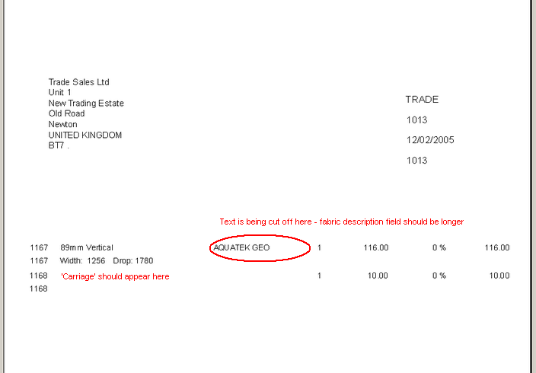

89. Financials > Post Credits to Sage

Credit notes are now appearing on this screen.

91. Financials > Post Invoices to Sage

In the sage export file, the nominal code is now selected from the first detail line nominal code, not the nominal code for the customer.

103. Order Processing > Orders > Order Acknowledgement (Letterhead)

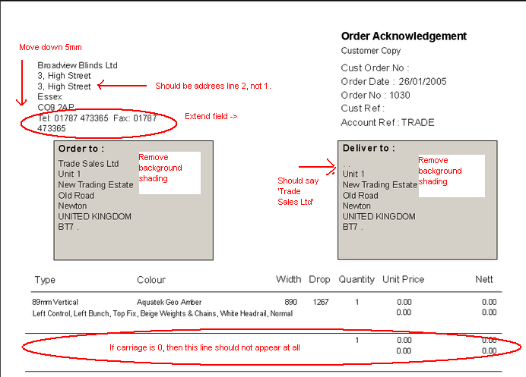

The rules for printing company name are as follows: for trade sales, print company name (as in Order to: above) and for retail sales print contact name.

104. Order Processing > Production Documentation > Works Order – Label 2

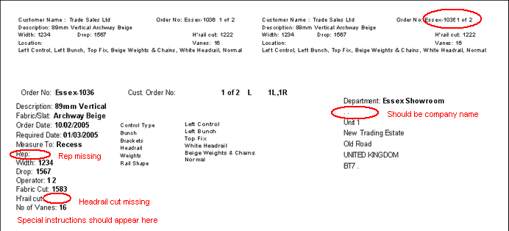

105. Order Processing > Production Documentation

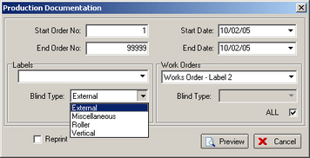

The ‘Blind Type’ lookup is now called ‘Blind Identifier’. The blind type lookup was only showing four records, but these are all the records in the blind identifier table:

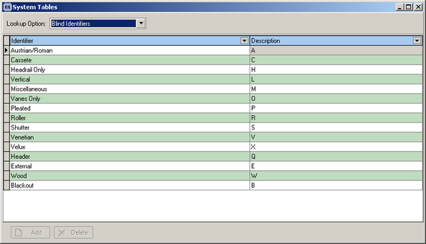

This has been corrected.

107. Order Processing > Sales Leads

When converting a sales lead to an order, an error message has been corrected. It was caused by a null fitter field in the postcode table.

114. Order Processing > Orders

When entering a ‘Velux’ blind, the following message appears about cord spacing. This is no longer happening.

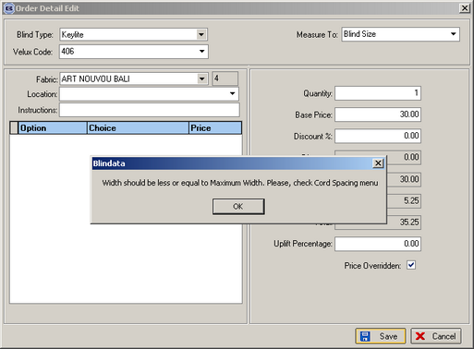

New Work and Customer Requests

The order control report has been changed to portrait – please let us know what you think of the layout.

Some of the changes have been made to the works order – label 1 report, but we cannot fit all the options on the label. It will need further redesign.

23. Brackets (not client specific)

This is a new table that calculates the number of brackets being used, dependent on the width of the blind. It duplicates the bill of material calculation for brackets, but also stores the number of brackets on the order detail line. See Access version (Blind Details > Blind Type Options > Brackets).

See development #35. Not needed now.

35. Order Processing > Orders > Orders Detail Line Entry (Client 1757)

Need to be able to charge for extra brackets according to the number of brackets.

At the moment we can charge an amount for an option by selecting an amount from Blind Details > Blind Type Options > Field Details.
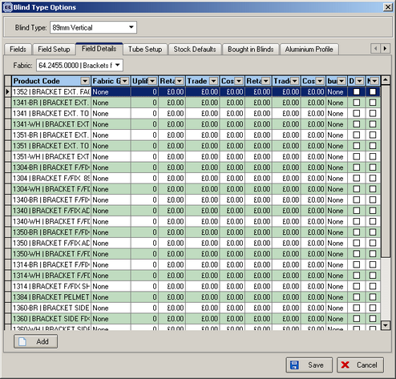

The problem is that this is a price for one bracket (or maybe a pair). The system may have calculated that the blind needs more than two brackets. Therefore we need some way of multiplying the add on price by the number of brackets needed (calculated in bill of materials) and then storing this in the option price. The easiest way to do this is to store bracket prices according to width break points in the option price table:

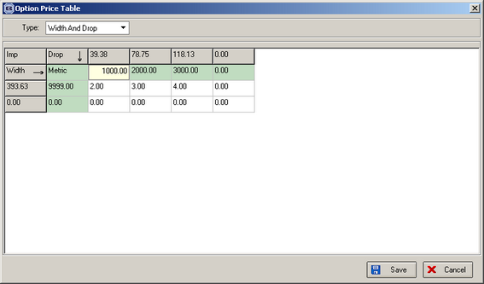

48. Administration > Import from Excel > Customers

Department, measure type, despatch method, area and rep are now mandatory fields.

