Blindata Release Note 1.5.5 

7 February 2005

Bug Fixes and Enhancements

27. Orders > Credit Note Entry

‘Inv No’ now says ‘Credit Note No’. in credit note entry. Entry Type is only ‘Credit Note’.

‘Must Go’, ‘On Customer Hold’, ‘On Credit Hold’, ‘Remake’, ‘Previously on customer Hold’ and ‘Date Hold’ do not appear for credit note entry.

52. Order Processing > Orders > Order Entry

Speed of order detail line entry has been improved by a factor of 3.

54. Invoice Print and Post > Invoice Batch Print

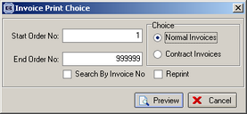

You can now batch print invoices by invoice or order.

65a. Order Processing > Order Enquiry

A detail line now appears on the order enquiry screen if the order is on credit hold and the operator should be allowed to flag the blind and the order as manufactured. But it is not possible to deliver an order that is on credit hold. A message appears saying ‘This order is on credit hold and cannot be delivered.’

68. Order Processing > Production Documentation > Works Order – Label 1

Cord spacing was overlapping into the option descriptions. This is now fixed.

71. Order Processing > Production Documentation > Works order – label 1

Works order – label 1 is now showing up to 13 options on the label instead of 8.

Changed ‘Cord Spacing’ to ‘C/S’ so the option descriptions won’t overlap.

We now show fabric code on label as well as description (move description to right).

Also options now print stock code and description – the font has been reduced from 8 to 7.

We have removed option list from top small labels and replaced with serial number (order detail id).

72. Order Processing > Production Documentation > Works order – label 2

E = external is now generating 1E in the blind identifier string.

Department appears on top of right hand ‘address’ label.

Delivery address has been put back on ‘address’ label.

On rhs top label, order no. is no longer overlapping ‘1 of 1’ text.

For vertical blinds, headrail cut is now on big label. Also the calculation has been corrected.

73. Order Processing > Orders

It is no longer possible to change an order once it has status = Invoice Posted. A message appears saying ‘An invoice has been posted for this order, therefore it cannot be amended’.

74. Order Processing > Orders > Order Acknowledgement (Letterhead)

Promised for 4/2/5

Tel and Fax number to be moved to right and level with address line 4 and postcode.

What should we display if there is no phone number? If there is too much text in line 4, it will overlap into Tel. May be we’d better keep this as we have it now? Look at the order acknowledgement below –can you make this change, please? The purpose of moving the address up is so that it will appear in a window envelope.

Remove VAT number – it is on footer of letterhead paper. Ok.

Vat No / Cust Order No / order date / order no / cust ref / account ref to be moved up so addresses will fit. These fields should be right justified to line up with right hand side of totals box. These should not be in bold and should be the same font size as the branch address. Ok.

Address boxes to be moved up 10 mm. Left hand address box to move 10mm to right. 50% ok.

Right hand side of right hand address box should be lined up with right hand side of totals box. Ok

On bottom left don’t need text ‘Carriage Text’ and ‘Trade’ – remove. Ok.

If discount % is 0%, it should be removed completely. The text ‘Disc %’ should also be removed if the detail line discount is 0 for all detail lines.

On order ack. and invoice, in totals box ‘deposit’ should say ‘Amount Recvd’. Ok.

These rules should apply for all letterhead reports.

I entered the following retail order and printed out the order acknowledgement below. We need to make sure the addresses appear correctly for retail orders.
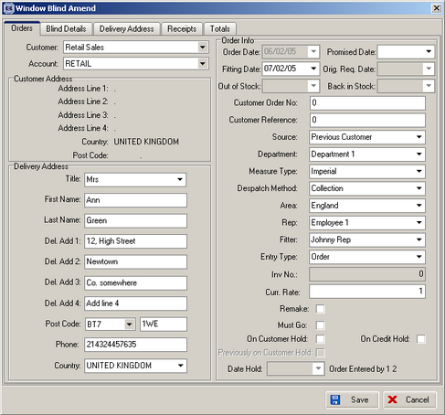

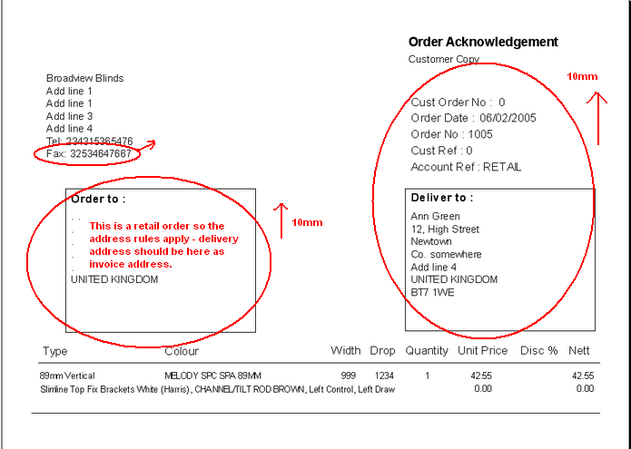

75. Order Processing > Orders / Quotations / Sales Leads

New maintenance table for Title. This table is now a lookup when title is being entered anywhere in the system.

77. Order Processing > Orders

Fitters lookup on order entry was displaying ‘In Service’ employees – is now ‘Is Fitter’.

78. Administration > Parameters > Reports

In Parameters, invoice batch print now has Letterhead option.

80b. Sales Files > Update Customer on Stop

On stop import routine – before all records are imported, the on stop fields in all customer records in Blindata are now set to false.

81. Sales Files > Update Customer on Stop

The current customer balance and credit limit

Credit-check1 – before this is imported, the credit limit and current balance fields are zeroised for all customer records in Blindata.

This is now importing column D instead of column E from credit-check1.

Outstanding orders on Sage Line 100

Credit-check2 – before this is imported, the Sage Order Totals field is zeroised for all customer records in Blindata.

Credit-check2 – now imports column E to Sage order totals, not column C.

82. Order Processing > Orders

At end of order entry screen, a credit message appears if the order has placed the customer over their credit limit. The message says ‘This customer has exceeded their credit limit. This order has been placed on credit hold.’

90. Financials > Invoice Batch Print / Post Invoices to Sage

Records appear in these menu options if order status = Invoice Printed. However, if you went back into the order and resaved it, the record no longer printed or displayed in Invoice Batch Print or Post Invoices to Sage. This has been fixed.

95. Blind Details > Blind Types > Blind Type Setup

The following fields cannot be saved in Blind Details > Blind Types. Try changing them – they don’t get saved.
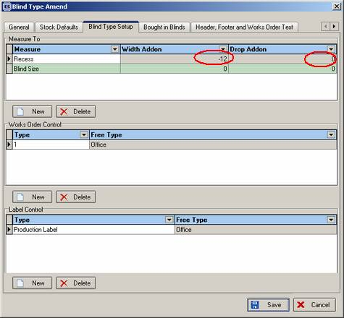

New Work and Customer Requests

In this version the Order Detail Amend form takes approximately 30% of the time it took previously. The form is now fully functional. If the current speed is acceptable we can leave it as it is, however we can speed it up a little more (by moving the calculation of the order detail price to the server). If we do that the form will work approximately twice as fast again, but it will take extra work. Please let us know what you think.

26. System Startup

Left hand menu now defaults to being minimised at startup.

