Blindata Release Note 1.5.3 

24 January 2005

Bug Fixes and Enhancements

1. Order Processing > Order Enquiry > Order Made

It is now not possible to change the status of a detail line to ‘Order Manufactured’ if any detail line for that order is flagged as out of stock. When you click on ‘Order Made’ a message appears saying ‘Detail line is flagged as out of stock’ and nothing gets done. The out of stock field is now displayed on the order enquiry screen.

5. Order Processing > Orders > Bill of Materials

If the blind identifier in the blind type record has been changed to W (for Wood), the bill of materials now works for calculator = Slats. It works in exactly the same way as if the blind identifier = Venetian.

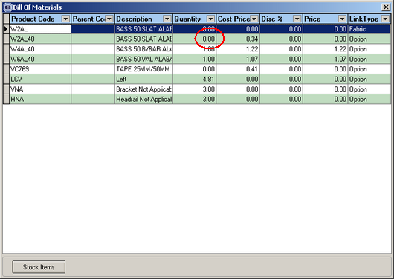

21. Order Processing > Production Lists

Order control report / production report – in both cases order is now by must go, then delivery day (that is, where the current date equals the customer delivery day), POS, remake, regular.

25. Order Processing > Orders

The option prices were not brought up properly when first displayed. In the example below, it was finding a price of 7.00 for the first two options. This has been corrected.
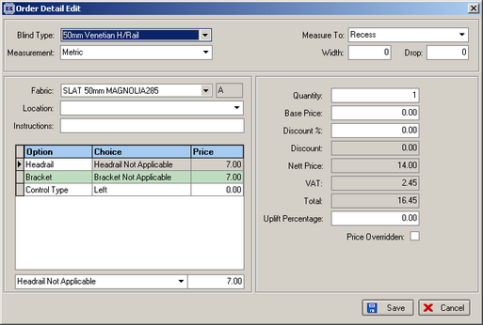

26. Pricing > Velux Price Table

Bug when trying to delete velux price table record has been fixed.

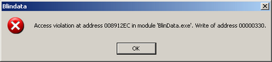

36. Order Processing > Orders > Order Entry

When the Required date has been calculated using the algorithm the Promise date and the Original required Date are now set to the same date. This Original Required date cannot be edited or changed from here.

37. Order Processing > Orders

It is no longer possible to delete an order once it has a status of ‘Order Manufactured’ or beyond. A message now appears saying ‘You cannot delete this order’.

38. Order Processing > Orders

When you delete an order, the message said:
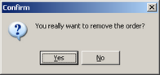

It now says ‘Do you really want to delete this order?’

39. Order Processing > Orders

Previously, an order could be changed to ‘Order Made’ without it having to go to Status ‘Works Order Printed’ first. If you click on the ‘Order Made’ when the order status = ‘Order Entered’, a message now appears saying ‘Order has not yet been printed out’.

The same logic will soon apply in Orders > Order Enquiry for the ‘Blind Made’ and ‘Order Made’ buttons.

40. Financials > Invoice Batch Print > Invoice – Bespoke 1

Client 1757 uses the order number as the invoice number, so order number is now used instead of invoice number on invoice print.

45. Order Processing > Orders

The following message now says ‘The fitter sheet was updated’.

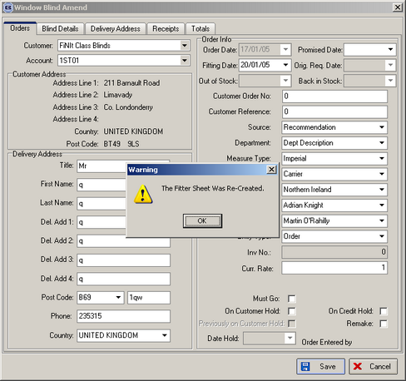

47. Order Processing > Orders > Order Entry

There was a bug when entering an order for a customer ‘on stop’. If you tried to enter an order for an ‘on stop’ customer, the following message appeared:
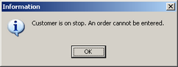

This was ok. However if you clicked Ok and then clicked Save the message appears again. If you click Ok again you can then go on to enter the order. This has been corrected, so if a customer is ‘on stop’, you cannot save an order at all.

50. Order Processing > Orders > Print Order

Order amend enquiry – print order acknowledgement error message – has been fixed.

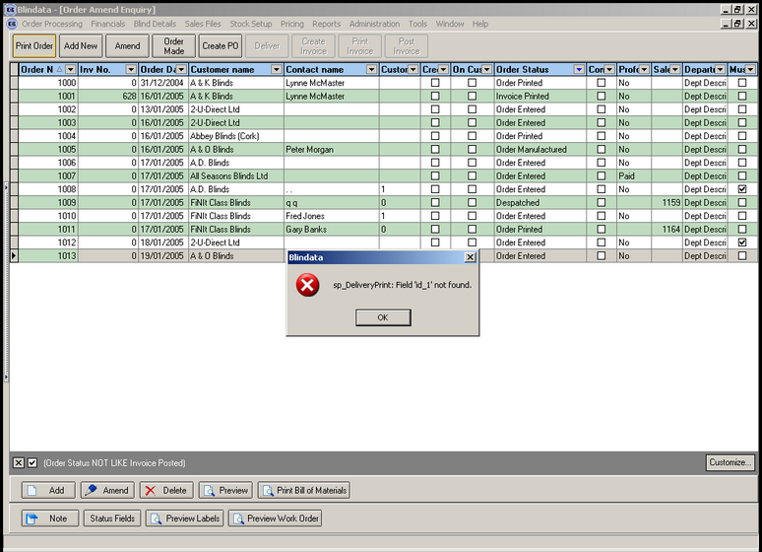

New Work and Customer Requests

8. Financial reports required (Client 9)

These are the financial reports that are either new or require some adjustment eg inclusion of origin. The numbers in brackets relate to client documentation.

Outstanding balances (1)
Incomplete trade invoices (3)
Retail orders not despatched
Zero value invoices (5)
Orders not yet invoiced (6)
Deposits by nominal (15a)
Balances by nominal (15a)
Outstanding retail debtors (10)
Cancelled orders report (12)
Orders/invoice numbers (13)
Trade credit notes listing (16)
Deposits for incomplete orders
Minus balances (18)
Receipts by date (21)
Receipts by type (22)

Administration > Import from Excel > Customers

A proforma field has been added to the end of the customer spreadsheet so it can be imported to the ‘Is Proforma Customer’ field. When the field is imported from Excel, there should be “YES” in that column for true, or anything else (including null) for false.

We can also update customer records using the import routine (like fabrics get added or updated).

