Blindata Release Note 1.5.1 

12 January 2005

Bug Fixes and Enhancements

Order Processing > Orders - SERIOUS
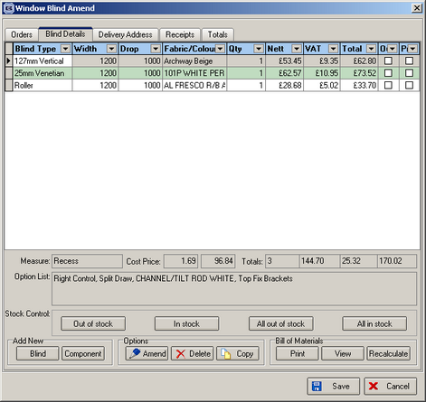

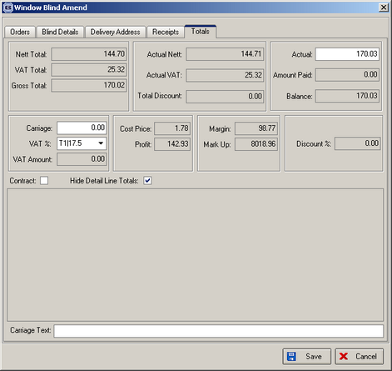

The above is a retail entry – the detail lines were entered and this is what was shown in the totals tab. Nothing was changed on this screen. The nett total, VAT total and gross total figures were correct, but the actual nett, actual VAT and Actual figures were incorrect. This was a rounding problem and is now fixed.

Order Processing > Order Enquiry

It is now not be possible to change the status of a detail line to ‘Blind Manufactured’ if the detail line is flagged as out of stock. When you click on ‘Blind Made’ a message appears saying ‘Detail line is flagged as out of stock’ and nothing gets done. Also, the out of stock field is displayed on the order enquiry screen.

Order Processing > Production List > Order Control Report

If the criteria for Order Control Report is start and end required date, records should be displayed in required date order within blind types.

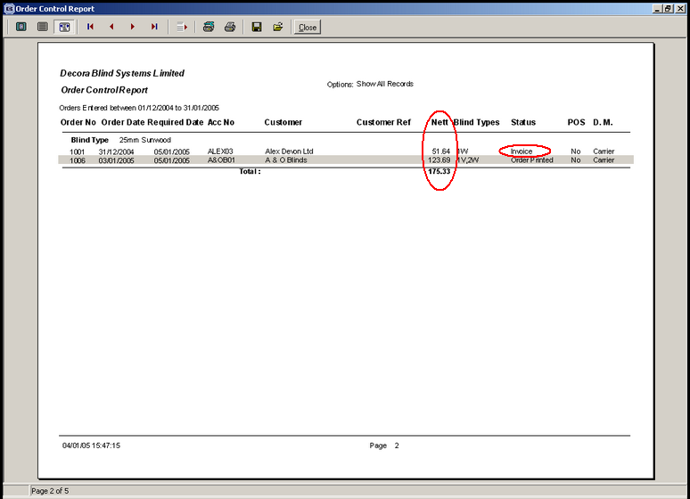

Removed nett values on this report. Status field description has been corrected – it now shows only show descriptions from Administration > System Tables > Order Status Descriptions

Order Processing > Production List > Production Report by Blind Type

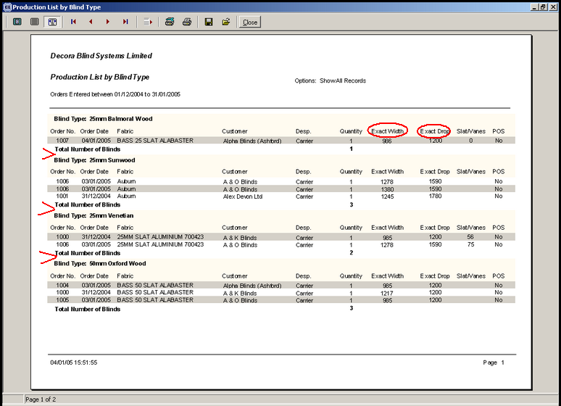

‘Exact Width’ now say ‘Width’ and ‘Exact Drop’ says ‘Drop’.

There is now a page break between blind types.

Order Processing > Orders > Detail Line Entry

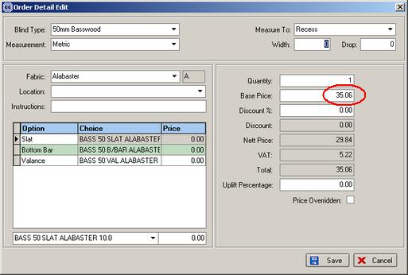

When you entered a retail order, and as soon as you enter a blind type in the detail line, it brought up a price. But it was the wrong price – there were no retail price tables in the system, so the price should be 0. This is now resolved.

3. Reports > Lead times report
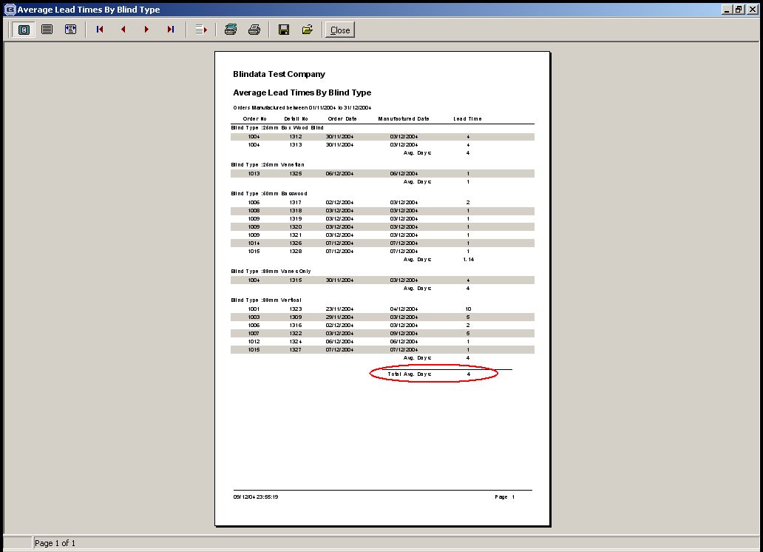
The total average days figure is now correct. The total average (which should probably be called overall average) is be the overall average figure.

4. Order Processing > Orders

Retail PPM is now picked up in order entry detail line. To test this you will have to set up a retail price per metre amount (Retail PPM) in Blind Details > Blind Type Setup.

It will be picked up when the option prices are being calculated in order detail entry:

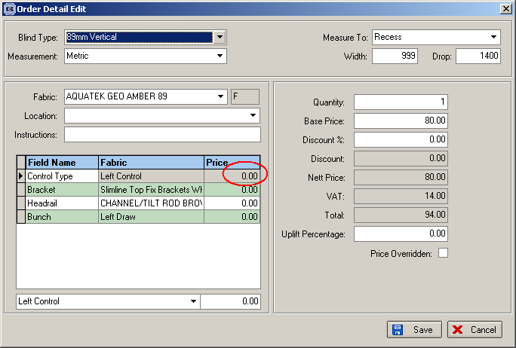

6. Order Processing > Orders

When a fabric is entered in a detail line, the program now looks look in Stock Items > Default Options to see if there are any records. If there are, a check is made to see if any of these default options match the blind type and link options for that detail line. If so, they now replace the existing default option.

Example: if we create a default option against record TUR0037 (25mm Slat T0001), it should then appear as a default option when the detail line is entered. A procedure should be written so these default options are selected after a fabric or an option is updated in a detail line.
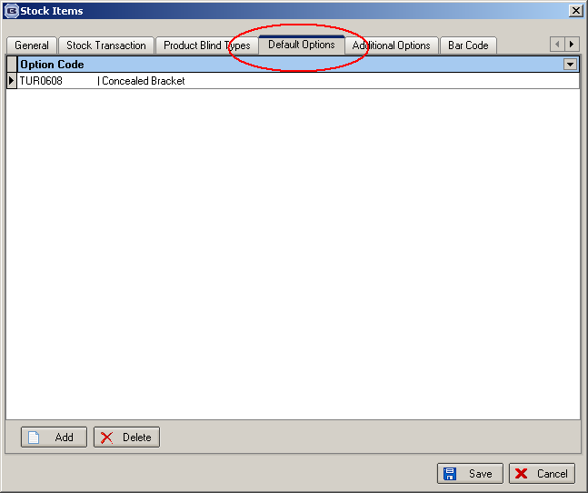

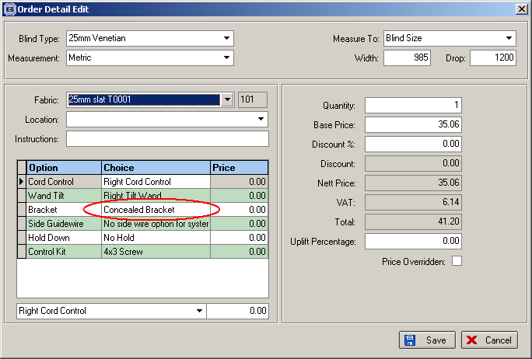

9. Order Processing > Orders > Box wood blinds

Request by client: need to display trim amounts for box blinds and also the number of slats to add or remove from the blind.

The trim amount is calculated by taking the manufacturing size of the blind and subtracting it from the width of the box blind that is being used, and then dividing by 2.

Example: man. width of blind is 1380. Box blind width used is 1500 (found in Box Blinds table). Therefore trim amount = (1500 – 1380)/2 = 60. This should be displayed on ‘works order – label 1’ in place of cord spacing (which isn’t needed for box blinds).

Calculation for working out the number of slats to add or remove.

Box blinds are bought in. They are then adjusted to fit the exact sizes of sales orders. This means trimming either side (see above) to get the correct width, then adding or removing slats from the blind to get the correct drop. There is a slight complication with the drop, however. Slats will get added or removed depending on what size of box blinds are in stock and the number of spare slats there are (spare slats get created because they have been removed from blinds when the drop is too big). This means the client must be able to adjust the point at which they decide whether slats get added or removed from the blind.

Solution

We create a new table (to be maintained in Administration > System Tables) called Box Blind Slat parameters. It should have the following layout:

Field Name | Type/Description
Id | Autonumber
Blind type id | References Blind Type table (only box blinds)
Slat divider | Number (eg 23.6, 43.6)
Lowest drop | Integer
Highest drop | Integer
Add_remove point | Integer

When a detail line is entered, the number of slats to add or remove should be calculated by the following algorithm:

Identify record in ‘Box Blind Slat Parameter’ table that equals blind type and where ‘man drop’ is between lowest drop and highest drop.

Number of slats to add = ((Man drop – Add_remove point)/ Slat Divider) rounded up to next whole number.

If the result is a minus figure, then this means that slats should be removed.

We need to store this field in the order detail line and then display it on the works order label if box blind = true.

Order Processing > Orders

If ‘Use Sage Line 100’ is set to True in Parameters, we have greyed out the ‘Order Made’, ‘Deliver’, ‘Create Invoice’ and ‘Print Invoice’ buttons on the order amend enquiry screen. This is to tie in with batch processing of orders by Sage Line 100 users.

Order Processing > Delivery Docket Batch Print

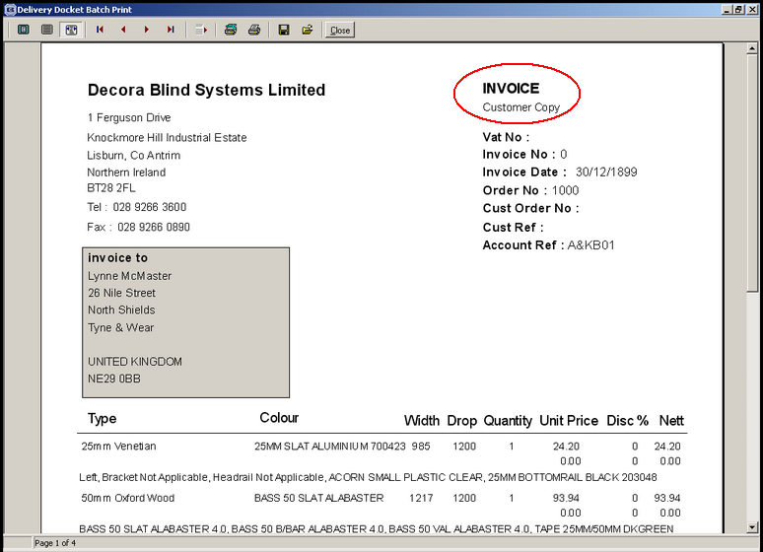

The circled area now says ‘DELIVERY DOCKET’, not ‘INVOICE’.

Order Processing > Delivery Docket Batch Print

Bug fix - After the delivery dockets have printed, the status of the orders now hanges to ‘Despatched’.

Order Processing > Orders

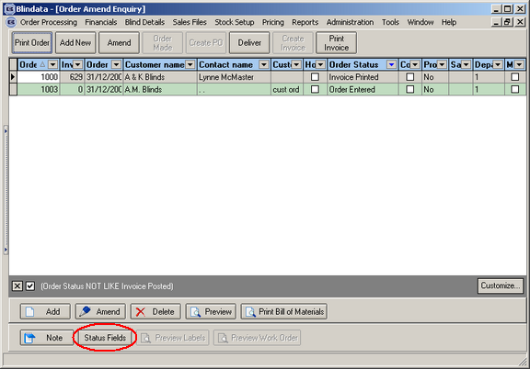

The button ‘Status Fields’ only be shows if the user has access rights to Administration > Users.

New Work and Customer Requests

Here is the list of the new functionality we completed:

- Financial reports required (Client 9 – Phase 4) – please see all these reports in Reports->System Reports.

- Finished Carriage Calculation. The system now adds carriage automatically dependent on area and carriage amount set by area. It can be switched off by setting the ‘carriage over’ figure in Administration > Parameters to 0.

- Receipts reports are now reported by department.

