Blindata Release Note 9.9.6 

10 April 2020

Bug Fixes and Enhancements

The following bugs were recorded in www.support.blindata.co.uk and have been resolved.

10056. Company > Financials
10069. Unable to Backdate Stock Transaction Entry
10080. EDI XML invoice export
10091. Reports > Sales Analysis
10102. When changing the group, room and location
10104. Line total and sub total per location

New Work and Customer Requests
7218. Sales Files > Reports > Credit Letters

This feature is only available to Blindata accounting users.

It is now possible to generate a letter to customers that owe money. A report has been created in Sales Files > Reports > Credit Letter called ‘Credit Letter’.

There is start and end date criteria, which is the start and end date for outstanding invoices ie invoices (SI records) that have a balance of > 0, have a payment due date of between the start and end date criteria, and which are not in dispute.

There is an option to email or print the letter to customer, but we should default to the same rule as the invoice print ie if the customer is set up as ‘Email Invoice Only’, then the credit letter is emailed. The email goes to the customer email address, if that is blank then to the default email address.

A customer history record is created for this action. The field name says ‘Credit Letter’ and there are no values in ‘Old Value’ and ‘New Value’.

7219. Sales Files > Reports > Stop Letter

This feature is only available to Blindata accounting users.

There is an option for ‘Stop Letter’ in the ‘Credit Letter’ section

The criteria for this report is the same as the credit letter. We also include the outstanding invoices on the report.

A customer history record is created for this action. The field name says ‘Stop Letter’ and there are no values in ‘Old Value’ and ‘New Value’.

7221. Stock Items > Stock Control History

The ‘Clear History’ field is greyed out unless Users > Advanced Permission(2) >Clear Stock History is set to true.

7222. Stock Items > Stock Transactions tab

There is a new column choice for ‘Supplier’ (or Vendor) which relates to the supplier_id held against the stock transaction.

7223. Sales Files > Customers

‘Delivery Notes’ is now a column choice in the Customer Enquiry, archive Enquiry and Global forms.

7224. Order Processing > Delivery Notes

At the ‘Create Order’ stage in Quotations, if a quote is being converted for a customer that has ‘Delivery Notes’ held against the customer record, those notes are now saved against the order.

This also happens if an order is copied to another order, and also if an import is done for a ‘HD Web Import’.

7225. Order Processing > Quotations > Email Quote

When a new quotation is created, the email should be sent to this email if it is filled in, otherwise to the email in the General tab.

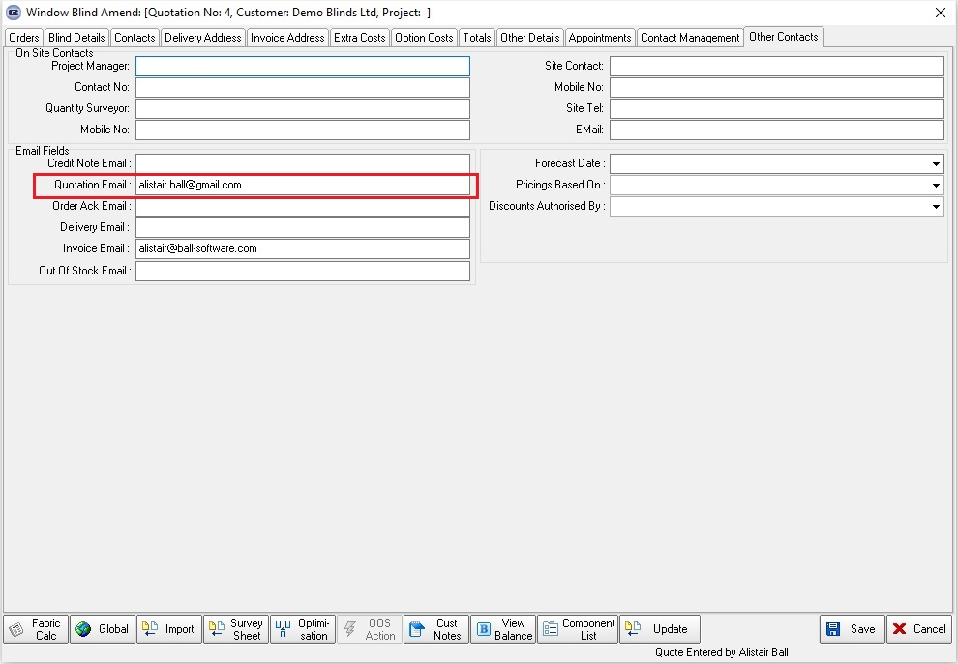

7226. Sales Files > Customers

There is a new field in the customer record called ‘Dispatch Warning Message’. When a user clicks or scans to dispatch an order, if this field is not null, it is displayed on the screen before the user can proceed.

7229. Quotation – Bespoke 67

The detail line pricing has been amended on the report and also on ‘Acknowledgement – Bespoke 67’. See Redmine 7895.

10045. Order Processing > Orders

At the moment there is functionality for entering a 'free type' fabric - it will remember the free type that was entered and be able to look it up when a second order detail line is entered. The same functionality has been applied when an option is entered

10046. Purchase Order Enquiry > Generate Regular PO > Generate

There is now functionality to handle purchase orders for stock items that have free type in them.

Let's say we have a sales order with two curtain detail lines in it. Both have a fabric selected called 'Prestigious Fabric' but one has free type of 'Oslo Green' and the second 'Oslo Blue'. These are actually two different fabrics, so when we create a PO using the 'Generate' button, we need to create two different lines. This means the 'Generate' button needs to take the 'Free Type' into account.

If 'Free Type' is blank, then the 'Generate' functionality works as it currently does - if it is not blank, then it creates a separate PO detail line. However if there are two stock codes the same and the 'Free Type' fields are also the same, it sums this quantity and only creates one line.

10067. Quotation - Bespoke 73

The list price now lines up horizontally with the fabric description.

10088. Inventory > Stock Items

There are two new fields in the Characteristics tab, 'Openness %' and 'Care Code'.

It is possible to import these in Import From Excel > Stock Update. It is also possible to update them in 'Fabric Group Setup'.

