Blindata Release Note 9.9.5 

3 April 2020

Bug Fixes and Enhancements

The following bugs were recorded in www.support.blindata.co.uk and have been resolved.

10047. Converting from Quote to Order
10050. Maintenance Routine
10053. Sales Analysis > Sales Analysis By Blind Type LYTD
10054. Report called Sales Analysis By Blind Type LYTD

New Work and Customer Requests
7045. Order Processing > Orders > Import

There is a new column for importing the cost price for a bought in blind. See Redmine 9428.
7180. Order Processing > Orders

When entering an order Blindata already takes into account the 'Minimum Chain Length' value, i.e. if the blind detail is not suitable for the 'Child Safety Rules' and 'Minimum Chain Length' then this blind detail is not saved. Previously a message appeared saying ‘The chain length should be between x and y’. The message now says ‘The minimum length for the chain is [Minimum Length] but the child safety rules has calculated a smaller size, so this cannot be done’ and it is not possible to save the blind.

7193. EDI Enquiry > EDI Import > PO XML File Fields

A while ago we implemented new tab called ‘PO XML File Fields’ in Parameters. This tab allows the user to control what fields are exported in EDI XML transaction. By default all fields were added with ‘Include’ flag ticked.

A new field has been added for OrderCategory_ which defaults to false.

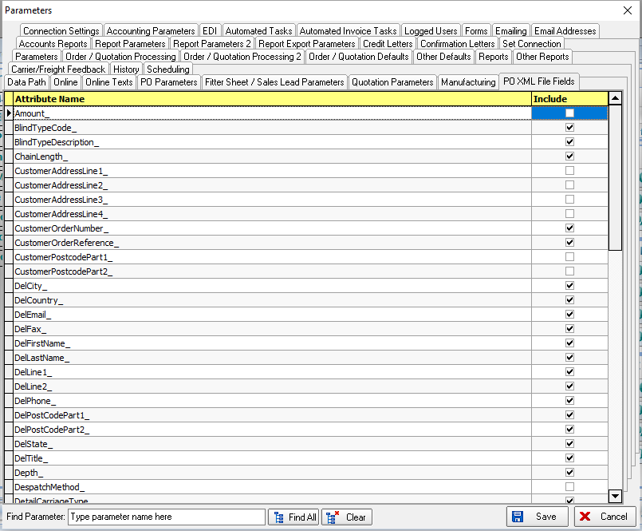

7194. EDI Enquiry > EDI Import > PO XML File Fields

New attributes have been added for ‘Invoice Company Name’, ‘Customer Address Line 1’, ‘Customer Address Line 2’, ‘Customer Address Line 3’, ‘Customer Address Line 4’, ‘Customer Postcode’.

These fields will only import to the order invoice address if ‘Is Variable Address’ is switched on in the customer record.

7195. EDI Enquiry > EDI Import > PO XML File Fields

New fields have been added for ‘Salesperson’ (Rep) and ‘Dispatch Method’ in the XML EDI Import file.

7196. EDI Enquiry > EDI Import > PO XML File Fields

A new field has been added for ‘Amount’. The ‘Amount’ will be a VAT inclusive amount, and will only be imported to a customer that has Trade Type = ‘Including Tax’.

7203. Works Order – Bespoke 45

The ‘Serial ID’ barcode now prints for the first detail line in the top right of this report (in the header).

7204. Delivery Docket – Bespoke 45

There is a new delivery docket called ‘Delivery Docket – Bespoke 45’ based on ‘Delivery Docket – ROI’ with some changes.

Changed page size from A4 to US Letter
Put main logo from Company Details in top left
Renamed "Delivery Docket" to "Packing Slip"
Renamed ‘CUSTOMER REF’ to ‘SIDEMARK’
Renamed "NO. OF ITEMS" column to "BOX NO."
Changed date format to US

7205. Order Processing > Archive Enquiry

The way the ‘Invoice Date’ filtering works has been altered to bring it in line with other date filters eg in the Quotation Enquiry’ form.

The ‘Invoice Date’ column should have a normal date filter on it. There is a new ‘Start Invoice Date’ and ‘End Invoice Date’ in the top right in the same way as there is for quotations. These default with an end date of today and the start date should be today’s date – the month field in Parameters (‘Archive Enquiry Default Months’).



There is also a flag to indicate that archived records without invoice dates should be shown.

7206. Automated Task.exe > Order Status Report

There is new functionality to determine which columns are displayed on the Order Status Report that is sent out from the ‘Automated Task’ program.

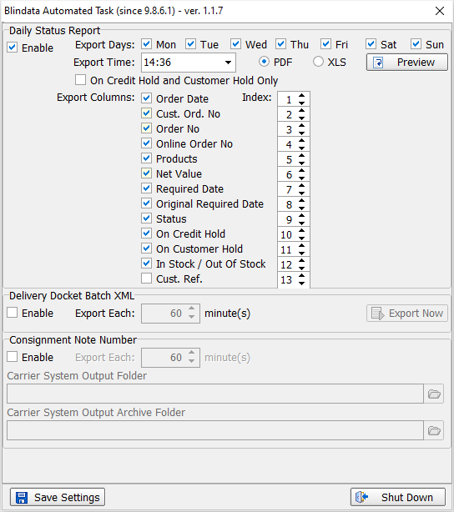

7207. Order Processing > Orders > Roman Creases

There was a problem with ‘Imperial Setup’ and the ‘Roman Creases’ table. We made a change in dev 6935 but this only partially resolved the problem.

If ‘Imperial Setup’ = true, then all sizes are assumed to be in Imperial measurements. However if you entered imperial measurements in the ‘Roman Creases’ table, it multiplied the sizes by 25.4 in the order entry. This has been resolved.

7208. Order Processing > Quotations

There is a new flag in the quotation called ‘Quote Contact Record’ which is set to true if a quotation contact record has been created. There is a column choice for this in ‘Quotation Enquiry’.

7209. Import From Excel > Unit Of Sale / Unit Costs / Cost Price By Quantity

This import has been split into 3 different imports.

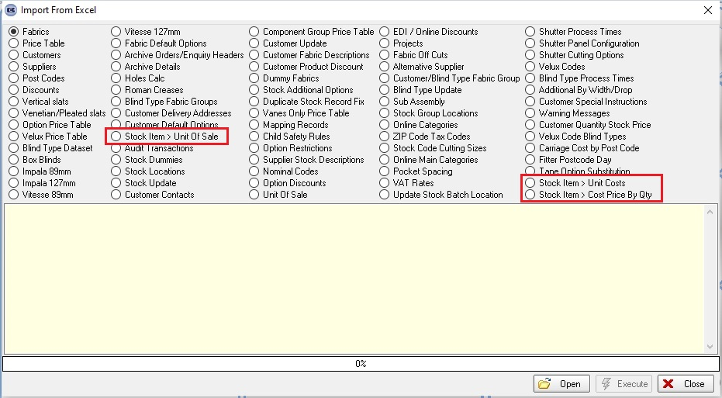

The record that is flagged as the ‘Default’ is the one used to update the ‘Unit Cost Price’ in the ‘General’ tab.

7210. Order Processing > EDI Enquiry > Sending Data

The EDI Transactions are saved in the database for suppliers with the 'Transfer File' method selected only. This can now also be done for the 'Transfer File 3' method.

7211. Sales Files > Customers

There is a new parameter in Administration > Parameters called ‘Display Customer Amend Warning Message’ which defaults to false. If set to true, a message appears when a customer record is saved saying ‘Have you checked this change with the customer?’.

7212. Acknowledgement – Bespoke 78

The fabric off-cuts were recently updated to zero the detail line and allow for a single remnant to be applied to multiple detail lines but the off-cut location did not carry over to any of the printed documentation. The remnant location has been added to the Order Confirmation Sheet.

7213. Blind Details > Blind Types

If a blind type is set as a ‘multi blind’, there is a new parameter called ‘Multi Blind First Line In Cust docs’, which defaults to false. This means the first line of a multi blind ie the one with the overall size, will not print if this is false.

7214. Order Enquiry > Blind Process Scan > Print Label

A label will now print after a process scan is done, providing ‘Print Label’ is set to true against the relevant man process type.

7215. Label Print – Bespoke 67

The ‘Free Type’ from ‘Label Control’ now prints in the top right of this label.

7216. Works Order – Bespoke 20

The blind location has been added to this works order.

7217. Works Order - Bespoke 77

The 'Works Order Non Print' flag logic now apply to 'Works Order - Bespoke 77'.

10025. Reports > Sales Analysis > Sales Analysis By Department By Blind Type (Weekly)

The new report has been created based on 'Sales Analysis By Blind Type (Weekly).

10029. Quotation - Bespoke 45

The 'Quotation Date' now prints in the header of this report.

10030. Stock Control > Fabric Offcuts

Records can now be deleted from this table.

10035. Order Processing > Orders > Bill Of Materials

There is now a flag in the stock record called 'Round Up To Nearest 0.1' which defaults to false.

If true, the quantity in the BOM is rounded up to the nearest 0.1 for the relevant stock record.

10036. Order Processing > Orders > Window Blind Amend

There is now a column choice for 'Number Of widths' on the 'Window Blind Amend' form.

10037. Order Processing > Orders > Price Overridden

At the moment the 'Price Overridden' flag is set to true if the base price is changed. We also want the 'Price overridden' flag to be set to true if an option price is changed.

Not all customers will want this, so there is a new parameter called 'Price Overridden If Option Price Amend' which defaults to false.

10040. Order Processing > Orders

If 'If Metric Use Centimetres' = true, when you amend a size in the 'Window Blind Amend' form, when you go to change the width or drop, the size changed to millimetres and the size had to be entered in millimetres. It now remains as centimetres and van be entered as centimetres.

10057. Dashboard

A couple of cosmetic changes have been made to the dashboard.

10058. Administration > Parameters

A new tab has been created called ‘Scheduling’ and all parameters relating to this have been moved there.

