Blindata Release Note 9.8.8 

14 February 2020

Bug Fixes and Enhancements

The following bugs were recorded in www.support.blindata.co.uk and have been resolved.

9090. PO Report with sub totals
9731. Same Day Order Cut of Time - Online Ordering System
9736. Quotes and Orders Missing out No Widths and Curtain Heading
9746. Incorrect Vat Value on Customers Invoices - Bespoke 72

New Work and Customer Requests
7048. Order Processing > Orders > Fabric Off Cut

There is now functionality so that one offcut can be used for multiple detail lines. We do not validate the sizes to see if they can be used. When the order is saved, the user is given the chance to select off cuts from the right hand side of this form. If the relevant off cut record is pointed at, then the left hand arrow can be used to assign the off cut to the detail line.

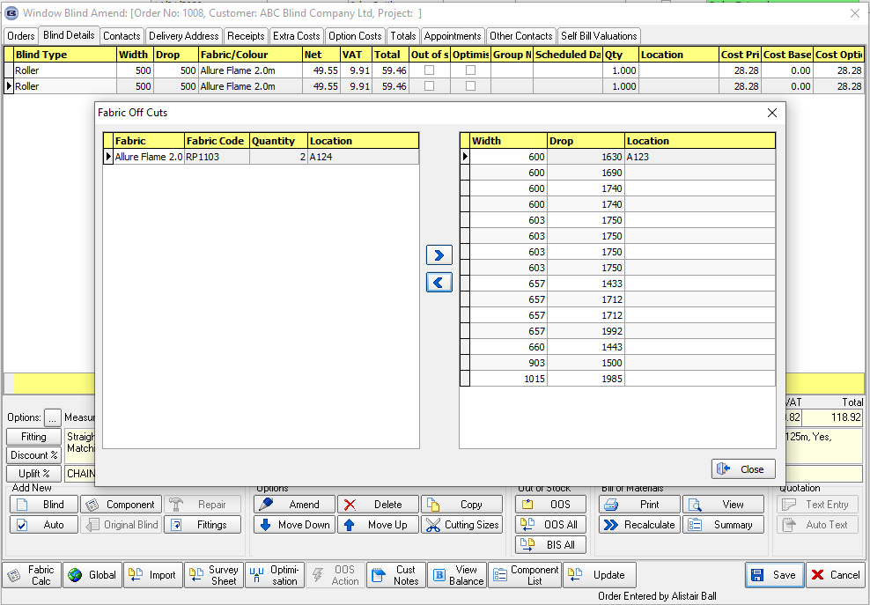

For this to work, the following flags must be switched on in Parameters.

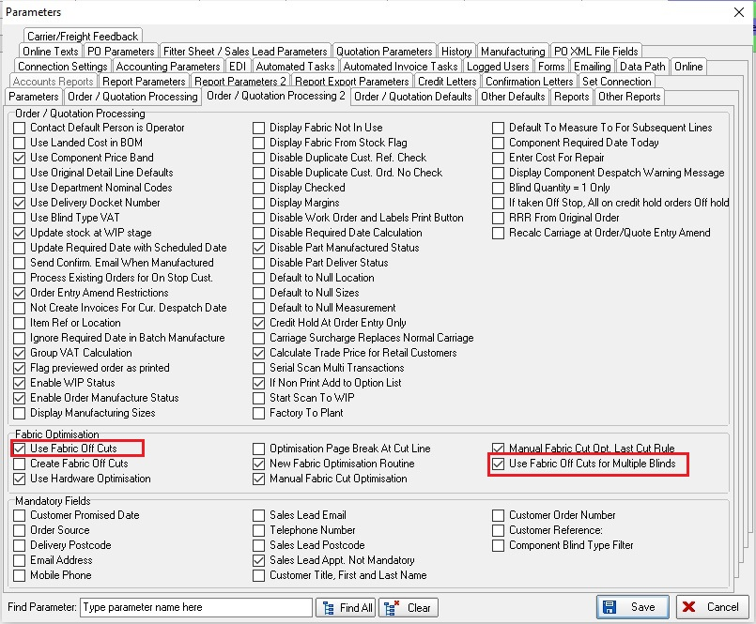

7080. Suppliers

When the blind type code is being looked up, the blind type description is also displayed.

7081. Suppliers

There is a new column in the ‘Blind Type Description’ for ‘Sales Nominal Code’. If this is filled, then it will be used as the sales nominal code in the order detail line entry for a web services blind type.

7082. Reports > Purchase Analysis

There is a new criteria for ‘Department’ which is applied to all of these reports.

7083. Administration > Employees

There is a new flag in the employee record called ‘Buyer’ which defaults to false.

There is a new field in the supplier record called ‘Buyer’. This will look up the employee record where ‘Buyer’ = true.

There is a new column choice for ‘Buyer’ in the ‘Stock Enquiry’ record.

7084. Stock Control > Reports > Stock History Report

There is a new report called ‘Stock History Report’. There are criteria for start and end stock code, and ‘Start Date’ and ‘End Date’.

The report shows ‘Stock code’, ‘Stock Description’ then all the history records for the stock record between the start and end date.

7085. Stock Control > Stock Items

If the ‘Stock In Hand’ advanced permission is set to false, then it is not possible to amend the ‘Stock In Hand’ field in the stock record. It is not be possible to amend the ‘On Sales Order’ or ‘On Purchase Order’ fields if this permission is set to false.

7086. Reports > Purchase Analysis > Purchase Order Analysis

There is now a 'PO No' field value to 'Totals' PO section. See Redmine 9090.

7087. Order Enquiry > Blind Process Scan

A change has been to the 'Blind Manufactured' functionality so if all the processes that require a scan are done, then the blind status changes to 'Blind Manufactured'.

There is a new parameter for this called 'Man Process Scan Only Required', which defaults to false. If set to true, then when all the processes that have ‘Scan’ = true are done, the blind status is changed to ‘Blind Manufactured’.

7094. Installer Export Sheet

See Redmine 9631.

There is now a lookup field for ‘Appointment Type’ in ‘Add Sales Lead’, ‘Fitting Appointment’ in the Fitters Sheet / Sales Lead form and in ‘Add Appointment’ in Order Processing > Orders > Appointments.

‘Appointment Type’ is now printed on the installer export sheet.

There is also a field called ‘No Lunch’ printed on the installer export sheet. It is ticked manually by the fitter if no lunch was taken.

The remainder of this development item will be included in v9.8.9.

