Blindata Release Note 9.8.1 

27 December 2019

Bug Fixes and Enhancements

The following bugs were recorded in www.support.blindata.co.uk and have been resolved.

6647. Default options report
7001. PP-Changing-Dispatch-Method
7681. customer sales history
8756. Invoice Bespoke 78 Changes
8905. invoices on statements not in order
9203. Telephone & mobile numbers for service calls not pulling through to fitters sheet

New Work and Customer Requests
6986. Blind Types > Cutting Options

‘Bottom Width’ and ‘LH Offset’ (from order detail line entry) are now buttons in the Formula.

6987. Financials > Post Invoices

There is a new parameter in Parameters > Accounting Parameters if ‘Sage 50/Instant’ is switched on called ‘Sage 50 SL Invoice Posting by NL Group’ which defaults to false. If true, the ‘Audit Trail’ groups records within invoice by nominal code, and then those grouped amounts are posted to Sage 50 instead of each individual invoice line.

This is also done for individual sales invoice posting from ‘Order Amend Enquiry’.

6989. Works Order – Bespoke 37A

See Redmine 8976. This report now prints across 2 pages where necessary.

6994. Commission Calculations

When a quotation is converted to an order, the commission is now being calculated. It also now calculates for EDI orders. See Redmine 8786.

6995. Email Order Ack at Label Print

This has the same functionality as ‘Email Order Ack at WO Print’ except the email will be sent when the labels are printed.

7001. Fitter Sheet – Bespoke 82

For a service appointment, the mobile number on the sales order now prints in this fitter sheet in the ‘Mobile No’ column.

7002. Fabric/Stock Default Options

There is a new report in Stock Control > Reports > called ‘Fabric/Stock Default Options.

There is a filter by blind type, blind identifier and start and end stock code.

The report prints in stock code order, grouped by blind type showing the stock code and description, and then showing the ‘Default Options’ held against the stock record (i.e. the records from the ‘Default Options’ tab in the stock record). The default options show the stock code and description.

7003. Customers > Sales History

If you right click on a customer, a context menu appears, and you can select ‘Sales History’. There is a new column on the right-hand side that gives the total of the months that are being displayed.

7005. Invoice – Bespoke 78

Changes have been made to the layout of this invoice – see Redmine 8756.

7006. Installer Export Sheet

1. Total time for the day was calculating incorrectly. The total time for the day now shows the difference from the start time entered in the first appointment to the end time of the final appointment.

2. There is now a field that calculates the total miles for the day. The field is called ‘Total Mileage’ and goes beneath the total time for the day. It is the total mileage for all the appointments.

7007. Fitters Sheet / Sales Leads

1. The following form now appears if you add an appointment in the order entry screen.

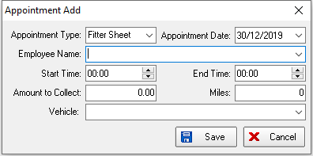

2. There is a new button on the left-hand side of the diary for adding a fitting appointment. This has an advanced user permission called ‘New Fitting Appointment’.

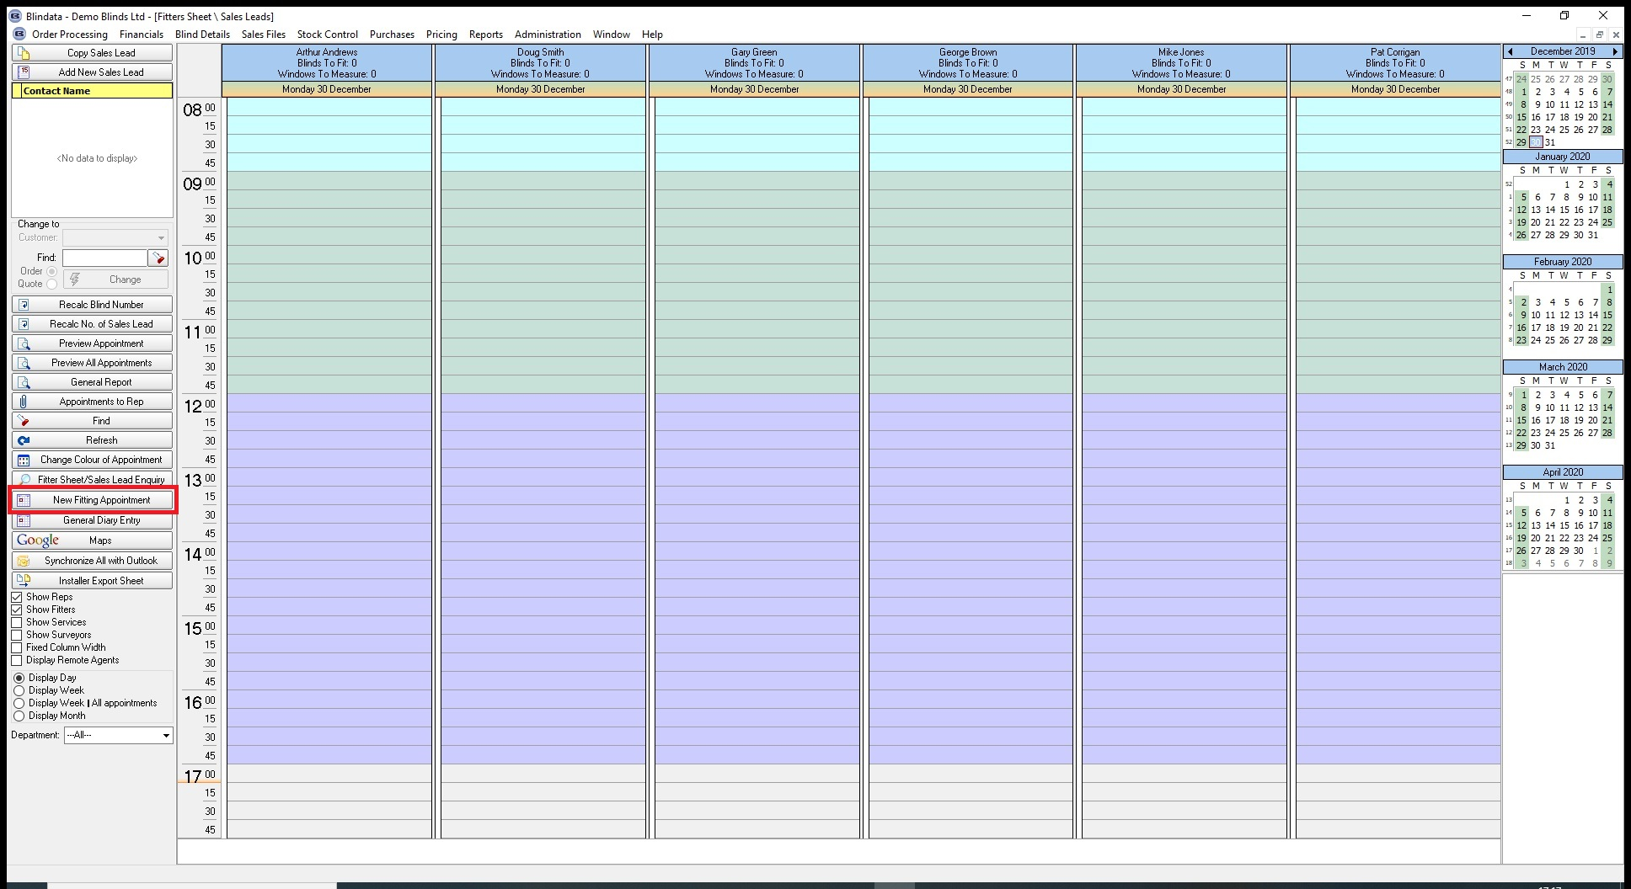

7008. Fitter Sheet / Sales Leads

There is now an entry field for ‘Mileage’ in the ‘General Diary Entry’ form.

