Blindata Release Note 9.7.9 

13 December 2019

Bug Fixes and Enhancements

The following bugs were recorded in www.support.blindata.co.uk and have been resolved.

9212. Purchase order enquiry
9244. Inactive Blind Types
9255. Errors causing major issues
9267. Fitter Sheet Amend Form Functionality
9280. missing vendor

New Work and Customer Requests
6487. Pricing > Option Discounts

It is now possible to set up option prices by Customer Class. This means we could have prices by customer or department or customer class. It is only possible to have one of these filled in any record.

The order detail line entry has been changed to take this into account.
6563. Pricing > Square Metre / Linear Width Pricing

When the formula form is displayed, there are now button choices for ‘Man Width’ and ‘Man Drop’. It is therefore now possible to create a price formula for the exact manufactured size.

6949. Works Order – Label 5

This works order label is now controlled by the setup in Blind Types > Blind Type Setup > WO Control.

There is also a new flag in Stock Items > Default tab called ‘Works Order Non Print. If this is set to true and this is the only option set up in WO Control, then a works order label will not print.

6959. Component XML File

‘Order Category’ has been added to the XML file structure for component lines. See Redmine 8409.

6967. Pricing > Square Metre / Linear Width Pricing

There is now a column choice for customer. It is not possible to save a customer and a department in the same pricing record. It is possible for both department and customer to be null, though.

The order detail line entry has been changed to check for a customer here as well.

6968. Import From Excel > Vanes Only Price Table

There is a new column for ‘Number Of Widths’ for import records to the ‘Vanes Only Price Table’.

6969. Administration > Parameters > All Off Credit Hold

There is a new parameter called ‘If Taken Off Stop, All On Credit Hold Orders Off Hold’ which defaults to false.

If this is set to true, when a customer record is set to false for ‘On Stop’, all orders for that customer are taken off credit hold.

6970. Sales Analysis > Sales Analysis By Product By Month

The grey background shading has been removed.

If the value for one single month in a product is greater than 33% of the total for the whole period, the background for that product line is in pink, and there is also an asterisk displayed at the end of the line, to the right of the total.

6971. Order Processing > Orders > Bought In PO Sent

There is a new flag held against orders called ‘Bought In PO Sent’. When a bought in PO is created for an order, this is set to true. This happens at ‘Create PO’ in Order Amend Enquiry and also in Purchase Order Enquiry > Generate Bought In PO.

There is also a column choice for this new field in the Order Amend Enquiry form.

6972. Fitter Sheet – Bespoke 83

See Redmine 9047.

6973. File Attachment Folder

See Redmine 9159

6974. Order Processing > Orders > Spec Ins Flag

There is a new flag in the Orders table called ‘Special Instructions’. If there are any detail lines with special instructions in them, then this flag is set to true. The program now checks to see if this flag is updated at the EDI Enquiry stage or when an order is being saved.

There is also a new column choice for this field in Order Amend Enquiry’.

6975. Sales Analysis Comparison Report

There is a new report in Reports > Sales Analysis called ‘Sales Analysis Comparison Report’.

The report is in customer order, with blind categories grouped horizontally.

There are six lines per customer.

The first line contains the figures for the previous year for the month of the end date.
The second line contains the figures for this year for the month of the end date.
The third line shows the % difference between lines 1 and 2
The fourth line contains the figures for the previous year from the start date to end date.
The fifth line contains the figures for this year from the start date to end date.
The sixth line shows the % difference between lines 4 and 5.

6976. Works Order – Bespoke 46

If Roman Creases is switched on in the blind type, they now appear on this report (see dev 5115).

6978. Order Acknowledgement Email

When an order acknowledgement is sent from ‘Production Documentation’, it brings up a message for each email – this no longer happens.

Also, if a works order is reprinted, an order acknowledgment does not print.

6979. Invoice – Bespoke 18

See Redmine 9083. The ‘Invoice For Payment’ now prints before ‘Commercial Invoice’.

The ‘Priority’ column was implemented for ‘Invoices By Area’ System Table.

6980. System Tables > Currency Types

There are two new fields in this table, one for ‘Denomination Main Unit’ and ‘Denomination Sub Unit’. These need to be filled for the following currencies:

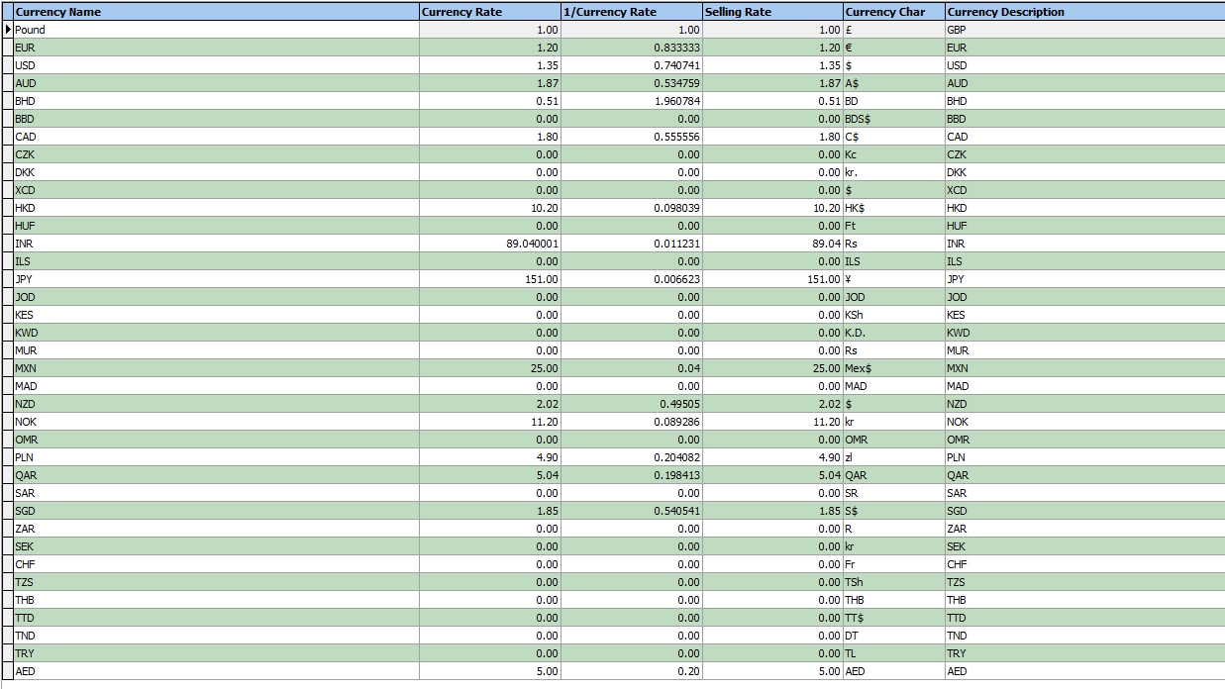

The ‘Commercial Invoice’ and ‘Export For Invoice’ (Invoice – Bespoke 18) have been changed to take these new fields into account.

6983. Fitters Sheet / Sales Lead > Create Fitter Appointment

There are two new entry fields here:

1. Amount To Collect.
2. Miles

Both of these fields replace ‘Status’ which defaults to ‘Entered’ and is no longer displayed.

6984. Fitters Sheet / Sales Lead > Installer Sheet Export

See the revised layout for this report in Redmine 9252.

The ‘Amount To collect’ and ‘Miles’ now print on this report. These fields can be filled in the fitting appointment entry in the Fitters Sheet / Sales Leads form.
6985. Parameters > Fitter Sheet / Sales Lead

There is a new parameter called ‘Check ‘Fitter Postcode Day’ which defaults to false. If true then the logic for that table is used. If false, then it is not looked at.

