Blindata Release Note 9.7.4 

7 November 2019

Bug Fixes and Enhancements

The following bugs were recorded in www.support.blindata.co.uk and have been resolved.

8984. Work Order - Bespoke 83 source field
8992. Order Processing > Orders > Appointments
8995. Order Processing > Contact Management > Assign To Service
9015. Overflow Error

New Work and Customer Requests
6865. Order Amend Enquiry > Order Made

We have a customer that uses a dummy customer to enter sales orders for components, that are then sent internally from the warehouse to the factory. This means the stock should go from 'Stock In Hand' to 'Factory Stock In Hand'.

To do this there is a new flag held against the customer record called ‘Internal Movement Account’ which defaults to false. If true, when the order stock is reduced in ‘Stock In Hand’, it should is added to ‘Factory Stock In Hand’.

Another dummy customer is then used to move stock from the factory to plant (effectively the factory floor) - what this really means is that the factory stock in hand is reduced and nothing else happens. When it goes into 'Plant' it is assumed it is going to be used and is therefore no longer treated as stock.

To do this there is a new flag held against the customer record called ‘Factory Movement Account’ which defaults to false. If true, when the order is made, stock is reduced in ‘Factory Stock In Hand’, and nothing else happens.

There is also a new flag in Parameters called ‘Factory To Plant’ which defaults to false. If true, when blinds are made, the factory stock in hand is not reduced because this has already been done at the Factory > Plant stage.

6874. Label Print – Bespoke 82

For verticals, the number of vanes was overlapping when the print is done. This only appears on the actual print – the print preview is ok. Some adjustments have been made to the field spacing.

6875. Fitters Sheet / Sales Leads

At the moment we show the total of blinds to be fitted at the top of the column for the fitter. It is also now possible to see the total of blinds to be measured in a separate field. ‘Blinds’ now says ‘Blinds To Fit’ and the new field says ‘Windows To Measure’.

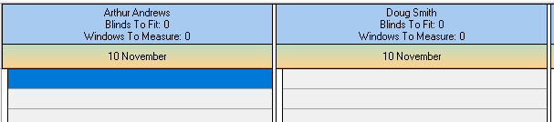

6876. Remake/Repair Redespatch

There is now a message displayed if a remake is done on an order from the first remake order. rather than the order being pointed at, it will relate back to the original order number and first remake order number.

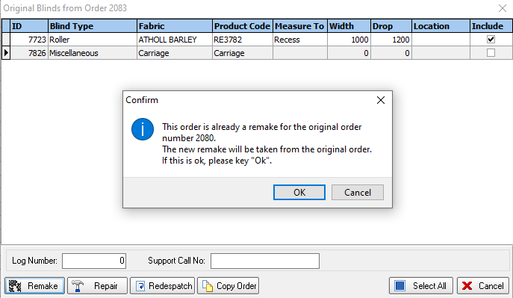

6877. Administration > Import from Excel > Blind Type Process Times

There is a new column for the employee group to be imported. If there is an employee group, there will be no employee.

6878. Sales Analysis By Trade Price

There is now a column for despatch date in this report. Also there is a flag in the blind type called ‘Exclude From Sales Analysis By Trade Price’ and, if true, it exclude those blind types in this report where the new flag is true.

6879. System Tables > Fitter Postcode Day

It is now possible to save this record with a null day.

6880. Fitters Sheet / Sales Lead

If a fitting appointment is created at this point it looks at the ‘Fitter Postcode Day’ to see if there is a matching record. This now also works where the day is null i.e. it will find the fitter based on the postcode alone and not the day.

If a fitter is found but a different fitter is then selected a message appears saying ‘Are you sure you want to change the fitter?’ If yes, then the fitting appointment is saved, if no the fitter can be changed back.

This functionality also applies to Orders > Appointments when a fitting appointment is created.

6881. Order Processing > Orders

There is a new parameter in Administration > Parameters called ‘Default To Measure To For Subsequent Lines’, which defaults to false.

If true, when a second or subsequent blind is entered after selecting 'Save & Next', the cursor goes to the 'Measure To' and not the Width.

6883. Quotation Laser Print (Letterhead Logo)

If ‘On Quotes’ is switched off, the options no longer print on this report.

6884. Order Processing > Archive Enquiry > Extract/Move To Archive

There is a new user button called ‘Extract From Archive’. If this is switched on, then in ‘Archive Enquiry’ a new button will appear called either ‘Move To Archive’ or ‘Extract From Archive’.

If an order has been fully archived using Administration > Archiving, then the button will say ‘Extract From Archive’. If a user wants to add or edit a contact management record for a fully archived record, then it must be extracted.

If the order has a status of ‘Invoice Posted’ but is not fully archived, the button will say ‘Move To Archive’ and it can be used to fully archive the record.

