Blindata Release Note 6.9.9 

22 July 2014

Bug Fixes and Enhancements

4787. Users > Advanced Permissions > Take Off Customer Hold

Even if “Take Off Customer Hold” = true for a user, if feasibility failed, the order was placed back on customer hold. Enabling this permission now allows the user to take off customer hold if feasibility fails as well.

4788. Sales Files > Reports > Aged Debtors Reports

The invoice date was being cut off for long date displays. This column width has been expanded and commas added to large amounts to make it easier to read.

4789. Purchase Order - Bespoke 37

The quantity that is showing up on the purchase order is now the ‘Quantity’ column on the PO amend window, not the ‘Unit Quantity’ column. The quantity then relates to the ‘Unit Of Sale’.

4790. Aeronaut - Excel File and Text Export

The detail lines of an order are now listed in the Aeronaut file by line number. The Aeronaut file and the labels now print in the same order as the acknowledgement.

4791. Quotation - Bespoke 37

The print layout sometimes printed an extra blank page. Fixed.

4792. Purchase Order Enquiry > Purchase Invoice

Because of rounding issues, the purchase invoice amount that gets posted was 0.01 different from the PO order amount. Fixed.

4793. Acknowledgement - Bespoke 37a
The number of characters displayed on the acknowledgement for ‘Comments’ for component detail lines has been increased to 200 characters.
4794. Picking List 37

The picking list was hanging before the print preview if there were large quantities entered. Fixed.

4795. Purchases > Purchase Order Enquiry > Update
Occasionally, the Actual NET field in the Purchase Invoice Create window for an invoice had to be changed due to rounding adjustments. Once the invoice is saved, the correct amount is now posted and shows correctly in the ‘Post Payments’ form.
4796. Sales Analysis > Sales Analysis Commission Report Grouped

Carriage has been removed from this report.
The account code is now beside the customer name.
The grey headings (customer name and customer subtotal) have been removed. We have also included the blind type as a column (after Tag).
The report has been made landscape as not all the columns would fit onto a portrait report.

4797. Cheque Remittance
The report is now named correctly when it is saved as a pdf.

The vendor/supplier address now appears beneath the vendor/supplier name near the bottom of the report.

4798. Quotations > Print Layout Text
If “Print Quotation Group Subtotals” and “Hide Detail Lines” is checked, the text now looks like this:
OPTION 1
Roller CS 101-1 White-118, CH-Chain, SF3-Fascia 3”
1 45 x 50
1 55 x 50
1 102 x 68
4799. Company > Nominal Ledger > Reports > Day Books Standard
This report now includes all financial transaction types, not just nominal journals.
4800. Blind Details > Blind Type > Link Options
The link options are now displayed in order by ‘Sequence’.
4801. Order Processing > Global Search
The credit note numbers were being displayed incorrectly. Fixed.
4802. Sales Files > Customers > Product Discount
The following special price was not being picked up at a specific customer site. Fixed.
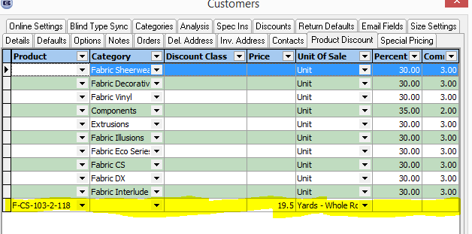
New Work and Customer Requests

3759. Reports > Purchase Analysis

There are now purchase ledger reports that are similar to the sales analysis reports. These can be found in Reports > Purchase Analysis.

There are criteria for supplier, blind type, link option, and start and end dates. It is possible to select the start and end date by either purchase order date or purchase invoice date.

There is then a field with a lookup to select the report layout.

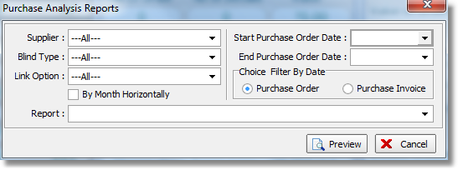

The reports analyse the purchase orders to get the net figures.

The first report is called ‘Purchase Analysis By Supplier’. It has columns for supplier account code, supplier name and net value. There is a total for net value as well.

The second report is called ‘Purchase Analysis By Supplier By Month’ and shows supplier account code, supplier name and then 12 months horizontally, with a total at the end.

3773. Blindata Installation

The Blindata installation / upgrade routine has been amended to assist customers that have more than one Blindata database.

There is another option similar to ‘Select Database’ but called ‘Select App Location’. It defaults to false which means the program will do what it does at the moment. If is is ticked, the user will be able to select the app location folder.

We have also taken the opportunity to allow for the upgrading of incremental releases eg from 6.9.9.1 to 6.9.9.2. This can now be done without amending the blindata.ini file manually.

3774. Parameters > Accounting Parameters

We have a new customer that has Sage 200, but they are not going to use the Sage 200 integration that is currently there (except for credit limit checking when an order is entered).

A new accounting option called Sage 200 Espi has been introduced, which replaces ‘Blindata & Lakeview’.

This will post sales invoices and purchase invoices to folders. We are also going to import customers and suppliers, so the following folders have been set up.

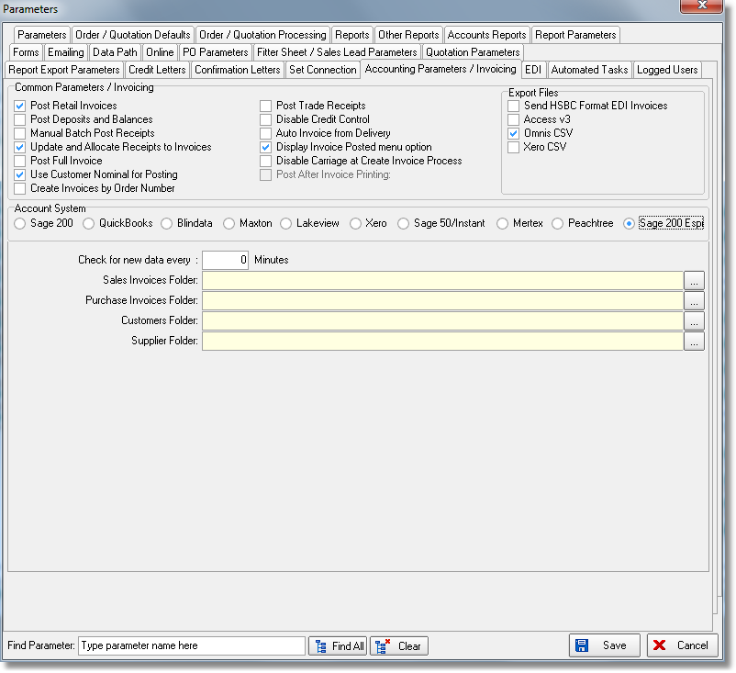
3775. Pricing > Option Discount

There is now a column for discount class. If this is left empty, then the option discount will work as it currently does. If the discount class is entered, then it is not necessary to have an option entered. The discount will be applied to any option with that discount class.

3776. Blind Details > Blind Types

There is now a Refresh option on the context menu for this form.

3777. Order Processing > Orders

In order entry the fabric can now be selected by ‘Fabric Type’ and ‘Colour’ instead of just by fabric description. At the moment we hold the fabric description here (1) but it can also be split up into ‘Fabric Type’ and ‘colour’ in the stock record.

There is a new parameter in the blind type record called ‘Select Fabric By Type/Colour’. This defaults to false but if true, the following should happen.

When a detail line is entered, instead of the user selecting from the fabric description lookup, they can select from a ‘Fabric Type’ lookup and then a ‘Colour’ lookup.

3778. Works Order – Label Blind Size 2.1

There is a new works order based on ‘Works Order – Label Blind Size 2’.
It include the TS2000 barcode for verticals and HD barcode for venetians. These print on the second label down on the right hand side.

Also include packing machine barcode – the one for Works Order Label 1 works. This should go in the address label section.

In order to print the barcodes for vertical and venetian blinds, please make sure that the flags below are switched on:
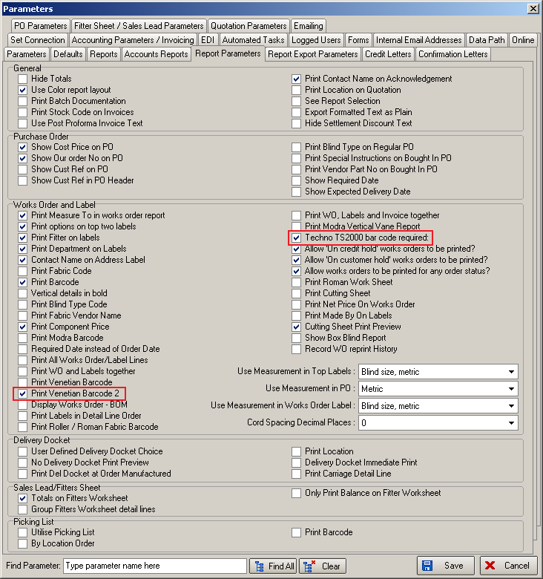

3786. Administration > Parameters

There is a new parameter called ‘Use Efficiency Processes’ which defaults to false. If false, it will be disabled, if true the efficiency processes will be enabled.

The Parameters form has also been redesigned.

- Joined ‘Emailing’ and ‘Internal Email Addresses’ tab to one tab called ‘Emailing’

- Tidied up ‘Parameters’, ‘Defaults’ tabs in the following way - tab ‘Default’ is split onto two new tabs – ‘Quotation / Order Defaults’ and ‘Quotation / Order Processing’

- Split ‘Reports’ tab into two ones – ‘Reports’ and ‘Other Reports’ and moved some reports to the ‘Other Reports’ tab.

