Blindata Release Note 6.9.8 

7 July 2014

Bug Fixes and Enhancements

4778. Fitters Sheet / Sales Lead

After a sales lead or fitting appointment is saved to the diary form, it used to be possible to double click on the appointment to open it. This is now working again.

4779. Works Order – Portrait Barcode

- ‘N/W’ now says ‘H/W’.
- Moved the barcode down and right to where ‘Quality _____’ was. Moved ‘No of Brackets’ etc down to where barcode was.
- Move the cutting options to below ‘Blind Serial No’ and allowed for 8 cutting options to print.
- Remove ‘Quality ___________’.

4780. Administration > Import From Excel > Unit Of Sale / Unit Stock Cost Prices

If records are imported, the unit price field is now updated as well as the price field.

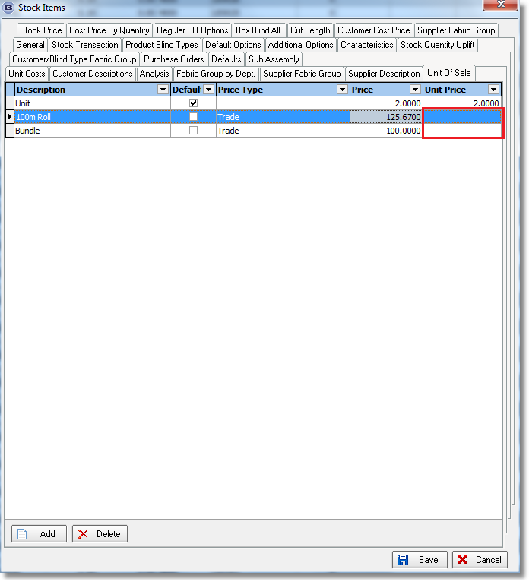

4781. Works Order – Bespoke 46

If the blind identifier = ‘Wood’, ‘Install Height’ is now printed instead of ‘C/S’.

4782. Administration > Import From Excel > Option Price Tables

In certain circumstances an error message could occur when trying to import option price tables. Fixed.

New Work and Customer Requests

3739. Warning Messages

It is now possible to have warning messages for certain combinations of blind type, fabric, option, width and drop. There is a new table called ‘Warning Messages’ in Administration > System Tables, which has fields for blind type, fabric, option, width, drop, message. It is possible to leave blind type or fabric blank.

When a blind detail line is entered, it now checks the ‘Warning Messages’ table to see if there are any matches and if so, to display the warning message. But it is still then possible to save the detail line. If a width and drop are entered in the warning messages record, then the message will appear if either the width or drop in the detail line exceeds the width or drop in the warning message record (unless it is 0).

3756. System Reports > Customers On Stop

There is now an option to group this report by rep. It is possible to select by ‘Rep’ or all with a flag that says ‘Group By Rep’.

3757. Purchase Order Enquiry > Regular PO

There is now more space in the free text field which will then print on ‘PO Label 2’.

3768. Reports > Sales Analysis > Sales Analysis By Option Choice

There is now a column for net total in this report.

3769. Order Processing > Order Amend Enquiry

If the buttons at the bottom of the ‘Order Amend Enquiry’ form are not visible, then other buttons that are visible will be moved leftwards.

3772. Order Processing > Orders

There is now a column choice for ‘Install Height’ in this form ‘View Details’ (in the context menu).

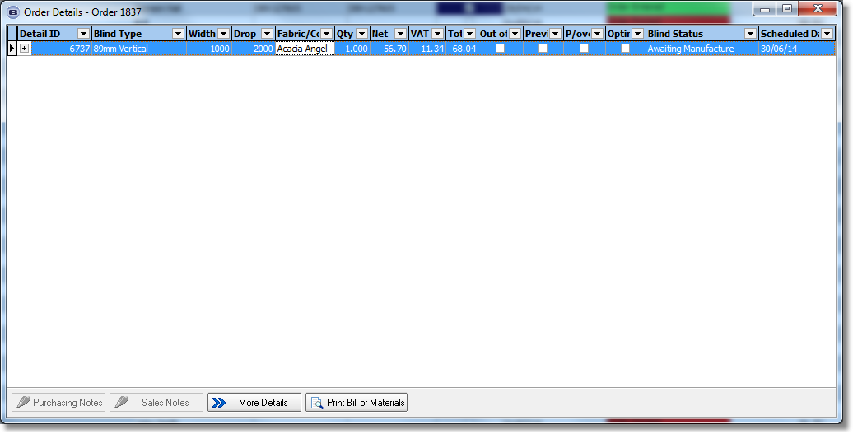

3781. Order Processing > Orders > Window Blind Amend > Recalculate

When the ‘Recalculate’ button is selected, the functionality has been changed so the cutting sizes are recalculated. This includes calculating the cutting sizes if they had not previously been calculated.

W223. Online Order Entry / Order Print

When entering a curved rail you initially got the boxes for width, drop, installation height & Depth. Once you have entered these details and then selected a fabric the Depth box disappeared. The depth then did not appear in the order Acknowledgement, and also did not import in the order. These issues have all been resolved.

