Blindata Release Note 6.9.6 

20 June 2014

Bug Fixes and Enhancements

4754. Archive Enquiry

When you went to print a credit note, the ‘Print Invoice’ button was greyed out. This has been fixed by adding ‘Print Credit Note’ button to the top panel.

4755. Archive Enquiry > Remake/Repair/Redespatch

When a detail line is selected for Repair, only the Location Width, Height, Measure and Fabric were copied onto the repair order. All other options were reset to default. The options now remain the same as the original order.

4756. Order Processing > Quotations > Quote Analysis
If the country is USA or Canada, the size of the report is now 8.5” x 11”.
4757. Sales Analysis > Commission Report Grouped

There are now columns with the order tag (cust ref), invoice number and invoice date.

4758. Acknowledgement – Bespoke 37a

The wrong price was printing in the ‘Net’ column. It is now the net price for the detail line, not the net total.

4761. Purchase Order Bought In – Blind Size

- The left hand address is now the address from the supplier record.
- The contact name from the order is now printed if ‘Direct Delivery By Supplier’ = true in the order.

4766. Purchase Order Enquiry > Regular PO

When changing the value in the regular PO, it is now updating the unit cost price

New Work and Customer Requests

3725. Order Enquiry > Processes

The amount available for a batch is now shown in the processes form in inches.

Also, if there is not enough stock in hand in the batch, it cannot be used.

3742. Sales Lead – Bespoke 53

There is a new sales lead report in Parameters > Reports > Sales Lead / Fitter Sheet Individual, called ‘Sales Lead – Bespoke 53’.

3744. Invoice – Bespoke 53

There is a new invoice layout called ‘Invoice – Bespoke 53’.

3745. Quotation – Bespoke 53

There is a new quotation layout called ‘Quotation – Bespoke 53’.

3746. Fitter Sheet – Bespoke 53

There is a new fitter sheet layout called ‘Fitter Sheet – Bespoke 53’.

3750. Order Processing > Orders

When an order is saved, the operator is saved to that order. If it is then changed, the operator is changed.
It is now possible to retain the original operator by setting a new parameter called ‘Retain Original Operator’.

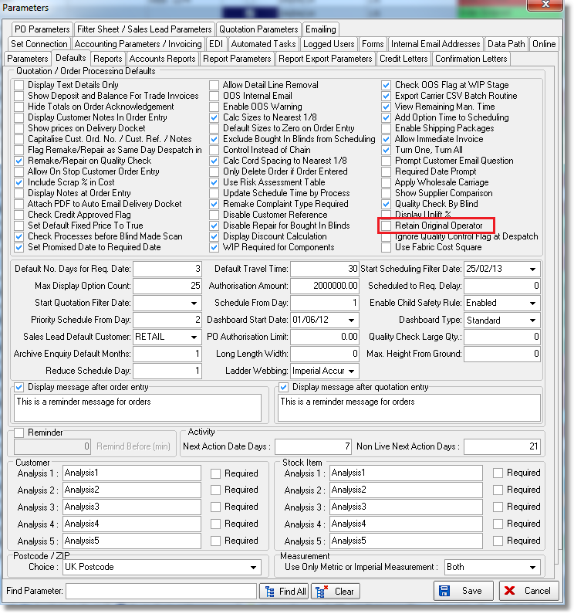

3751. Order Processing > Quotations

When a proforma or quote is converted to an order, the operator who does the conversion can now be held against the order. There is a new parameter for this called ‘Retain Quotation Operator’.

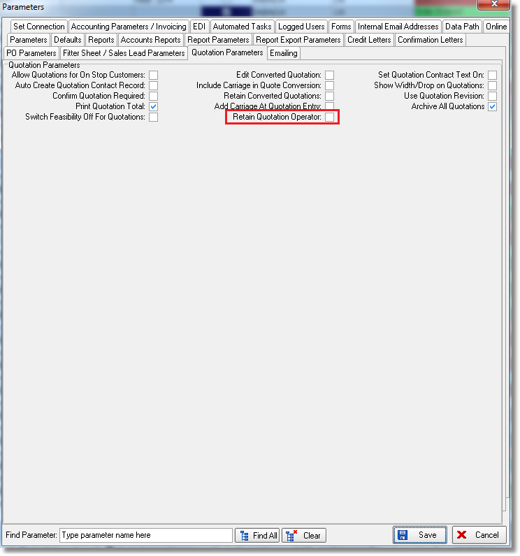

3752. Orders By Operator (Detailed)

There is now a choice to group this report by status (as it currently does) or to print in time order, in which case there will be no grouping by status. The choice is ‘Group By Status’ or ‘In Time Order’.

3754. Order Processing > Orders > Quality Control

There is a new parameter so the quality control check is not done at the despatch stage. The new parameter is called ‘Ignore Quality Control Flag at Despatch’. This applies at all despatch points.

3758. System Tables > Carrier File Setup > Tuffnells Carrier File

There are new field choices of Customers > Delivery Email Address and ‘Cust Ord No’.

3760. Order Processing > Orders > Bill of Materials > Cost
When calculating total cost of materials, there is now a parameter to use the fabric cost square instead of linear yardage cost. The total cost is calculated as Cost Square (fabric) + Cost Price (all other components). The parameter is called ‘Use Fabric Cost Square’ in Administration > Parameters.
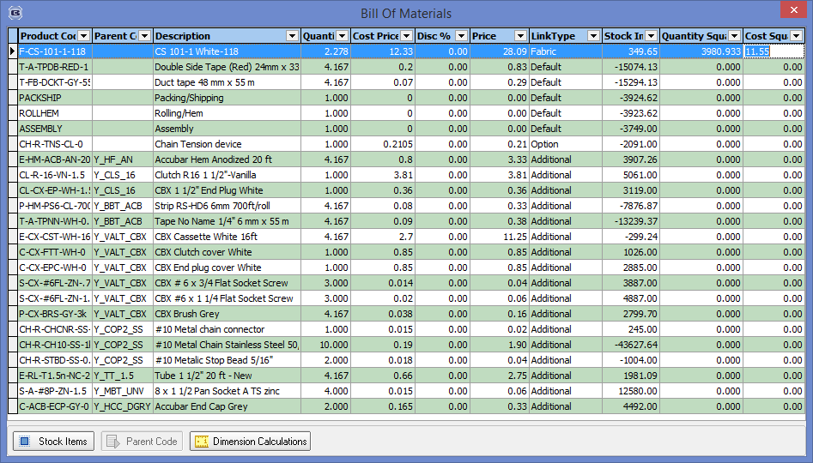
3767. Works Order – Delivery 8

The scheduled date now prints on this report instead of required date, but only if ‘Use Production Scheduling’ is switched on.

