Blindata Release Note 6.9.7 

1 July 2014

Bug Fixes and Enhancements

4762. Purchase Order Processing

For ‘Deliver Filtered Records’, we now to check that all the detail lines are being delivered in the order before the despatch method is changed.

Also if all the blinds in the sales order have been ‘PO Delivered’, then the status of the sales order is changed to ‘Despatched’.

4763. PO Print Regular

There was a blank page printing at the end. Fixed..
Page numbering was wrong in the email version. Fixed.
Note now appears on right in header and not in the centre of the footer.

4769. Statement – Bespoke 37

The statements are no longer including stock nominal transactions.

4770. Works Order – Delivery 8

The scheduled date is now printing if ‘Use Production Scheduling’ is switched on and there is a scheduled date for the order.

4772. Works Order – Portrait Barcode

The sizes that are calculated from the blind type record have been removed because they are no longer relevant, and have been replaced by the parameterised cutting sizes.

4773. Motor Label

The fields on the right hand side now print properly.

4775. Blind Types > Cutting Options > Formula

The formula is applied using the manufacturing width and drop size, not the entered size.

4777. Label Print – Bespoke 28

‘Order Date’ now appears on both the small labels.

New Work and Customer Requests

3753. Customer Label 100mm x 50mm

A new label print has been created, called ‘Customer Label 100mm x 50mm’, based on ‘Customer Label 4” x 2”.

It prints 7 lines on the label, and has contact name added as first line. Also there is the choice of changing the contact name (as well as company name). it is also possible to print labels for the delivery address as well, so there is a button on the ‘Delivery Addresses’ tab as well.

3755. Order Processing > Global Search

There is now a button for ‘Print Invoice’.

3761. Pricing > Discounts / Commission

There is a new table in Administration > System Tables called ‘Commission Discount Ranges’ in which a single commission rate can be assigned to a range of discount percentages.
The table is used in a lookup to automatically update the Commission field depending on the value that is held in the Discount field on the Blind Edit window and Total tab during order entry.

The fields in this table are ‘Lower Discount’, ‘Upper Discount’, ‘Commission %’. So the table may look like this

Lower Discount Upper Discount Commission %
0 5 8
5.1 10 6
10.1 20 4
20.1 40 2

The order entry will find the discount and commission as it currently does but then also look in this table. If the discount % is between the lower and upper figure, then the commission % from this record in the table should be used. This is also checked if the discount % is changed.

3764. Order Processing > Orders

There is a new flag held against a user called ‘Add Contact Record After Order Exit’. This is displayed below ‘Activate Amendment Reason’.

If this is set to true, the contact management should appear for an order after going into an order, regardless of whether it is changed or not. It bring up contact management then add contact record.

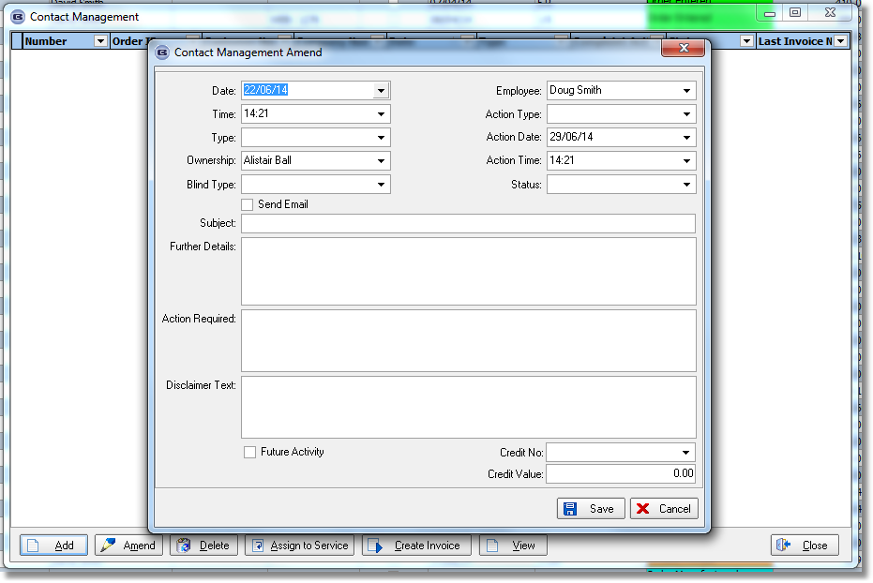

3765. Purchase Order Processing > Create Invoices

There is now an option not to post all detail lines – they appear in financials, but to group the transactions by nominal code.

The carriage amount is now shown in the bottom part of form. The message about entering carriage has been made more meaningful.

Also, if Blindata accounting is used, the user is also asked to enter a transaction reference, and this now also happens with the integration to Sage.

3766. EDI Enquiry > EDI Import

There is a new flag in the customer record (in the Options tab) called ‘Use XML File Descriptions’. If this is set to true, When the EDI file is imported for this customer, it will have stock codes that can be mapped, but the blind type, fabric and option descriptions will be held in a new table. These need to be kept because they will appear on the despatch docket.

Therefore we now hold these against the actual order so that the relevant descriptions can be used for the delivery docket.

3770. EDI Import > Stock Warnings on Online/EDI Orders

If a stock warning is generated on an order imported through EDI enquiry, previously the order was still automatically checked. This has been changed so that the EDI Import routine will not mark an order is checked if any stock warnings are generated.

3771. Order Enquiry > Despatch / Despatch Scan

This is actually a very simple change. The despatch date that is saved in the serial detail line is now the current date, not the despatch date entered.

