Blindata Release Note 6.9.4 

10 June 2014

Bug Fixes and Enhancements

4731. Order Processing > Orders

Occasionally the wrong email address was saved in an order. Fixed.

4732. Label Print – Bespoke 33A

The text has been moved very slightly vertically on the labels.

4733. Label Print – Bespoke 33A

Carriage type was put on this label but was printing in the middle of the repair text (if the order is a repair). Fixed.

4734. Daily Status Report

When the subject line was created for the reports that get emailed out to the customers from the program we wrote, the subject lines are now different, because they could have been treated as outgoing spam. Therefore ‘Daily Status Report from Demo Blinds Ltd’ has been changed to ‘Daily Status Report for [customer company name] from Demo Blinds Ltd’ (Demo Blinds Ltd is taken from Company Details).

4735. Post Invoices

When Maxton invoices get posted, the figures were sometimes held to 4 decimal places. It They are now only held to 2 decimal places.

4736. Label Print – A4 88mm x 14mm

This label print was coming up with a ‘no records’ message when you try to print it. Fixed.

4737. Statement – Bespoke 37

- This report now prints in invoice date order then invoice number order.
- The date in top right is the statement date (trans end date), not the current date.
- The totals at the bottom were incorrect. They are now calculated from the ‘Trans End Date’, not the current date.

4739. Transaction Log Error

Errors found in the transaction log have been resolved.

4740. Fitters Sheet / Sales Leads > General Diary Entry

When entering a general diary appointment, it was putting it against the employee that is highlighted in the diary rather than the employee selected in the general diary entry. However after exiting the diary and back in, it displayed against the correct employee. It now puts this into the correct employee straight away.

4741. Label Print – Bespoke 29

‘Made By’ printed regardless of whether ‘Print Made By On Labels’ was true or false. It now looks at this parameter to determine whether it should print or not.

4742. Contact Measurement Sheet

This now prints the company name in the sales lead, not the company name from ‘Company Details’.

New Work and Customer Requests

3727. Order Processing > Orders on Customer Hold

There is a new advanced permission flag called ‘Take Off Customer Hold’ which defaults to false. It is displayed in the ‘Orders’ section. If this flag is false, then the user will not be able to take an order off customer hold.

3731. Stock Control > Amending Batch Number Amounts

If the amount in the batch is wrong, there is now a way of amending it.

3732. EDI Import
The online ordering system now records that the chain length has been amended and then puts that field in the XML file. The import routine now looks at that field to see if the chain length has been overridden, and if so, imports that chain length amount and does not change it.

3733. Reprinting Works Orders

Re-printing worksheets – it used to show in the history if a work order sheet had been reprinted but we disabled this. This can be reinstated by setting a new parameter called ‘Record WO reprint History’ which defaults to false.

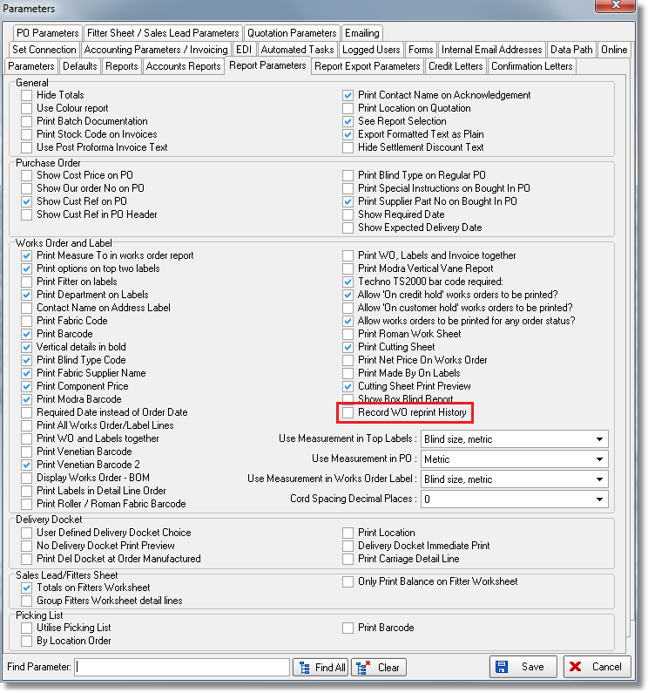

3734. Order Enquiry > Stop/Start Manufacture

When ‘Incorrect status’ shows on the screen below, it now also says what status of the blind actually is.

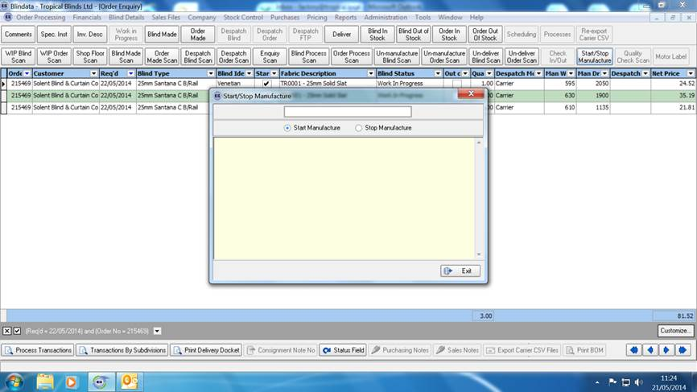
3738. Purchase Order Enquiry

The ‘Carriage’ amount was previously uneditable. It is now possible to edit this field at any point up to the purchase invoice being created.

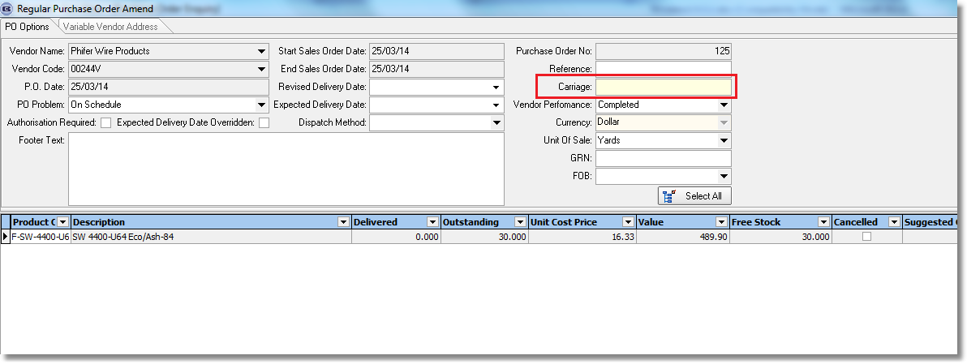

3748. Sales Files > Customers > Reports

There is a new option for only emailing statements.

