Blindata Release Note 6.9.5 

16 June 2014

Bug Fixes and Enhancements

4743. Statement – Bespoke 37

The period totals at the bottom of the statement were incorrect – fixed.

4744. Customer Transaction Report

This no longer contain transactions that are ‘Manufactured Inventory’ or ‘Purchase Inventory’. These are internal nominal transactions.

4745. Aged Debtor Reports By Invoice

The aged debtor report only shows the outstanding invoices ie those that have not been paid or that are partially paid. The detor totals for each customer is the same as the statements.

In Canada, the report prints as size 8.5” x 11”.

4747. Label Print – Bespoke 33A

For blind identifier = Vertical, the last small label (on bottom of address label) now has order no, customer, then under that 1 of n, no of louvers, fabric description.

The cutting sizes now prints in one column, not two.

If the install height is entered in inches, it prints on the label in metric.

4748. Purchase Order Processing

When you deleted a regular PO detail line, ‘Detail’ was spelt incorrectly. Fixed.

4749. Acknowledgement – Bespoke 37a

Sometimes the net price appeared here as zero, but the total was correct. This happeed in detail lines with discount.
Also, ‘Unit Of Sale’ is now printing the unit of sales, not the measurement unit.

4751. Quotation – Bespoke 37

- The hardcoded text from the bottom left has been removed.
- The quotation text from Company Details > Report Texts > Quotation Text now prints in the bottom left.
- There was a bug with the printing of page numbers. For example, for a 2-page quote it prints page 1 with a heading of “Page 3 of 3” and page 2 prints as “Page 1 of 3”.
- If “Print Quotation Group Subtotals” and “Hide Detail Lines” is checked, the text currently looks like below but the options should be listed before the first detail line…
Group Text 1
Blind Type, Fabric & Options of detail line #1
(qty) W x H detail line #1
(qty) W x H detail line #2...etc
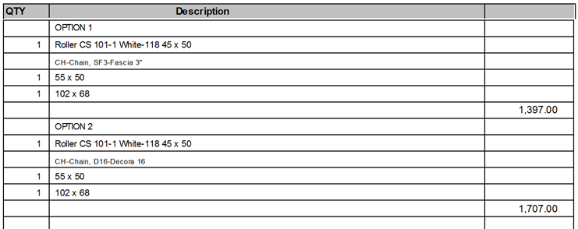
If “Display Text Details Only” is checked, the group subtotals no longer displays.
4752. Order Processing > Orders
For Canada and the USA, address line 2 is no longer validated in order entry.
4753. Archive Enquiry > Email Credit Note

The email was pulling the default email text for Invoices - it is now printing the email text for Credit Notes (Admin > Company Details > Email Texts 2).

Also, there is now a separate button for emailing credit notes as opposed to invoices.

New Work and Customer Requests

3555. Efficiency Reports (Phase 1)

The following work has been carried out.

- There is a new system table called ‘Process Group’. This is also now held against the user, and has also been added to the ‘Process Times’ form. The process time can then be picked up by blind type, process, option and process group. If the process group is left blank, it will work as it currently does.

- There is a new system table called ‘Employee Group’. This is also now held against the employee.

- There is a new system table called ‘Production Area’. This is also now held against the employee.

- There is a new system table called ‘Efficiency Process’.

- In Blind Types > Process Times, there is a new field called ‘Option’ (as well as ‘Process Group’ from 1). This field could be left blank, but if filled, the process time will be looked up by the blind type, process, process group and option selected. If blank, then the process time will looked up as normal.

- In Blind Types > Process Times, there is a new button called ‘Efficiency Process’. This displays a form similar to the ‘Process Times Table’ except it holds the ‘Efficiency Process’ instead of the time.
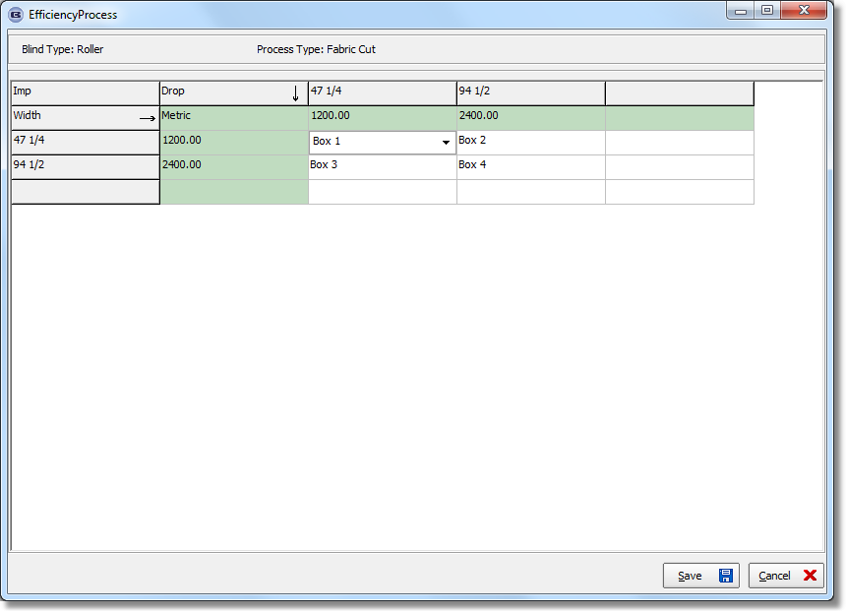

- A new field has been added to the ‘ProcessTransaction’ table called ‘Efficiency Process’. When the process scan is done, the efficiency process is found according to blind type, process, process group, production area, width and drop, and then saved in the new field.
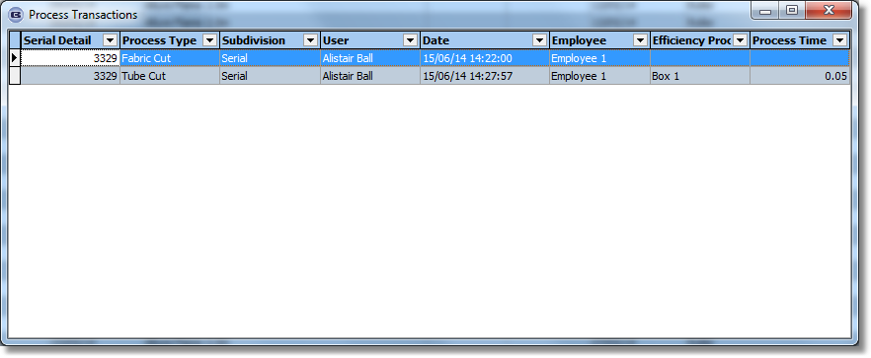

- Previously a WIP scan and Blind Made Scan did not record a process transaction but this is now possible. There is a new parameter flag called ‘Record WIP Process’ in Parameters which defaults to false. There is also a new column held against the process type called ‘Type’ so we can identify the ‘WIP’ or ‘Made’ process. When the blind is WIPd it records the relevant process, same for Blind Made Scan.

- The Employee form has fields added for ‘Monday’, ‘Tuesday’, ‘Wednesday’, ‘Thursday’, Friday’, ‘Saturday’ and ‘Sunday’. These will hold the default minutes worked. There are also new fields for ‘Shift’ and ‘Employee Group’.
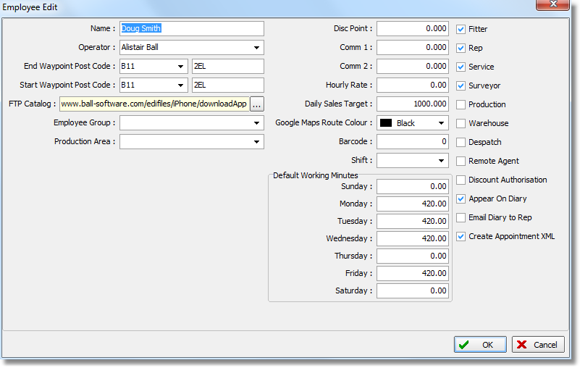
- An ‘Employee Working Hours’ form has been created. This form has a similar style to the ‘Scheduling’ form. We need to hold by day: Hours, Holidays, Sick, Overtime. (We also need to hold fields for ‘On Job Cross Training’, ‘New Start Training’, ‘Machine Breakdown’, ‘Trainer Off Standard Allowance’, ‘Other Tasks’, ‘No Of Quality Issues’). This form can be accessed from Administration > System Tables.

Once these are all set up, they can be adjusted manually.

There is a button for this form in the Employees table as well.

3737. Purchase Order Enquiry

There is now functionality to deliver multiple bought in purchase orders at once. There is a new button on the ‘Purchase Order Enquiry’ form called ‘Deliver Filtered Records’. This will change the status of the PO to delivered. If the sales order has all blinds manufactured, the status should change to ‘Order Manufactured’ and then ‘Delivered’. The user is also be asked for the despatch method for these orders.

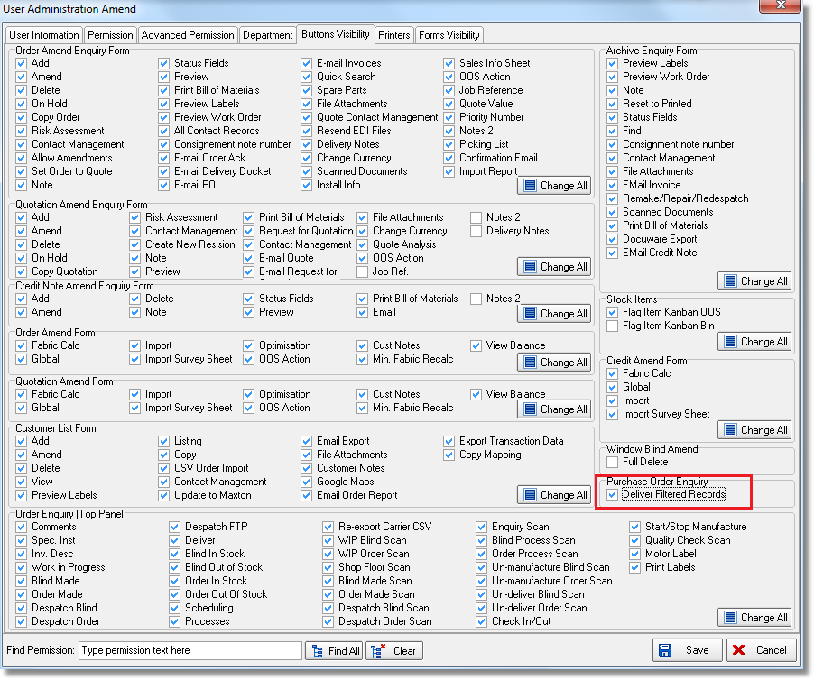

3740. Invoice – Bespoke 46 / Invoice – Bespoke 46a

‘Invoice Terms’ from the customer record is now printed on the invoice.

3741. Import From Excel > EDI / Online Discounts

There is an import routine for ‘EDI / Online Discounts’. The spreadsheet has columns for:
Start Date, End Date, Account Code, Blind Type Code, Discount %, Employee.

3743. Order Processing > Orders > Order Details

In ‘Order Details’ there is now an option choice for ‘Measurement’.

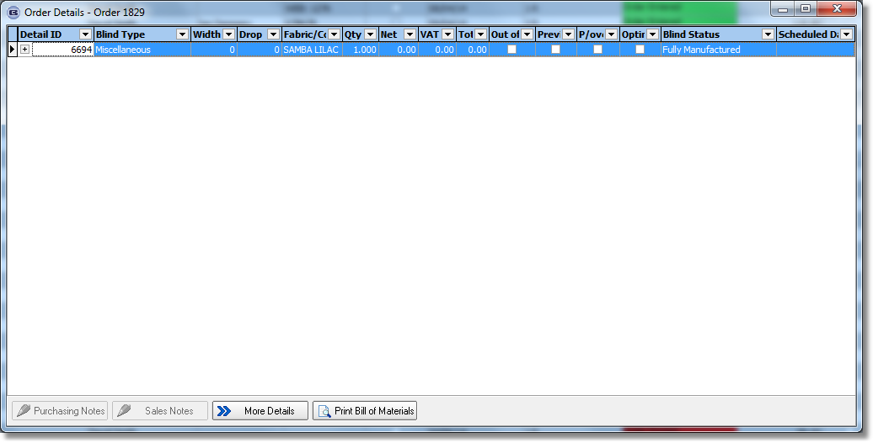
3762. Order Processing > Order Enquiry > Processes

There is a column choice for ‘Blind Type Description’ on this form.

