Blindata Release Note 6.9.2 

23 May 2014

Bug Fixes and Enhancements

4712. Sales Analysis Commission Report Grouped

This was showing far too many decimal places in the discount % - it now only shows 2 decimal places.

4713. Purchase Order Bought In 8.5 x 11

The ‘High priority’ texts have been removed.

4715. Pricing > Option Price Enquiry

The ‘Save’ button now works when clicked.

4716. Works Order - Label Blind Size 2

- The cutting sizes have been moved right a bit (so the right hand side of the cutting sizes lines up with the right hand side of the bar code.
- The chain length is now an integer.

4717. Invoice – Laser Print (Letterhead Logo)

If the detail lines fill up the first page, and there are none on the second page, it printed ‘Page 2 of 1’. Fixed.

4718. Order Processing > Archive Enquiry

Invoices without invoice numbers will now appear in Archive Enquiry.

4719. Purchase Order Regular – Bespoke 37

The unit that prints on the purchase order layout was the ‘Measurement’ field from the stock item. It now prints the unit of sale in which the purchase order is ordered.

4720. Order Processing > Orders > Component Detail Line

- If a component detail line is added and it has a lot of text entered in the comment box (up to 200 characters), it was being cut off in some of these reports. This field is now expandable so it prints up to 200 characters.
- The currency sign is now next to the amounts in all these reports.

This has been done first for Acknowledgement – Laser Print, Acknowledgement – Laser Print (Letterhead Logo), Invoice – Laser Print, Invoice – Laser Print (Letterhead Logo).

New Work and Customer Requests

3549. Purchase Order Regular – Bespoke 46

There is a new regular PO report called ‘Purchase Order Regular – Bespoke 46’ (A4 for UK and 8.5 x 11 for USA and Canada).

3681. Order Processing > Order > Window Blind Amend

There is now a context menu choice for ‘Option List’ in the Window Blind Amend form.

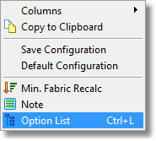
This choice will then display the options. Please note that Ctrl+L will also do this. The button with the 3 dots beneath ‘Option List’ can also be used to display the option list.

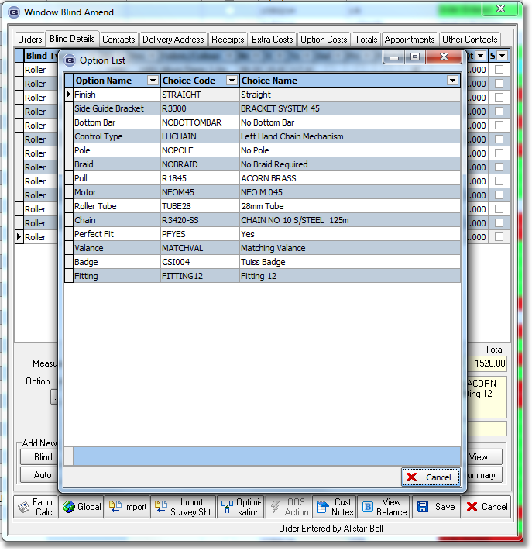

3682. Quotation - Laser Print

The ‘Location Field’ has been added to this report in the detail section. The options now print in two columns in this report.

3683. Pricing > Discounts

It is now possible to update the discount end dates by filtering records in the discount amend form, and then clicking on the new ‘Update’ button.

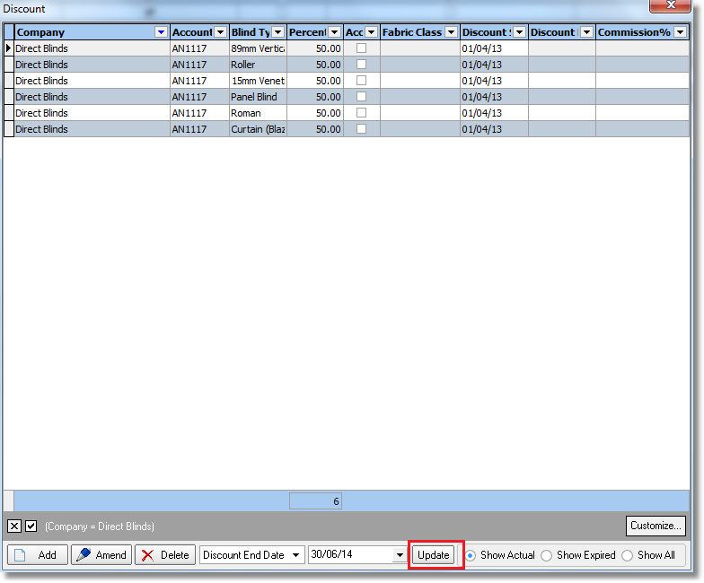

3686. Sales Files > Mapping

It is now possible to record and view the history of changes in the Mapping form.

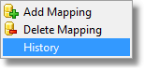
3692. Option Price Table Enquiry

There is a new ‘Price Method’ in the ‘Option Price Enquiry’ table called ‘Zeroise Base Price’. If the option price has a price method of ‘Zeroise Base Price’, then in the detail line the price found in the option price table will still be selected but the base price that has already been found in the normal price table lookup will be zeroised.

This is required because one customer has price tables that are dependent on options that have been selected, rather than just the blind type / width / drop / price code.

3694. Dispatch Label

There is a new despatch label called ‘Despatch Label 3 x 1’. It prints company name and address and prints out 1 label per box (the number of boxes is entered at the dispatch stage).

Address Line 1 (Company Name)
Address Line 2 (Address)
Address Line 3 (City), Address Line 4 (Province)
State Zip (Postal Code)
3700. Employee Process Drilldown Report

There is a new column for fabric description in this report, and the records now print in order of when the process was done instead of order number ie by the date/time of the process in ascending order.

3701. Production Process by Employee By Week

There is a new report based on ‘Production Process By Employee’. Instead of hours horizontally it shows days horizontally. This will show 7 days with the user entering a start and end date. This is a portrait report.

3709. Order Processing > Quotations

There is a new parameter called ‘Switch Feasibility Off For Quotations’. If this is set to true, then the feasibility check is not be applied for quotations.

3710. Administration > Import From Excel > Postcodes

The current ‘Postcodes’ import has been changed so it only imports the first part of the postcode and updates the ‘Postcode’ table. If the first part of the postcode already exists as a record in the database and it is in the import file, then it is not imported.

3711. Order Processing > Orders > Multi Blinds

If the blind identifier = ‘Multi Blind’, there is a new flag displayed in the blind type record called ‘Check Widths Add Up’. If this is set to true, then the blinds that make up the multi blind should have a total width = the multi blind width.

For example, if a multi blind is entered with a width of 2300mm, and there are three blinds that are tied to that multi blind (by having the same multi blind code), then the sum of the widths of these blinds + the gap should equal 2300mm.

It also does the check for each set of multi blinds. If you have 3 multi blinds on an order called M1, M2, M3 and each of these multi blinds has two ‘sub blinds’ (called M1-1, M1-2, M2-1, M2-2, M3-1, M3-2), then we need to check that the width of M1 = width of M1-1 + gap + M1-2, then M2 = width of M2-1 + gap + width of M2-2 etc.

3712. Works Order – Bespoke 52

If a blind identifier = Multi Blind, then the multi blind code is now printed on this report, beneath the ‘Quantity’ field eg Mult Blind = M1.

If the blind type record has ‘Display Multi Blind Code / Seq’ = true, then it prints ‘Multi Blind Code / Seq’ below the quantity eg Multi Blind Code / Seq = M1 / 1.

3713. Import From Excel > Customer Update

It is now possible to update the ‘Email Invoice Only’ and the ‘On Commercial List’ fields.

