Blindata Release Note 6.9.1 

19 May 2014

Bug Fixes and Enhancements

4676. Order Processing > Orders > Order Made

Timeouts on other PCs when using the ‘Order Made’ button were reported by a customer that has ‘Use Stock Nominal’ = true.

We have made several fixes that may have contributed to this, however this still requires investigation.

We have also created a table called ‘TransactionLog’ in order to keep information about unclosed transactions Blindata generates. Also closed transactions that have been open too long (30 seconds by default) will also be inserted in the table too. We hope it will help to trace and fix problems with blocking database objects in Blindata Application in the future.

4694. Quotation – Bespoke 46

This report has been tidied up.

- There is now more space between the ‘account Ref’ colon and the code.
- The install height is now an integer if metric.
- For large figures, the last decimal place was not printing. Fixed.
- The currency sign is now next to the amount.
- The ‘Page 1 of n’ was overlapping the fields below – it has been moved up slightly.

4696. Sales Analysis By Commission Grouped

The commission amount, commission % and discount % now appear on this report.

4697. Picking List – Bespoke 37

1. The logo now prints out the same size as it does in ‘Invoice – Bespoke 37’.
2. The date format is now taken from Windows ie in this case mm/dd/yyyy.

4698. Acknowledgement – Laser Print 8.5 x 11 (report & pdf)

There is now more room for printing comments on wholesale/component lines.

4699. Statement – Bespoke 37

This statement is no longer showing the Inventory/Purchase journals. The ‘Ref.’ column heading has been changed to ‘Invoice No.’.

The headings at the bottom have been changed as follows.
Period 1 --> 30 days
Period 2 --> 60 days
Period 3 --> 90 days

4700. Label Print – Bespoke 33A

The number of vanes and Impala information was being chopped off if there was a location entered. This now prints in full.

4701. Works Order – A4 Packing Slip

The ‘Chain Length’ now prints beneath the fabric description.

4703. Purchase Order Regular – Bespoke 42

If more than 2 pages were on the report, page 3 was a blank. Page 5 or 6 could be blank as well. Fixed.

4707. Financials > Invoice Batch Print

A change has been made to the EDI import routine. If there is an email address in Sales Files > Customers for ‘Invoice Email’, this is saved in the order ‘Invoice Email’ field when the order is imported.

4708. Credit Note – Bespoke 46

‘INVOICE’ now says ‘CREDIT NOTE’.

Tel number has been removed from the address box.

4709. Invoice – Bespoke 46a

The customer batch invoice layout footer is now identical to the footer in ‘Invoice – Bespoke 46’.

4710. Statement – Bespoke 37

- This logo is now 4” wide x 1” deep.
- The customer address has been moved left so it is in line with the left hand side of the logo.
- The address is now in the format:

Company Name
Address Line 1
Address Line 2 (Should be optional; we have to put a period in this line if it is not used; BD won’t allow blanks. Can this be turned off and made dynamic so that if it is not populated, it will be hidden?)
Address Line 3 (City), Address Line 4 (Province)
State Zip (Postal Code)

4711. Label Print – Bespoke 28

If ‘Print Made By On Labels’ is set to true, then ‘Made by’ [Company Name] now prints on this report on the top labels.

New Work and Customer Requests

3674. Credit Note – Bespoke 37

There is a new credit note report called ‘Credit Note – Bespoke 37’.

3677. Administration > Import From Excel

There is a new import routine for import ‘Unit Of Sale’ records. This should have columns for unit of sale, quantity.

3678. Purchase Order Bought In – 8.5 x 11

There is a new bought in purchase order report called ‘Purchase Order Bought In – 8.5 x 11’.

3684. Order Processing > Orders > Remake/Repair

There is a new parameter in Administration > Parameters called ‘Disable Repair for Bought In Blinds’. This defaults to false. If it is set to true, then in Remake/Repair/Redespatch, the ‘Repair’ buttons will display a message saying It is not possible to repair bought in blinds’.

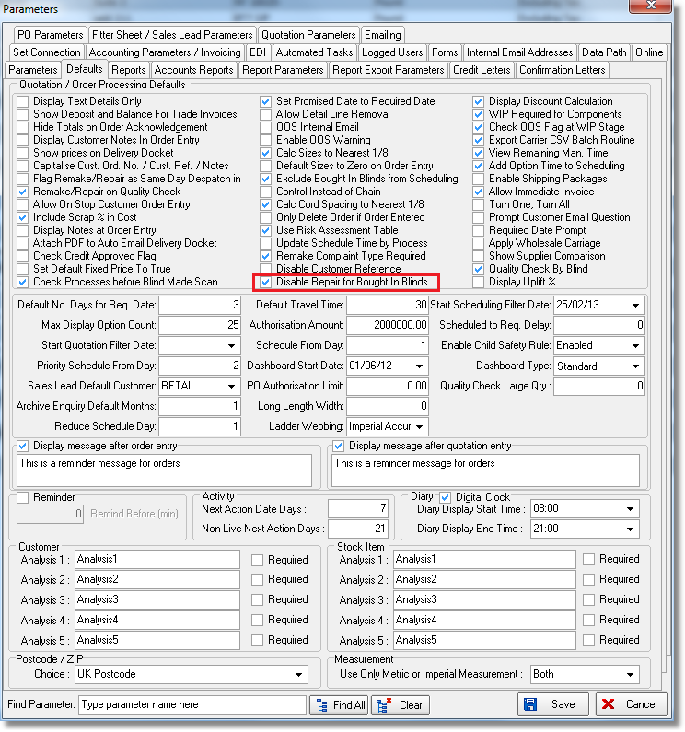

3685. Sales Files > Customers

There is a new flag in the customer record called ‘Exclude From Authorisation Check’. This defaults to false, but if set to true, orders for this customer will not get put on authorisation hold at all.

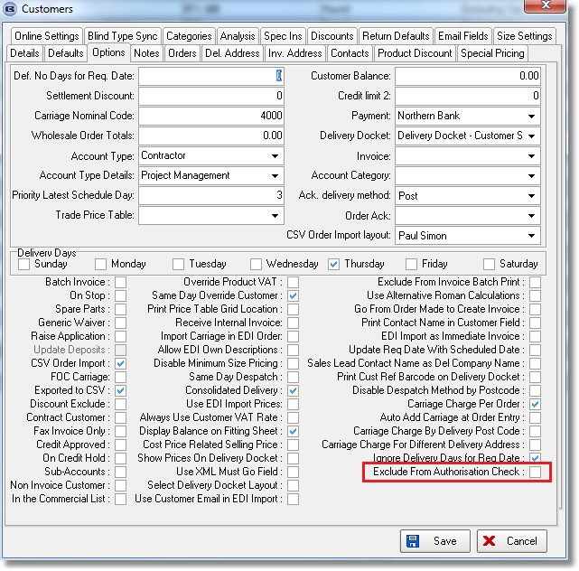

3687. Order Processing > Orders > Credit Check

If an order is a remake and the total value of the order is 0, then it should not go on credit hold, even if the outstanding orders in Blindata + accounts > credit limit. If the remake has a value of > 0, then the normal credit check will still apply.

3689. Customer Discount Email Report

The customer discount report has been altered so it only shows ‘live’ discounts ie it does not include those that have an end date of before the current date.

3690. Order Processing > Orders > Uplift %

There is a new parameter in Administration > Parameters called ‘Display Uplift %’ which defaults to false. This means the ‘Uplift %’ in the window blind amend form will not be shown. But if ‘Cost Price Related’ = true in the blind type record, then it is shown regardless of what the new flag is set to. If the new parameter is set to true, then the field will always be shown.

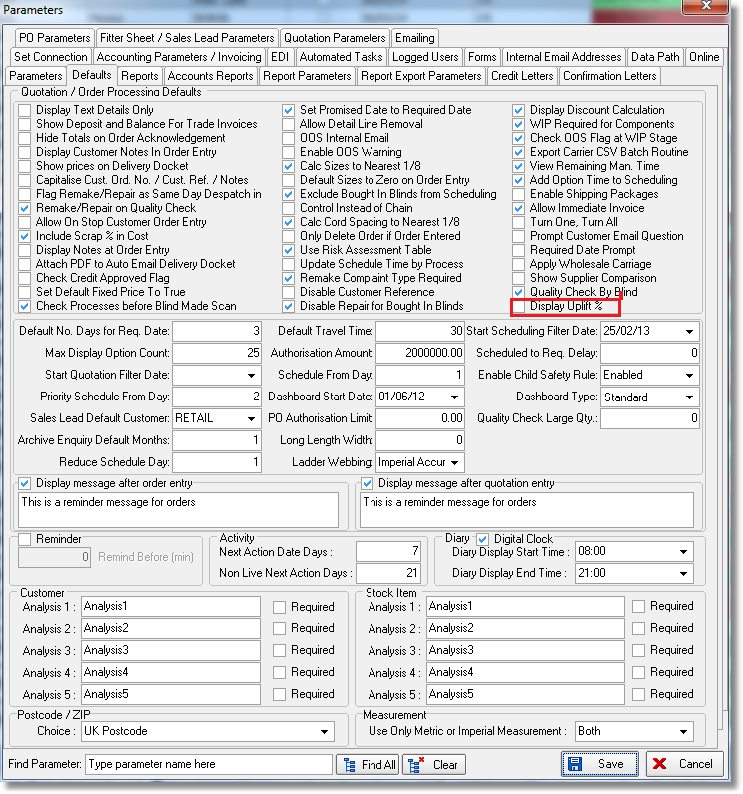

3691. Administration > System Tables > Same Day Despatch

There is a new system table called Same Day Despatch FOC. This contains fields for customer and blind type. When an EDI import is done, or the order is entered manually, this table is checked for matching records. If one exists, the no same day dispatch charge will be made.

3693. Order Processing > Orders

‘Invoice Terms’ from the customer record is now a column choice in ‘Order Amend Enquiry’.

3695. Order Processing > Order Enquiry > Processes

When fabrics are sold wholesale, they need to deduct from the relevant batch number. If ‘Manual Stock Usage’ is set to true, stock will not be deducted for wholesale orders when ‘Order Made’ is selected.

Wholesale orders will now appear in Order Enquiry > Processes, which means that batch numbers can be selected by fabric. There must be a ‘Fabric Cut’ manufacturing process set up in the miscellaneous blind type for this to work.

