Blindata Release Note 6.8.8 

28 April 2014

Bug Fixes and Enhancements

4656. Order Enquiry > Processes

When you try to complete processes for non fabrics, the following message appeared. This has been fixed.

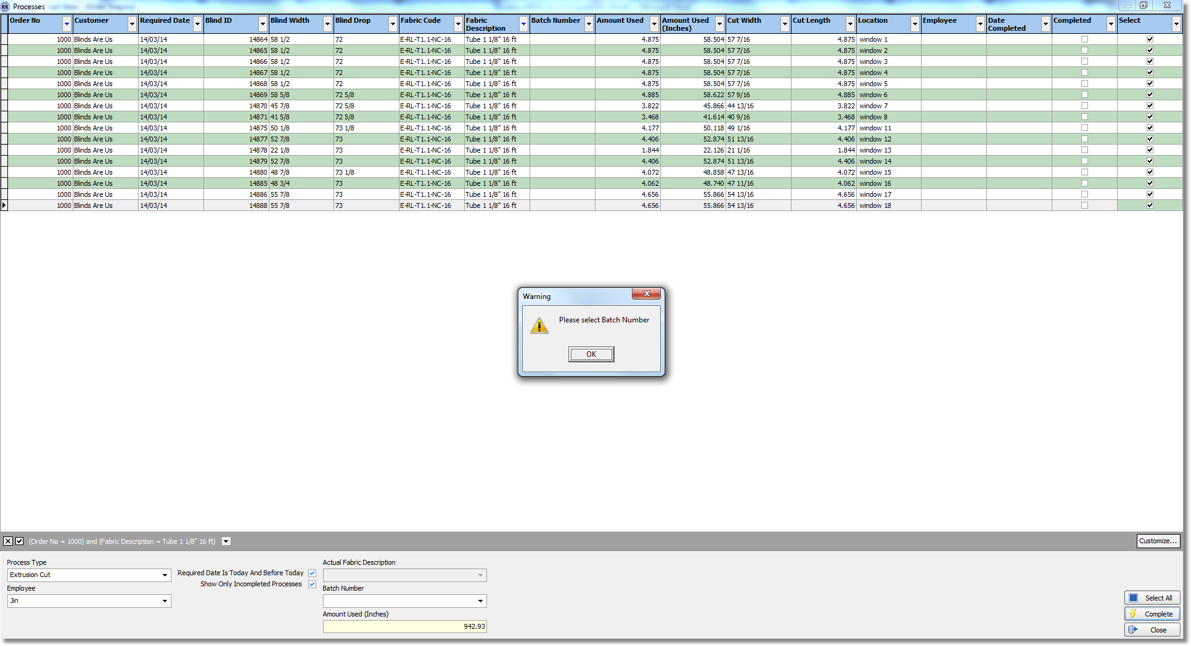

4657. Bank > Bank Reconciliation

The ‘Receipts’ and ‘Payments’ columns were the wrong way round. The sales receipts are now in the ‘Receipts’ column and the purchase payments aree in the ‘Payments’ column.

4658. Works Order – BOM

If the blind identifier = Panel, then the number of panels now appear on this report.

4659. Works Order – 4 Per A4

The margins on the first and second sets of labels have been moved slightly..

4660. Sales Lead Individual Normal

‘Other’ has been replaced with ‘Install Height’.

4661. Invoice - Laser Print 11 Detail Lines

- Invoice text from ‘Company Details’ now prints if Trade Type = Including Tax. It works for ‘Excluding Tax’.
- The currency sign is now beside the numbers.

New Work and Customer Requests

3640. API For Credit Check in Mertex

There is now a WEB service for checking the credit limit and outstanding balance in the Mertex accounting system. See specific notes.

Sales Analysis Commission Report Grouped

This report is still grouped by order but is now grouped by blind type within order.

3647. Acknowledgement – Bespoke 37a

This layout has been changed to look more like a standard portrait report, but with ‘Terms’ in the header as well.

3661. Required Dates / Delivery Days

If the parameter to ignore delivery days when the required date is being calculated in order entry is switched on (‘Ignore Del Days For Remake Etc)’ this now applies to all orders, and the message is only shown once.

