Blindata Release Note 6.8.2 

18 March 2014

Bug Fixes and Enhancements

4578. Order Enquiry > Processes

There was a bug with calculating the amount used after the number of inches have been entered. If multiple lines have been selected, it was updating the stock multiple times. Fixed.

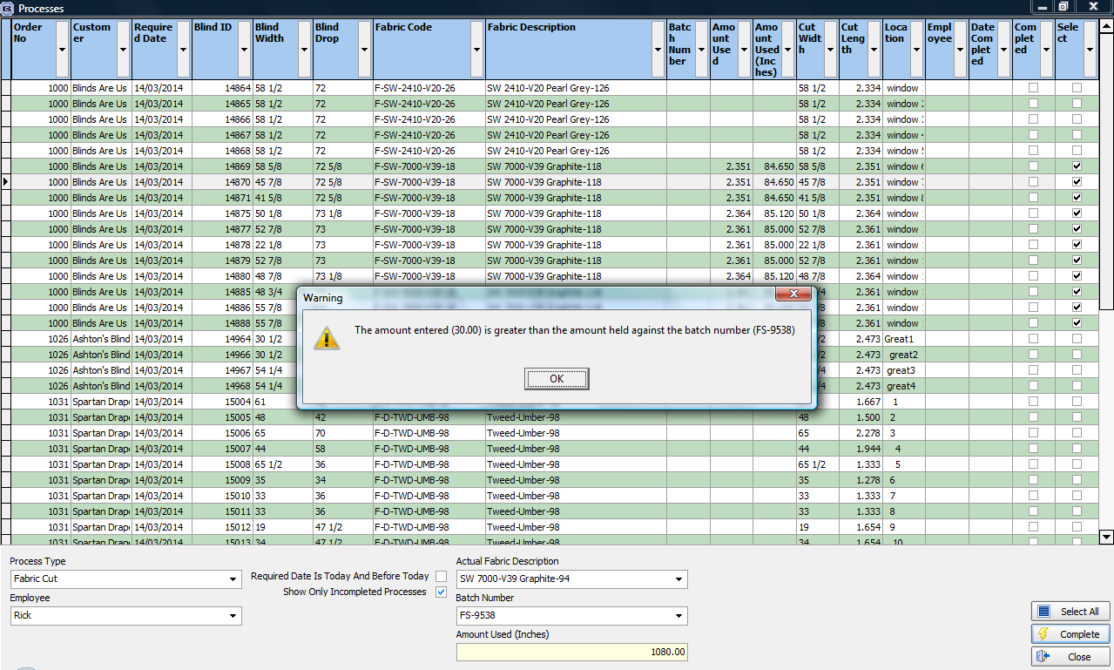

The cut width for the extrusions was incorrect. Fixed.

The ‘Select All’ button is taking a long time, even after records are filtered. This has been speeded up slightly.

The ‘Complete’ function was taking too long. This has been speeded up slightly.

4588. EDI Import

The incorrect nominal code was being held for ‘Standard Next Day Carriage’. This was caused by the EDI import taking the nominal code from the blind type record instead of from the stock record (for carriage records). Fixed.

4589. Stock Items > Additional Options

After a new stock code is entered and you then go into the ‘Additional Options’ tab, the new stock code was not available in the lookup. This only worked after you log out of Blindata and back in. Fixed.

4593. Sales Files > Customers > Copy

This was not copying the ‘Receive Internal Invoice’ flag when the customer record is copied. Fixed.

4594. Order Processing > Orders

If a blind type is exempt (and has an ‘Exempt’ record set up in Blind Details > Blind Types > Child Safety Rules with no stock code against it), the following appears. This information form no longer appears for operating method = Exempt.

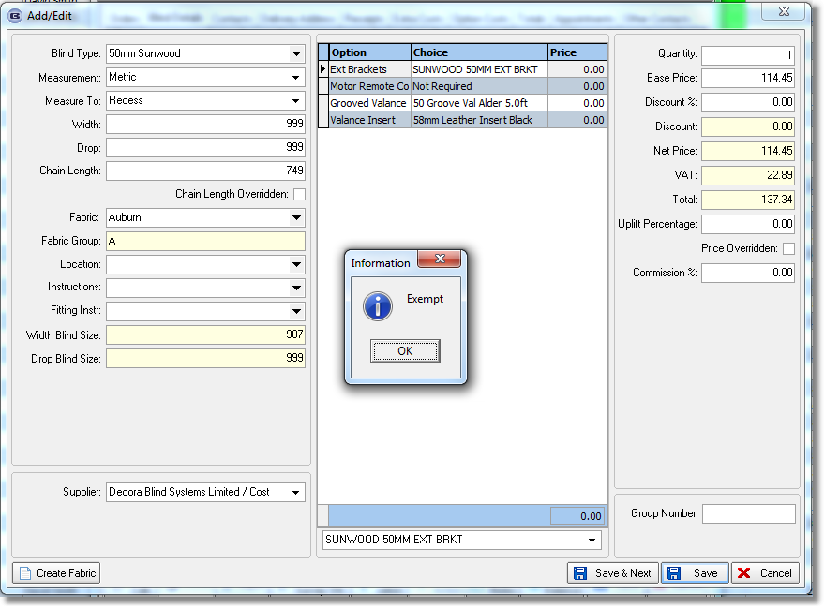

4595. Order Processing > Paid Proformas

When a proforma quotation is changed to ‘Paid’, it was not being saved. It reverted to ‘Yes’ immediately. Fxed.

New Work and Customer Requests

2841. Sales Analysis Commission Report

A new sales analysis report has been created called ‘Sales Analysis by Commission’. It does not include orders where ‘No Commission’ = true.

The report shows orders by detail line, showing blind type description, fabric description, width, drop, detail line net total, commission amount, by rep by customer.

The commission amount is calculated in the report as (net total * commission %)/100.

3595. Blind Type Dataset Export

When a blind type is exported that has a different related blind type to the blind type, it exports the related blind type code.

3605. Blind Details > Blind Types

For vertical blinds, there is now an option to get the system to use the headrail cut size to then work out the number of vanes for verticals, instead of using the blind size width. There is a parameter in the blind type form (if blind identifier = Vertical) called ‘Calc Vanes By Headrail Cut’.

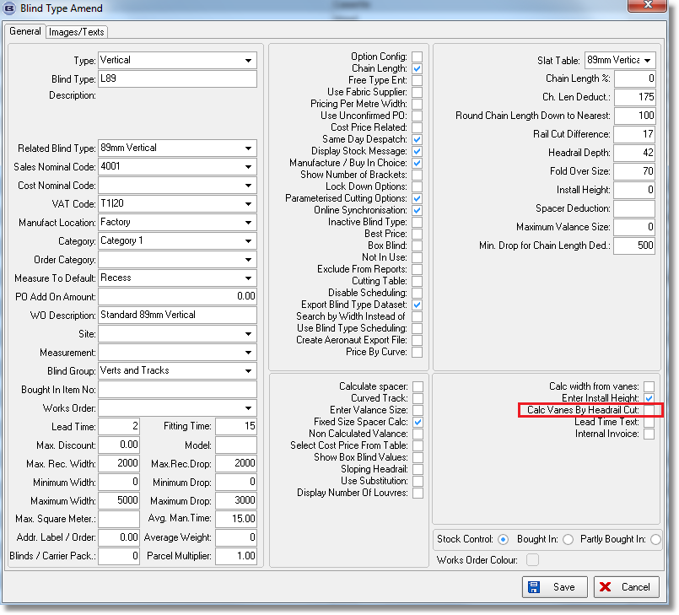

This defaults to false – if true, it then uses the headrail cut (from cutting sizes) to work out the number of vanes (ie when looking up the number of vanes table).

3610. Stock Valuation Report

The value is now in the format 999,999.

There is also an option to collapse fabrics so batches are not shown – only the stock in hand total is printed.

3613. Stock Control > Stock Transaction Entry

It is now possible to see the stock in hand figure before it gets updated by either an issue or a receipt. This is displayed after the stock item is selected. If ‘Batch Numbering’ is switched on, then the available amount in each batch is displayed.

3614. Administration > Users

There are now advanced permissions for Order Enquiry > Motor Label, Check In/Out, Purchasing Notes, Sales Notes, Print BOM.

3615. Sales Files > Customers

There is now an email order acknowledgement layout held against the customer so a different order ack can be emailed to the end user. There is a new field in the customer record called ‘Order Ack’ with a lookup for the email order acknowledgement reports.

3616. Import From Excel > Unit Of Sale / Unit Cost Import

There is now a column to import the default record (true/false).

3617. Order Processing > Orders > Blind Details

There is now a column choice in the ‘Blind Details’ form for ‘Install Height’.

3619. Acknowledgement – Bespoke 31 pdf

‘Location’ is now printed in the detail section, to the right of ‘Install Height’.

