Blindata Release Note 6.8.1 

7 March 2014

Bug Fixes and Enhancements

4565. Order Processing > Orders

If an option is entered that has a child safety rule of ‘Exempt’ then a message no longer appears.

4574. Quotation – Bespoke 37

The ‘Print Quotation Totals’ flag is now working.
Special instructions now print beneath each detail line.
The ‘Terms’ box has been removed from the header section.
‘W H’ has been removed from the section heading regardless of flags selected.

4582. Administration > Maintenance > Recalculate On Purchase Order

The ‘On Purchase order’ was not being recalculated properly after the previous release. Fixed.

4583. Order Processing > Quotations

When a detail line in a quotation was deleted, the ‘On Sales Order’ figure was being reduced to for each bill of materials record. This no longer happens.

4584. Order Processing > Orders

If an imperial measured detail line is entered, and the child safety rule fails, the amount that is then calculated was incorrect. It calculated as millimetres and was then saved as inches (and is therefore far too big). Fixed.

New Work and Customer Requests

3590. Order Enquiry > Export Carrier CSV Files (Tuffnells csv)

We have removed C/R and commas before sending delivery notes to the csv file. If these were allowed into the csv file, then the format got changed and it could not be imported.

The logic of how many Tuffnells labels are being created has been altered. Previously the user had to filter records by ‘Required Date’, but it was possible to accidently create the file with all the orders. The user is now asked for the required date when the ‘export Carrier CSV Files’ button is selected as a double check. It efaults to the current date.

3591. Daily Order Status Report

A column has been added for ‘In Stock/Out Of Stock’. This is for the report that is emailed out using the ‘Automated Tasks’ program.

3599. Works Order – Bespoke 52

There is a new works order form called ‘Works Order – Bespoke 52’.It is 8.5” x 11” as it is for a USA customer. The date formats are all m/dd/yyyy.

This is based on ‘Works Order BOM’. There is more room for options, up to 20 (and they do not wrap round).

3600. Label Print 3 ½ x 2

‘Made by’ is now printed on this label.

The company name is now taken from the ‘Company Details’ company name).

3601. Sales Lead / Fitters Sheet Full

This has been replaced by the child safety text from Company Details > Fitters Sheet / Sales Lead Text tab. Underneath this text there is now text that says ‘Customer Signature: ________________’.

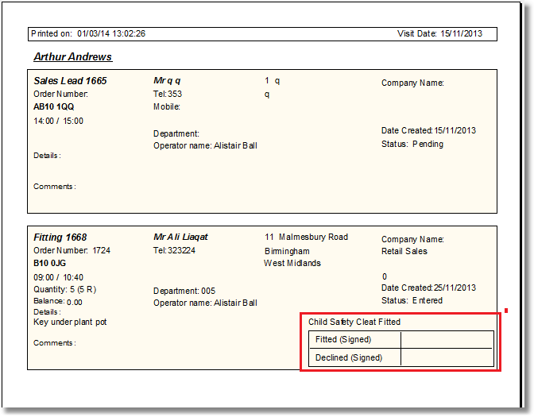

3602. Sales Lead Fitters – Individual : Sales Lead Individual Extra

This has been replaced by the child safety text from Company Details > Fitters Sheet / Sales Lead Text tab.

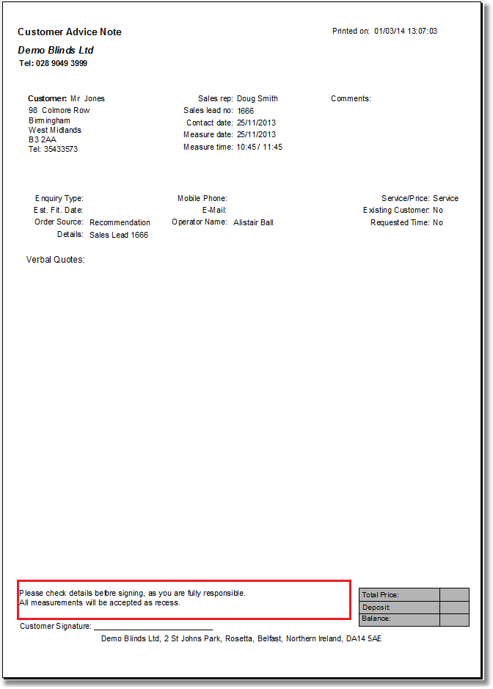

3603. Fitter Report > Fitter Sheet 15

The child safety text from Company Details > Fitters Sheet / Sales Lead Text tab now prints here, instead of the hardcoded text. There is also more room for this so ‘Start Time’ and the rest of that line and ‘Fitters Comments’ have all been moved up 20mm.

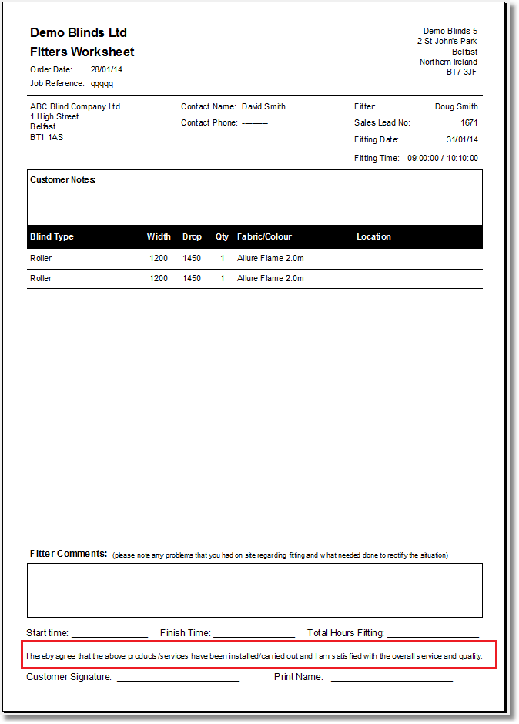

3604. Production Documentation > Works Order – Bespoke 46

If ‘Required Date’ is selected, the works orders now print off in Required Date order then Order Number order.

3609. Process Scanning

We have made two changes to process scanning recently, devs 3523 and 3561. These deal with process scans for options (3523) and process scanning in sequence order (3561). We can now handle process scans in order properly if you also have a process scan for an option. For example, in roller blind if a shaped finish is selected then it might have a process scan, but this process scan is not in the sequence, set up in Blind Types > Man Process Types.

The following setup is required. There is a new flag in Blind Types > Man Process Types called ‘Option Choice’.

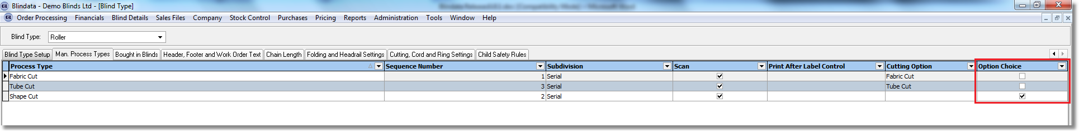

If an option is to be scanned, then in Stock Items the following field needs to be set up. It will also be necessary to untick ‘Non Stock’ in the General tab of the stock record.

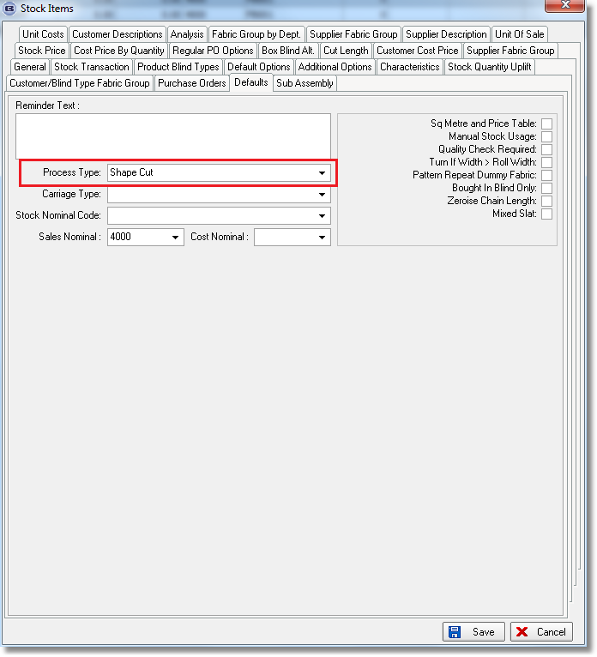

Once this setup has been done, it will be possible to scan the relevant option.

