Blindata Release Note 6.7.8 

14 February 2014

Bug Fixes and Enhancements

4531. Order Processing > Orders

There was a bug in the child safety functionality if an install height was entered and then a chain length was amended manually. Fixed.

4532. Order Processing > Order Enquiry

The column choices are now displayed in alphabetical order.

4533. Order Processing > Order Enquiry > Processes

If a different fabric is chosen, then when the process is completed for ‘Fabric Cut’, the ‘On Sales Order’ figure for the original fabric was reduced correctly. But the ‘On Sales Order’ figure in the ‘Batches’ tab should also be reduced. This is now being done.

4534. Picking List 37

If the ‘Works Order – Bespoke 37’ is set to print, if the order has only components in it, a message appears multiple times, the report did not print and the status did not change. Fixed.

4535. Order Enquiry > Processes

The employee lookup in the bottom left now only shows employees where ‘Is Production’ = true.

4536. Administration > Import From Excel > Child Safety Rules

An error message appears when you were trying to import a spreadsheet. This was a temporary bug only found in v6.7.7.

New Work and Customer Requests

3559. Blind Details > Blind Types > Works Order

It is now possible to hold a works order layout against the blind type record.

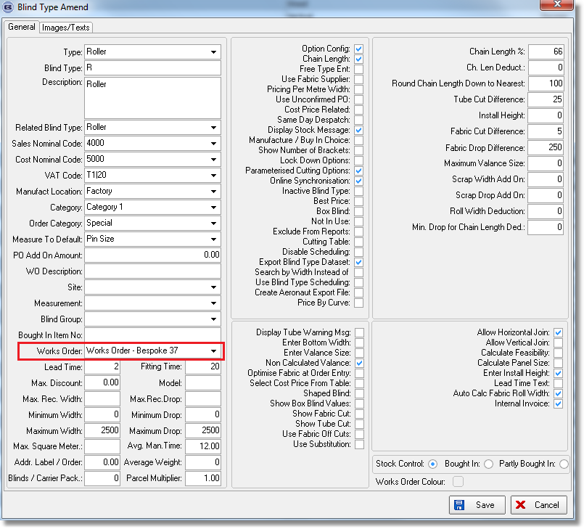

When a works order is printed from the ‘Order Amend Enquiry’ form, it now looks at the blind type record to see if there is a works order layout set up here. If so, this will be used. This means we could have multiple works order layouts printing for an order. If the field is blank in the blind type, then it work as it currently does ie it selects the works order layout from Parameters > Reports.

The ‘Production Documentation’ print remains unchanged.

3560. Quotation > Create Orders

There is now an advanced permission for this flag. It is called ‘Ignore Lines’ and defaults to false.

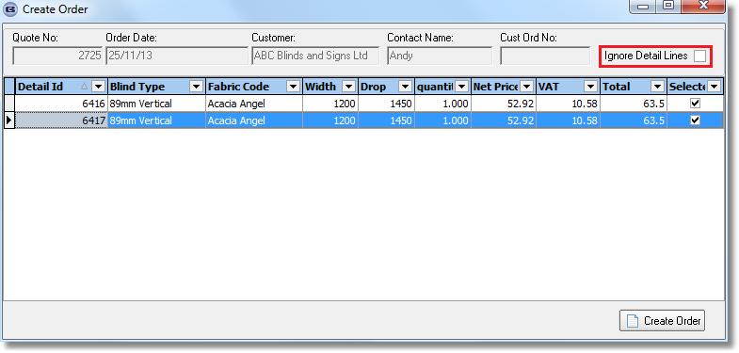

3561. Order Enquiry > Blind Process Scan

There is a new parameter call ‘Enable Scanning by Sequence’. If this is switched on, then processes must be scanned in their sequence order (set up in Blind Types > Man Process Types.

The sub division filed must also be set up in ‘Man Process Types’ if this new parameter is switched on. This was put in a long time ago because you could have a situation where the blind is made in two or more parts and processes are tied to this. For example, for a vertical blind the headrail can be made independently of the vanes. So we could have processes for the headrail cut in subdivision 1 and for the vanes in subdivision 2. So we could have

Process Type Sequence Subdivision Scan
Headrail cut 1 1 Yes
Trucks 2 1 Yes
Cording 3 1 Yes
Vanes Cut 1 2 Yes
Sewing 2 2 Yes

So if ‘Headrail Cut’ was scanned first, this would be ok. But if ‘Sewing’ was then scanned this would not be ok because an earlier scan in the same subdivision had not yet been done.

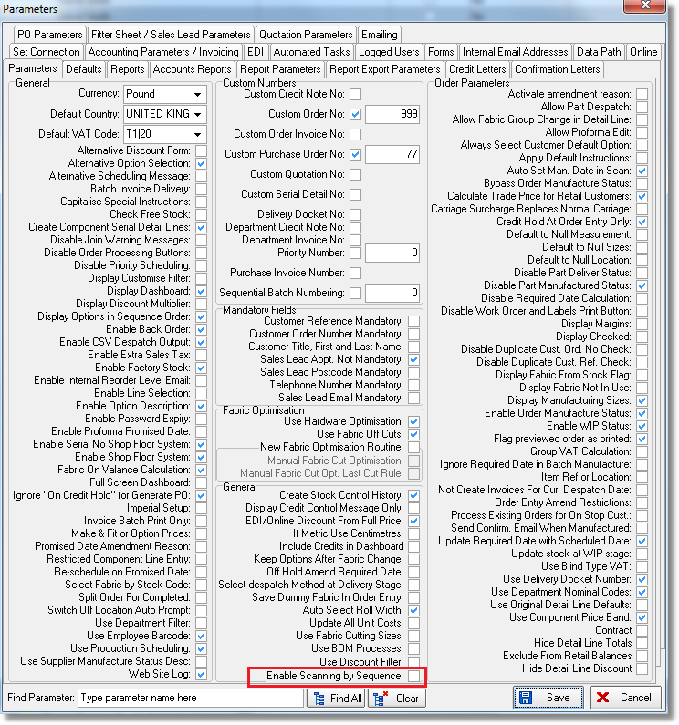

3563. Order Processing > Order Enquiry

There is now a column choice for ‘Account Code’ (from customer record).

3571. Label Print – Bespoke 33A

The number of brackets now prints in red

On bottom right small label (address label) we now print order no, 1 of n, number of louvres, fabric description (latter two on second line).

Cust ord no now prints on the top two labels (verticals only, to left of 1 of n)

3572. Administration > Maintenance

There is now a maintenance routine to change all the price codes in the Stock Items > Unit Of Sale from one price code to another. This option is called ‘Update Unit Of Sale Price Tables’. There is then be a choice to select the price code to change and the new one.

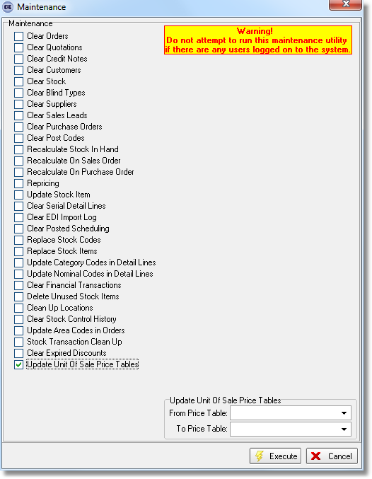

This is required because companies will create price codes called ‘Trade 2013’, ‘Trade 2014’ and want to change them all at once.

3573. Stock Control > Stock Items

There is a new advanced permission flag in ‘Stock Items’ called ‘Stock In Hand’. This restricts users from changing the stock in hand figure in the stock record.

3574. Stock Control > Reports > Fabric From Stock Report

There is now a choice to enter start and end date. The report now only shows fabrics.

3575. Alternative Generate PO

It is now possible to generate a regular PO for those sales orders where ‘Fabric From Stock’ = false. To do this, a new parameter called ‘Generate PO For Fabric Only’ needs to be switched on. If this is switched on, then the ‘Generate’ button in the regular PO form will only generate PO detail lines for orders where ‘Fabric From Stock’ = false.

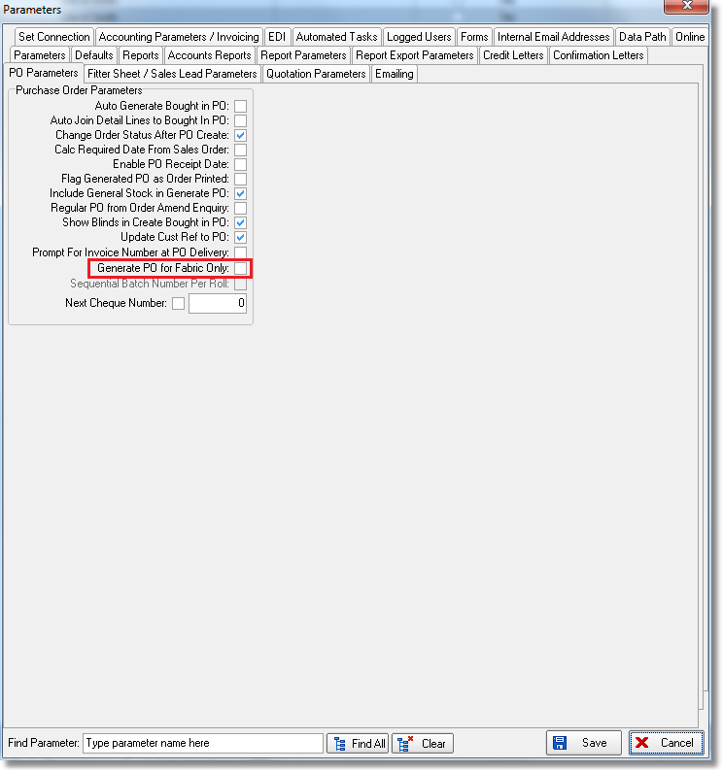

3578. Administration > Maintenance

There is a maintenance option to update the ‘Unit Price’ field in all Stock Items > Unit of Sale records – this is useful if the quantity is changed in the ‘Unit Of Sale’ system table record.

3579. Import From Excel > Customer Delivery Addresses

There is now a column in the import file for importing VAT / Sales Tax code.

3581. Quotation – Bespoke 37

The header for this quotation has been changed.

If ‘Hide Detail Line Totals’ is switched on, the detail line amounts do not show.

If ‘Print Quotation Total’ is switched off, the the total does not print (also the net and sales tax totals do not print either).

3582. Invoice – Bespoke 37

- The page number has been moved to the bottom of the page and replaced by ‘Payment Method’.
- The city and state are now on the same line and the postcode moved up a line.
- The contact name has been moved down to below ‘Purchasing Contact’.
- The box of fields in the header has been centred horizontally on the page.

There is now a different format for the distribution orders. Colour, Width and Drop columns have been replaced by Description and Unit of Sale columns.

3583. Acknowledgement – Bespoke 37

The new logo contains tel and fax number and website, so these fields have been removed from the header and the logo takes up the available space.

3584. Delivery Docket – Bespoke 37

The ‘Boxes’ column has been removed (appeared for component lines).

3585. Administration > Import From Excel > Suppliers

There are two new import columns in the supplier spreadsheet – ‘Nominal Code’ and ‘Bank Nominal Code’.

3586. Administration > Import From Excel > Customer Update

There is now a column to import ‘Web Site’.

3587. Stock Items > Characteristics tab

There are two new fields called ‘Antimicrobial Desc’ and ‘Fire Resistant Desc’. It is also possible to import these fields in Import From Excel > Stock Update. It is now possible to import ‘Turn If Width > Roll Width’ in ‘Stock Update as well.

