Blindata Release Note 6.7.7 

7 February 2014

Bug Fixes and Enhancements

4530. Feasibility

Fabric deductions were incorrect for orders requiring fascia bracket covers. There was a bug in the Feasibility Check Algorithm > Fabric and Tube Calculation (variable D) > D Calculation 18. Fixed.

New Work and Customer Requests

3538. Order Processing > Order Enquiry

There is a new button on the ‘Order Enquiry’ form called ‘Motor Label’.

The label size is 4” x 2” (same size as ‘Despatch Label 4 x 2’) and prints out:

Customer Name Order No.:
Customer Serial No.:
Address 1st Line Year of manufacture:
Town/City Blind Type:
Postcode Motor Option Item Description:
Country
CE Logo


3365. Measure To / Options

It is now possible to force certain default options dependent on ‘Measure To’ entered.

The ‘Measure To’ field is now held in the top section of the Blind Details > Link Options form. If this is left blank, then it will behave as it currently does. If it has a ‘Measure To’, then the link options will apply if that ‘Measure To’ has been selected in the order detail line.

3552. Order Processing > Orders

There is now a check to see if the number of panels entered in an order detail line is > the minimum number of panels. This involves checking the ‘Single Bunch Panel Blinds’ or ‘Split Bunch Panel Blinds’ tables to see if the number of panels entered is >= the lowest number of panels in these tables (depending on bunch selected).

If not, a message appears saying ‘The minimum number of panels is n’, where n is the lowest number of panels.

This has also been done for the online version see dev W211).

3554. Pricing > Discounts

Some improvements have been made to speed up the opening of the Discounts form.

As there are possibly expired discounts in the table we have added three radio buttons at the bottom of the Discount form called ‘Show All’, ‘Show Actual’, ‘Show Expired’. ‘Show Actual’ will be ticked by default therefore only discounts with ‘End Date >= Current Date’ will be displayed by default.

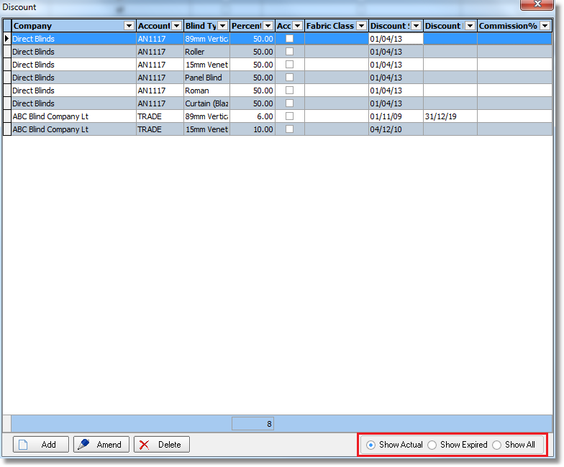
There is a new parameter called ‘Use Discount Filter’. It is false by default and in this case all discounts will be shown.

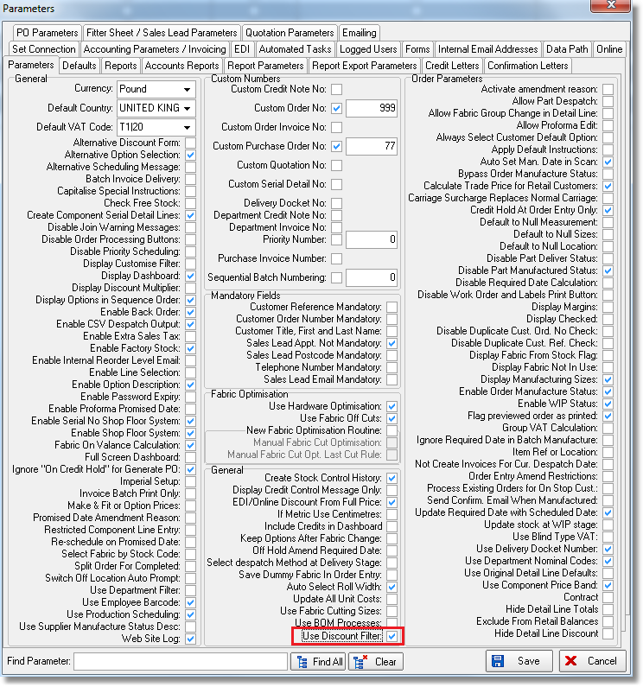
If ‘Use Discount Filter’ = FALSE then discount form will behave as it does right now. If this parameter is TRUE then a new form is displayed called ‘Discount Filter’ after clicking “Amend” on the ‘Discount Management’ form. This form contains drop-down lists which are relevant for the selected Discount Type (for example for ‘Customer Blind Type’ discount this is Customer and Blind Type) with an ‘All’ choice which will be default. Also there will be three buttons at the bottom: ‘Save’, ‘OK’, ‘Cancel’. Here the user will be able to select the required value from a drop-down list (or select ‘All’). If the user clicks ‘Save’ then entered filter data will be stored against Discount Type selected and after that the Discount form with the applied filter will be displayed. If the user clicks ‘OK’ then the selected filter will be just applied without saving. ‘Cancel’ will just close Discount Filter form without showing Discounts.
There is now a ‘Clear Expired Discount’ choice in Administration -> Maintenance.

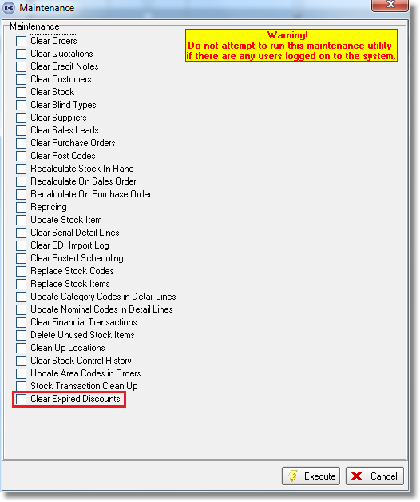

3564. Contract Measurement Sheet

There is a new choice of report for the ‘Sales Lead / Fitter Sheet – Individual’ report choice called ‘Contract Measurement Sheet’. This is ‘Company Name’ in Company Details.

3565. Import From Excel > Customer Default Options

There is an extra column in the spreadsheet import for ‘Fabrics’, which holds the fabric (stock) code.

3566. Import From Excel > Stock Update

It is now possible to import the ‘Manufacturing Time’ field.

3567. Works Order – Label Blind Size 2

A new works order report has been created called ‘Works Order – Label Blind Size 2’. This is the same idea as ‘Works Order – Label Blind Size’, except that there are only two sets of labels per page. But each set of labels contain 6 labels – 4 that are 20mm deep (instead of 2).

This has the same rules as ‘Works Order – Label Blind Size’ except that only two sets of labels will print per A4 page. The extra small labels will contain the same information as the existing top two do.

3568. Label – Bespoke 29

In the red rectangle ‘Made by [Company Name]’ is printed, where [Company Name] is the company name in Administration > Company Details.

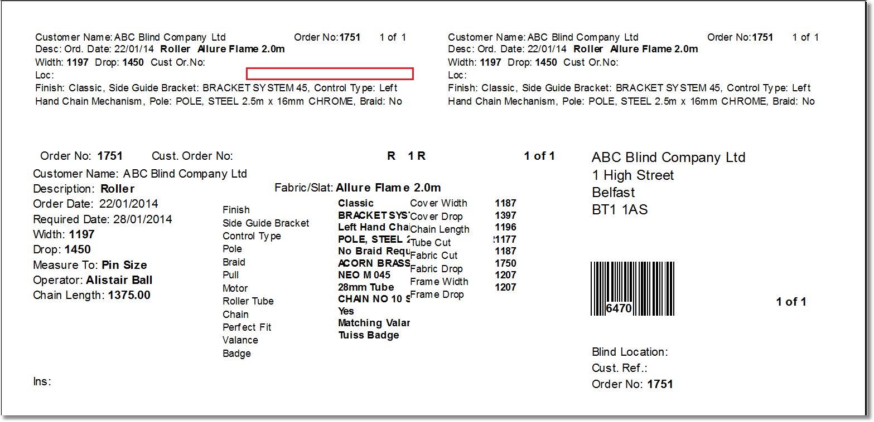

3576. Works Order – Bespoke 37

- he following changes have been made to the layout:
Current:
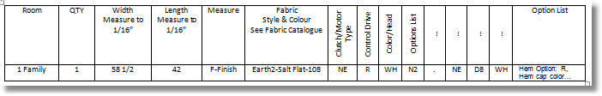
New:
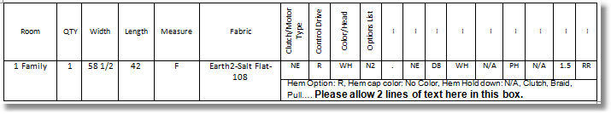

3577. Order Processing > Orders

There is an advanced permission flag called ‘Allow Bought In Split Order’. If this is true, then orders with bought in detail lines can be split. A customer wants to split bought in split orders but only allow non bought in blinds to be selected. Therefore there is a new advanced permission flag called ‘Allow Only Non Bought In Split’. If this is true (and ‘Allow Bought In Split’ = true), then only non bought in detail lines can be selected to be split.

W211. Order Entry > Panel Blinds

Online ordering now checks to see if the number of panels entered in an order detail line is > the minimum number of panels. This is done by checking the ‘Single Bunch Panel Blinds’ or ‘Split Bunch Panel Blinds’ tables to see if the number of panels entered is >= the lowest number of panels in these tables (depending on bunch selected).

If not, a message appears saying ‘The minimum number of panels is n’, where n is the lowest number of panels.

This has also been done for the desktop version (see dev 3552).

