Blindata Release Note 6.7.6 

31 January 2014

Bug Fixes and Enhancements

4522. Administration > Parameters > Internal Email Addresses

The SMTP email address label has been tidied up.

4523. Purchase Order Enquiry > Generate PO

A problem was occurring if the ‘Generate’ button was used to generate purchase order detail lines. If a purchase order was saved, then you went back into the purchase order and deleted one of the lines, it removed the PO transaction in the stock item but left a PO stock transaction.

4524. System Tables > Unit Of Sale

If you tried to delete a ‘Unit Of Sale’ record, you got the following message. Also, if there are records with this ‘Unit Of Sale’ in the aOrderDetail record, a similar error occured. Fixed.

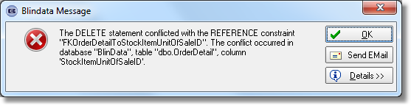
4525. Works Order – Bespoke 22

If there are multiple records set up for ‘WO Control’, then there are now multiple pages printed out ie if there was one order detail line and two records in ‘WO control’, then two pages should print out. Temporary bug fixed.

4526. Order Processing > Orders > Work In Progress

Items were being taken out of stock in hand when WIP is done instead of reducing the factory stock in hand, if factory stock is enabled. This was happening with certain bill of material records. Fixed.

4527. Sales Analysis by Customer by Month

If a number of months are selected, it was not putting the customers in alphabetical order. Fixed.

New Work and Customer Requests

3541. Order Processing > Different Fabric Widths

At the moment we have functionality where a dummy fabric can be entered and an actual fabric is then selected (after looking up the ‘Fabric Roll Widths’ table). We have a parameter called ‘Save Dummy Fabric In Order Entry’ that determines whether the dummy fabric should be kept in the order detail line or not.

We have now introduced functionality to select the correct roll width to use. Previously the only way to do this was to enter an order for a fabric with multiple roll widths, select a fabric with the first roll width, check the cost price (and write it down manually), then use ‘Global’ to change the fabric to the next size roll width and do the same again. After all the fabrics with different roll widths have been tried, the most cost effective one is then selected.

There is a new flag on the order entry form called ‘Auto Select Roll Width’. This will be enabled if the parameter ‘Auto Select Roll width’ (in Administration > Parameters) is switched on and a relevant fabric has been selected in one of the order detail lines.

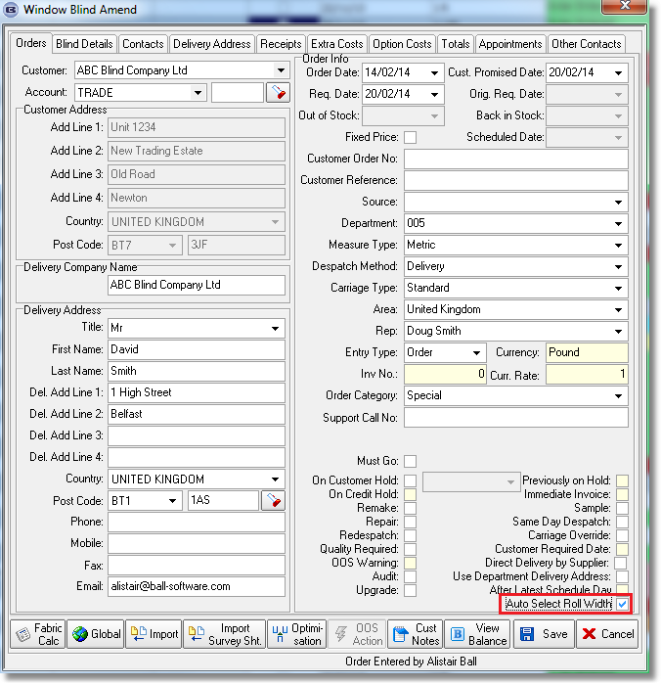

We did not make this an automatic routine, because it would have significantly increased processing time, as it would have run this routine every time an order was saved.

First of it, it checks to see if the fabric selected is available in multiple roll widths ie is it in the ‘Fabric Roll Width’ table?

If there are 3 fabrics with the same colour but different fabrics, it runs a routine to check which is the most efficient to use. This will involve replacing the fabric in the detail lines, optimising on the fabric and then holding the cost price total as a variable. This will be done for each fabric and then the fabric that has the lowest total cost price should be selected.

There are a couple of other things we need to take into consideration here.

If the user is going to select a dummy fabric in the order detail entry, the user should not have the choice of selecting the specific size fabric. This means the

For example, if we have dummy fabric ‘Fabric AAA’, and it is related to ‘Fabric AAA1’, ‘Fabric AAA”’ and ‘Fabric AAA3’, then only ‘Fabric AAA’ should be visible in the order detail entry. We therefore need a flag to identify the related fabrics so they are not shown in the drop down.

In the documentation that goes to the customer – order acknowledgement, delivery docket and invoice, this should show the dummy fabric description, not the specific fabric one.

This needs further discussion.

Here is the new parameter in Administration > Parameters called ‘Auto Select Roll Width’.

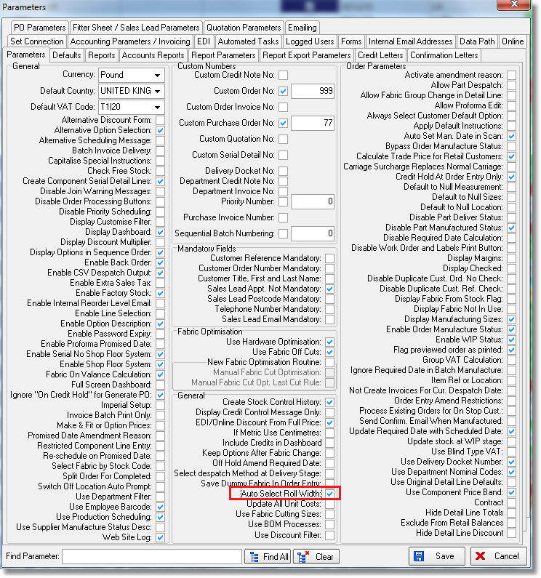
We suppose it does not make sense to check ‘Save Dummy Fabric In Order Entry’ and ‘Auto Select Roll Width’ flags at the same time as these flags are contradictory.

The following logic will now apply.

- If ‘Save Dummy Fabric In Order Entry’ = True then we will show all allowed fabrics for this Blind Type in ‘Fabric’ drop-down list (including fabrics related to dummy one) and will always leave selected fabric in Order Detail line even if it is Dummy.
- If ‘Save Dummy Fabric In Order Entry’ = False and ‘Auto Select Roll Width by Cost Price’ = False then we will show all allowed fabrics for this Blind Type in ‘Fabric’ drop-down list (including fabrics related to dummy one). In this case we will use the existing logic when the user is able to select the desired Roll Width manually (‘Auto Calc Fabric Roll Width’ = True in Blind Type record) or the system selects fabric with Max Roll Width.
- If ‘Save Dummy Fabric In Order Entry’ = False and ‘Auto Select Roll Width’ = True then we will show all allowed Dummy fabrics for this Blind Type in ‘Fabric’ drop-down list (excluding fabrics related to the dummy one). After ‘Save’ we will get a list of all related fabrics, calculate Order Total Cost Price by replacing Dummy fabric in all Order Detail lines with each related one and then leave Fabric with Min Total Order Cost Price in all Order Detail lines where the Dummy fabric was selected.
We hold real Fabric ID in Order Detail -> fabric_id field and also store Dummy Fabric ID in Order Detail -> DummyFabricID field so we will know which fabric was originally selected in Order Detail entry. In other words in this case we always able to find out both Dummy and Related fabric.

3544. Order Enquiry > Blind Process Scan

If the ‘Sequence Number’ in Blind Types > Man Process Types > 0, then the ‘Blind Made’ scan cannot be done until all processes with ‘Sequence Number’ > 0 are scanned. If these processes have not been scanned, then a message appears saying ‘The following processes have not been scanned: (list of processes).

3550. Purchases > Suppliers

In North America ‘Suppliers’ are called ‘Vendors’. Therefore if the default postcode/Zip code is set to USA or Canada, the word ‘Suppliers’ is replaced by ‘Vendors’ in the menu and in the supplier/vendor form.

3551. Purchase Order Enquiry > Update

There is now a ‘Select All’ button here which will flag all the lines as ‘Included’.

It is now possible to make this form full screen size.

There is now a context menu for this form, with column choices and configuration saving.

3553. EDI Import

Sometimes an EDI Import can take place where the fabric is not related to Blind Type. The order imports which is fine, however the order is no longer checked and scheduled automatically.

When this happens, a message is saved in the log file that says ‘Order nnnn has been imported with a fabric that does not relate to a blind type.

