Blindata Release Note 6.7.5 

24 January 2014

Bug Fixes and Enhancements

4510. Archive Enquiry > Remake/Repair/Redespatch

An error message occurred when doing a Remake/Repair/Redespatch for a retail order. This was because the system did not know how to calculate the required date. This has been fixed by setting the required date = current date.

4511. Order Processing > Orders > Component Detail Entry

If a component detail line was entered and the unit of sale was ‘Inch Of Yard’, which is set up as 0.0277 (but displays as 0.03 on the ‘Unit Of Sale’ system table), the price was calculating incorrectly. Fixed.

4512. Administration > Archiving

An error message occurred when archiving a month (‘There is a record with max Order/Credit/Quotation number in the works order data. You cannot move this month to archive). This was caused by a cancelled credit note. A quick solution was to enter a credit note with no detail lines in it.

4513. Works Order – Bespoke 22

There is now only one fabric total, which is the total grouped by fabric.

4514. Label Print – Bespoke 22

The fabric colour was being cut off – it has been extended to the option name.

4516. Purchase Order Enquiry > Generate PO

If you entered a regular PO, saved it, then amended it and removed a line, then if you pressed ‘Save’ in the bottom right, the ‘On PO Order’ figure in the stock record was updated properly. If you selected ‘Cancel’ instead of ‘Save’, it did not update the ‘On Purchase Order’ amount in the stock record. Fixed.

4519. Order Enquiry > Blind Process Scan

Orders with miscellaneous detail lines were not changed to manufactured after the process scans were completed if the system was setup to print the delivery docket immediately. Fixed.

4520. Invoice – Bespoke 28

- The discount amount was missing if the guarantee text printed – fixed.
- The total amounts are now in bold.

New Work and Customer Requests

3535. Emailing

It is now possible to do emailing by a mixture of Outlook and by SMTP Mail Server. Previously there was only the choice of one or another. There is now a new parameter for this called ‘Order Ack to be sent by Outlook’ in Parameters > Set Connection. All order acknowledgements that are manually emailed (ie by selecting the ‘Email Order Ack’ button in ‘Order Amend Enquiry’ can now go out via Outlook. All other emails will go out via smtp, if the smtp details are set up.

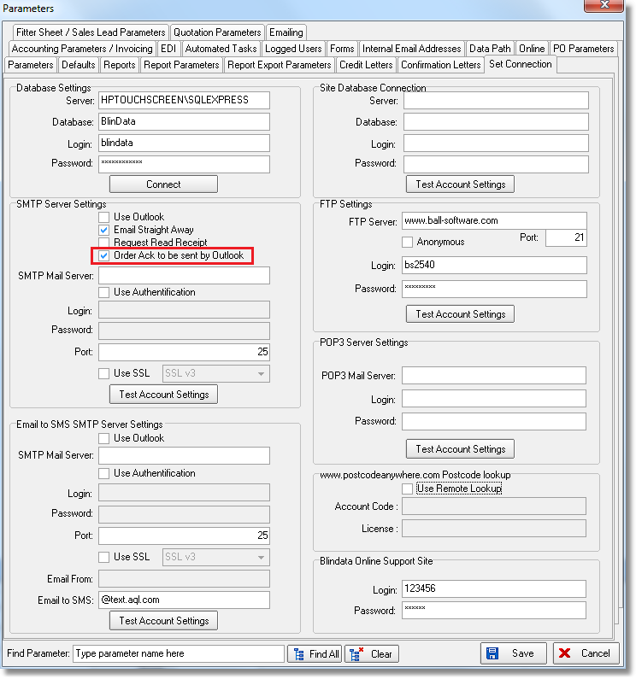

If an email is sent via smtp it can now also have a bcc email done as well. There is now a new email address field called SMTP bcc email address’ in Parameters > Internal Email Addresses.

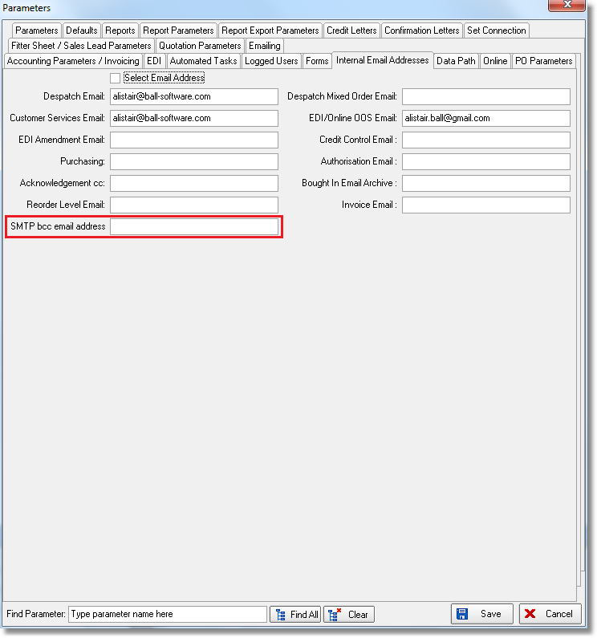

3542. Order Processing > Orders

It is now possible to have a popup warning for both desktop and online for patterned fabrics with a scallop.

When a detail line is saved, if the fabric has ‘Pattern Repeat’ > 0 and an option has ‘Fabric Related’ = true, a message appears saying ‘You have entered a patterned fabric with a matching scallop. Please be aware that the pattern between the blind and the scallop may not match’.

3543. Remake/Repair/Redespatch

There is a new flag on the customer record called ‘Ignore Del Days for Remake Etc’. If this is set to true, then when an order is entered or created using the Remake/Repair/Redespatch function, the delivery days in the customer record are ignored when calculating the required date.

3545. System Tables > Option Restrictions

There is now a ‘Copy to Clipboard’ choice on this form.

3546. Order Processing > Global Search

There is now a Remake/Repair/Redespatch option on this form, in the context menu (right click on form).

3547. EDI Import

If there are warning messages about min/max sizes, the orders get imported but are not flagged as checked.

A note is added to the order stating what the problem is eg ‘The width of the blind in detail line n is too wide for this blind type’.

3556. Use BOM Processes

There is a new parameter in the system called ‘Use BOM Processes’. If this is set to false, then the Order Enquiry > Processes form will work by looking at the processes that are held against the blind type. If it is true, then it will look at the processes that are held against the BOM records.

3557. Administration > Import From Excel > Stock Update

There is a new field to import here called ‘Cost Discount’. If this is imported, the ‘Cost Price Less Discount’ field is recalculated. Also it updates the unit record in the ‘Unit Cost’ tab of the stock record.

This functionality is already working in Import From Excel > Fabrics.

