Blindata Release Note 6.7.4 

17 January 2014

Bug Fixes and Enhancements

4495. EDI Enquiry > Receiving Data > Import Report

This was showing the message ‘The report is empty’. Fixed.

4496. Order Processing > Bought In Order Tracking

It was possible for a blank email to be sent customers after a change had been completed in the Bought In Order Tracking Form.

There is a routine on this form which sends an email to customers after the “Manufactured” button is clicked and ‘Due Date’ on the popup form is entered. In this case a confirmation message will appear and after that an email can be sent. The body for this email is taken from “Company Details > Bought In Order Update Text” field and this field should not be empty. We have added an additional condition in this routine to check that the ‘Company Details > Bought In Order Update Text’ field is filled? If this field is empty, then a message appears saying ‘There is no text in the ‘Bought In Order Update Text’ field in Company Details > Email Texts 2. Please fill this in’. The email will not be sent if this is empty.

4497. Global Search

On the Global Search screen when a user clicks ”View Details” and “History” the system showed “Works Order Printed” if the works order had been viewed from Global Search. This now says ‘Works Order Viewed From Global Search’.

4499. Quotation Prints

If a quotation has over 400 detail lines on it, the quotation print was timing out. The timeout period has been increased to 20 minutes. The report print will be speeded up if quotations and orders are archived regularly and also if logo sizes are kept as small as possible.

4502. Feasibility

After setting up cutting option type in Blind Type > Cutting Option > Type (shown below), a blind width much greater than the roll width can be accepted at order entry. Fixed.

4503. Order Enquiry > Processes

The ‘On Sales Order’ figure for the batch number in a fabric record is now reduced correctly when a fabric cut process is completed.

4506. Purchases > Generate Regular PO

If ‘Use Supplier Part No in XML File’ = true, then this is used when the wholesale XML file is created.

4508. Purchase Order Enquiry > Update

When a purchase invoice is posted to Blindata Accounts, it posts a financial transaction for each line included. It now only post one financial transaction which is the total and posts underlying related nominal transactions.

4509. Financials > Invoice Batch Print > Invoice – Bespoke 28

When this invoice is printed from ‘Invoice Batch Print’, it printed the totals twice. It now puts the £ amount in one column and the pence in the other column.

Also, if there is guarantee text to print, it now replaces the words ‘Less Discount’ instead of printing both of them.

New Work and Customer Requests

3516. Administration > Export Data > Blind Type Dataset

When a blind type dataset is exported, it now exports all the child safety data as well ie the records that are in Blind Types > Child Safety Rules

3517. Administration > Import From Excel > Blind Type Dataset

This has been changed so the child safety records are included in the import.

3523. Order Enquiry > Blind Made Scan

It is now possible to have a process scan by option. Let’s take the example of a roller blind. If it has a straight finish, then no extra work needs to be done, but if it has a shaped finish an extra piece of fabric may have to be cut. This takes time to do and we have customers that want to know who does this work.

Therefore we need to be able to have processes associated with certain option choices. We can do this already because we hold ‘Process Type’ against the stock record.

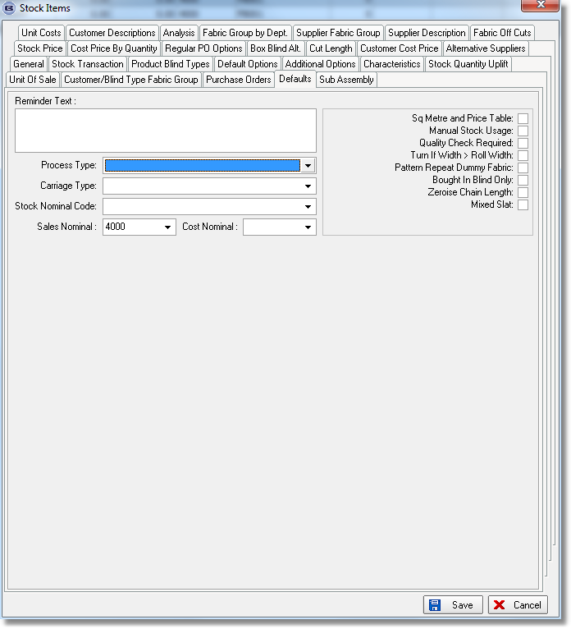

The problem at the moment is when we scan a process, it checks to see if the process is held against the blind type – if it isn’t then it gives the following message.

Therefore it now checks to see if there are any processes held against options as well.

3536. Quality Check By Blind

Previously the quality check functionality only worked at the order level and had to be done before an order was despatched.

There is now a new parameter called ‘Quality Check By Blind’. There is also a new field called ‘Quality Check Large Quantity’ which is an integer and defaults to 0.

There is also a new advanced permission called ‘Quality Check Scan’ in the Order Enquiry section of Advanced Permissions.

Order Enquiry

It is now possible to quality scan blinds if the number of blinds on the order <= ‘Quality Check Large Quantity’. If the quantity >= this number, then the existing quality control works.

If ‘Quality Check By Blind’ is switched on and the advanced permission ‘Quality Check Scan’ = true, then a button appears in Order Enquiry called ‘Quality Scan’.

It is only possible to quality scan a blind if it has a status of ‘Work In Progress’ (if ‘Enable WIP Status’ = true). If false, then it will only be possible to quality scan the blind if it has the status ‘Awaiting Manufacture’.

If ‘Quality Check By Blind’ = true and the quality scan has not been done, it is not possible to scan a blind as ‘Blind Made’.

3537. Works Order Label 1

Delivery Country now appears on works order.

3539. Despatch Label 4 x 2

- Moved Drop left.
- Moved ‘colour’ and ‘Cust Ref’ up a line.
- Expanded Location field so it goes right across the label. Previously it was cutting off long locations.

3540. Order Processing > Despatch

It is now possible to have a popup warning text specific to a blind type. There is a new field in the blind type record called ‘Despatch Warning Message’.

If an order which is being despatched contains any of the Blind Types which have text assigned then a popup now appears. (Multiple blind types can have different warnings, and these have been combined into one popup message.

This has been applied in both Order Amend Enquiry and Order Enquiry form ‘Despatch’ and ‘Despatch Scan’ buttons.

3548. Order Processing > Quotations

Previously, if you tried to change the customer in a quotation when the status is ‘Quotation Printed’, a message appeared saying ‘The customer cannot be changed while there are one or more detail lines attached to the order’. It is now possible to change the customer – as you can do at the ‘Quotation Entered’ status.

