Blindata Release Note 6.7.2 

6 January 2014

Bug Fixes and Enhancements

4457. Picking List 1

This report now only print one line per detail line if quantity > 1.

4460. Purchase Order Enquiry > Regular PO Amend

If you clicked on ‘Deliver All Selected’ before you select any lines, an incorrect message appeared. The message now says ‘No stock items have been selected’.

4461. Purchase Order Enquiry > Amend

If you selected ‘Cancel’ at the point where the batch numbers are being displayed, the purchase order still got delivered but the batch numbers were not stored. Fixed – the PO is now not delivered at all.

4463. Order Processing > Orders > Bill Of Materials

The quantity for square inche is now correct.. It is the fabric cut width x fabric cut drop (‘Use Fabric Cutting Sizes’ = true).

4464. Purchase Order Enquiry > Regular PO > Amend

There were too many batch numbers being generated if ‘Use Imperial’ = true and ‘Sequential Batch Number Per Roll’ = true. The number of batches is actually the number of rolls that are delivered so should be unit quantity / roll length

So if ‘Use Imperial’ = true, if the unit quantity is 40 and the measurement unit = Yards, and the roll length is 720 inches, then we know this is 2 rolls, because (40 * 36) / 720 = 2.

4468. Order Enquiry > Processes

If ‘Use Imperial’ = true, then the ‘Cut Length’ should be in inches. To resolve this there is a new column choice called ‘Cut Length(Inches)’.

4469. Order Enquiry > Processes

After columns have been changed and ‘Save Configuration’ selected, the changes are now saved. This was not working previously.

4470. Order Enquiry > Processes

Previously it was only possible to change multiple lines in Processes if the serial detail lines are tied to one order detail line. This now work for multiple order detail lines within the same order.

4471. Order Enquiry > Processes

The batch number and fabric were not matching in the selection at bottom of Processes. It is now only possible to select a batch number (which then update the fabric).

4472. Order Enquiry > Processes

It is now possible to manually change the total amount at the bottom of the Processes form. This was a bug – it now works if ‘Manual Stock Change’ is flagged as true – not false.

4473. Order Enquiry > Processes

When the quantity is entered for a batch it allowed the user to enter an amount that is greater than the amount held against the batch. It still allows this but a warning message appears saying ‘The amount entered is greater than the amount held against the batch number’.

4474. Purchase Order Enquiry > Update

When a purchase invoice is update (and ‘Blindata Accounting = true), the account field was filled incorrectly. Fixed.

New Work and Customer Requests

3441. Feasibility

Previously the feasibility compared the fabric roll width to the blind width and warned that railroading was required if the blind width is bigger than the roll width.
At the moment we compare the man width and man drop before deciding if the fabric should be turned or if it needs a join. In this example we have entered pin size, which deducts 3mm from the width. Because 2004 has been entered in the width, the width blind size is 2001, and the roll width is 2000, so this message appears correctly.

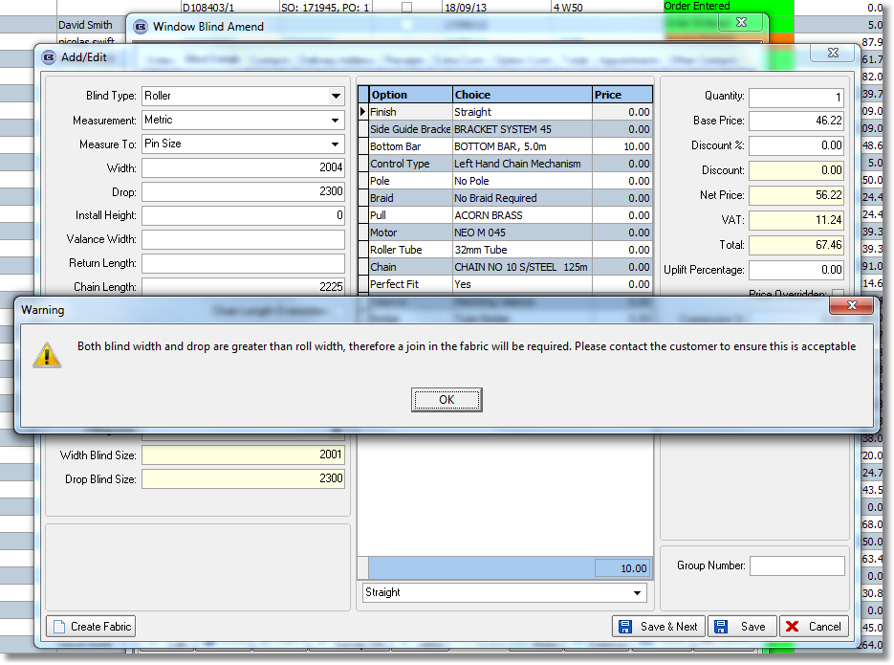

But this is not the actual size of the piece of fabric that is cut – it is dependent on the cutting size for the width and drop. Therefore we should be looking at the cutting sizes to determine what happns.

This applies to the feasibility calculation and to the normal calculation. There is a new parameter called ‘Use Fabric Cutting Sizes’. If this is set to false, then the previous existing logic will work. If true, then we now look at the cutting size calculation rather than the width blind size and drop blind size.

If it is true a new tab will appear on the ‘Fabric Amend’ form called ‘Cutting Options’. There are two columns only – one is a cutting option choice and the second one is type. The type can be chosen from three values only (Fabric Width Cut, Fabric Drop Cut and Calculator). If ‘Fabric Width Cut’ or ‘Fabric Drop’ cut is chosen for a cutting option, it means the cutting option will be used as the actual fabric size in different functionalities. If ‘Calculator’ is selected, the cutting option value (dividing by 1000) will be used as the BOM quantity for this stock item. We also need to take into account Imperial. It will not be divided by 1000 if in inches.

We added a ‘Cutting Options’ tab to the stock record. In actual fact we will have to set up the identical records for all roller fabrics, so it would make more sense if this was also held against the blind type record.
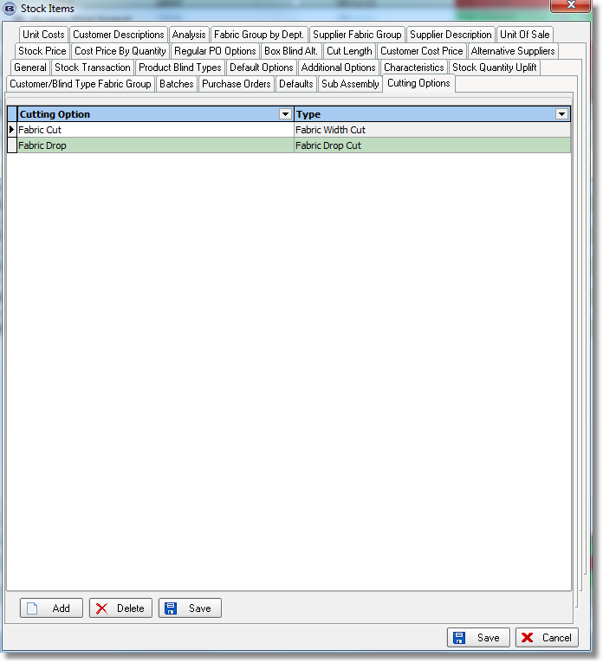

There is a new ‘Type’ field in Blind Types > Cutting Options.

First of all we will try to calculate Cutting Sizes using Stock Item > Cutting Option tab. If no record is found on this tab then it will try to calculate them using Blind Type > Cutting Option > Type.

3472. Administration > Company Details > Logos

There are another 3 fields (Logo 11, Logo 12, Logo 13) for logos. Fields ‘Logo 10’ and ‘Logo 11’ are for proformas (headers and footers respectively).

The new proforma report uses ‘Quotation – Bespoke 20’ but will take the logos from these fields.

3473. Administration > Parameters > Reply Email Address

There is now an ‘Invoice Email Reply To’ email address for Proforma Invoices and Invoices in the ‘Internal Email Addresses’ tab. This is called ‘Invoice Email. If this is filled, then it will be used as the email address the invoices and proformas were emailed from.

3499. Order Enquiry > Processes

Some amendments have been made for the way stock is deducted if ‘Batch Numbering’ is switched on for a fabric. This also relates to fabrics which have multiple roll widths.

When the order is entered, the fabric selected will default to the largest roll width after the dummy fabric has been chosen. However a different roll width may be used to make the blinds.

It is now possible to select the fabric cut processes and then be able to enter the batch number (from a lookup) and the inches used, like this.

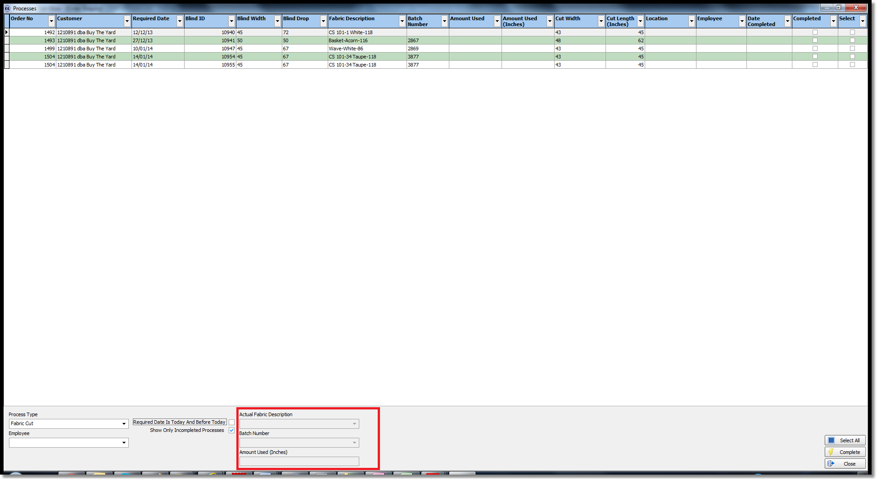
The batch number lookup display all the batch numbers that relate to the dummy fabric.

So let’s say we have the following fabrics, and the order detail line has AAA3 in it.

Fabric AAA, description = ‘Fabric AAA’, dummy = true
Fabric AAA1, description = ‘Fabric AAA’ 70” ‘, dummy = false, roll width = 72
Fabric AAA2, description = ‘Fabric AAA’ 96” ‘, dummy = false, roll width = 96
Fabric AAA3, description = ‘Fabric AAA’ 120” ‘, dummy = false, roll width = 120

The following batch numbers are held:

AAA1: batch numbers 1234, 1345, 1456
AAA2: batch numbers 1245, 1567, 1568
AAA3: batch numbers 1666, 1667

So when the batch number lookup is done in ‘Processes’, it will show:

1234
1245
1345
1456
1567
1568
1666
1667

Let’s say batch number 1567 is selected and the amount entered. The following then happens.

The ‘On Sales Order’ amount for AAA3 will be reduced and the relevant stock transaction will be deleted. The BOM record for AAA3 will be removed and replaced by AAA2. The ‘On Sales Order’ figure for AAA2 will be unchanged, but the stock amount in the stock item batch number will be reduced and the stock in hand figure also reduced. A stock transaction record will also be added.

This will have to be done for each record that has been selected.

In the ‘Processes’ form, the amount used will be stored against the first process record and zero will be held against the other records selected.

3500. Fabrics With Multiple Roll Widths

As we get more customers in North America, it is becoming obvious the fabrics with different roll widths is a big issue that we need to resolve properly. At the moment there is functionality to create a dummy fabric record and then relate other records to it in System Tables < Fabric Roll Widths.

So we could have the following fabric records set up:
Fabric AAA, description = ‘Fabric AAA’, dummy = true
Fabric AAA1, description = ‘Fabric AAA’ 70” ‘, dummy = false, roll width = 72
Fabric AAA2, description = ‘Fabric AAA’ 96” ‘, dummy = false, roll width = 96
Fabric AAA3, description = ‘Fabric AAA’ 120” ‘, dummy = false, roll width = 120

In ‘Fabric Roll Widths’, the records are held like this:

Dummy Stock Code Roll Width Real Stock Code
AAA 70 AAA1
AAA 96 AAA2
AAA 120 AAA3

When an order detail line is entered, if the user has chosen a dummy fabric, it will be replaced with a related fabric, defaulting to the biggest roll width (fabric AAA3). This is ok, but it has the disadvantage of displaying a different fabric description, which the customer should not really see. (The customer is not interested in the roll width, just the fabric type and colour).

There is an argument that when the order detail line is entered, it stores the dummy fabric code (and does not do the replacement). This is because the user does not know which fabric roll width is actually going to be used). This will be decided either at the ‘Processes’ stage or when the blind is being made.

There is another argument that we do not need to store a dummy fabric, but just select one of the fabrics as the ‘parent’ and the other ones as ‘related’. So in this case we would have these 3 fabrics like this.

Fabric AAA1, description = ‘Fabric AAA’ 70” ‘, dummy = false, roll width = 72
Fabric AAA2, description = ‘Fabric AAA’ 96” ‘, dummy = false, roll width = 96
Fabric AAA3, description = ‘Fabric AAA’ 120” ‘, dummy = false, roll width = 120

In ‘Fabric Roll Widths’, the records are held like this:

Parent Stock Code Roll Width Related Stock Code
AAA3 70 AAA1
AAA3 96 AAA2

So we now have a new parameter called ‘Save Dummy Fabric In Order Entry’. If this is set to true, then the dummy fabric is not replaced by the related fabric record.

3501. Stock Items > Stock Value

There is a new field in the stock record, which is just a calculated field. It is called ‘Stock Value’ and is equal to the ‘stock in hand’ x ‘unit cost price(base)’. It is also a column choice.

To make room for this field in the ‘General’ tab, all the nominal code fields have been moved to the ‘Defaults’ tab.

3502. Order Enquiry > Processes

The Processes form default size has been made full screen size so that all column names are clearly legible.

Extra columns have been included and some column names have changed. The ‘Cut Width’ and ‘Cut Length’ are both now in inches if ‘Use Imperial’ = true.

Order Detail No → changed to Blind ID
Cutting Width → changed to Cut Width
Fabric Length → changed to Cut Length

When a line is selected, the ‘Cut Width’ field will be filled automatically with the cutting size.

It is possible to hold the same process type against multiple stock items and these are now displayed in the Processes for if a relevant process is selected.

3503. Order Processing > Orders > Bill Of Materials

We now record the area of fabric required for each blind. If ‘Use Imperial’ = false, then the area is recorded in square metres. If ‘Use Imperial’ = true, the area is recorded in square inches. This figure is held against the fabric BOM record.

The fabric dimensions are taken from the fabric width cut x fabric width drop if ‘Use Fabric Cutting Sizes’ = true, otherwise it is man width x man drop.

If ‘Use Stock Nominal’ = true, we also record the fabric cost of goods sold against the fabric BOM record. This is calculated as:

Quantity Sq Inches x ((100+Scrap Allowance %)/100) x Cost per Square inch.

3504. Order Enquiry > Blind Made / Order Made

If ‘Use Stock Nominal’ is set to true, when the blind is made, the following financial transaction is posted. The figures are taken from the BOM for the blind.

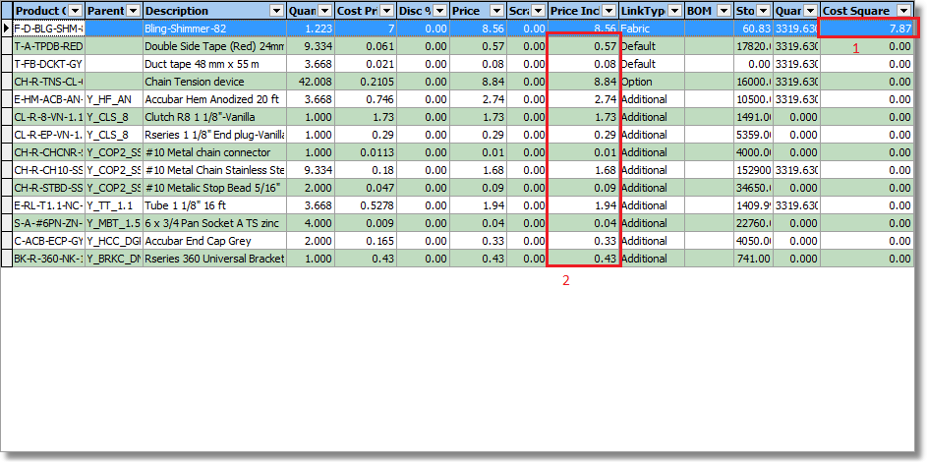

DEBIT: Cost Of Goods Sold – this updates the cost nominal in the Blind Type record with a financial amount that is the theoretical area cost of the fabric (1) plus the cost of the other BOM items (2).

CREDIT: the stock nominal code in the stock item for each item listed on the BOM excluding Fabric, (1). If there are multiple stock nominal codes, they should be grouped by stock nominal

CREDIT: the stock nominal code in the stock item should be updated with the financial value of the theoretical area cost of the fabric (1).

The theory of this is described here.

http://www.accountingunplugged.com/2008/09/07/cost-of-goods-sold-work-in-progress-and-inventory/

3505. Value Of Raw Materials Inventory Report

There is a new report that provides the sum of the fabric inventory values by Fabric stock nominal account.
The figure in red is calculated as Value – Stock Nominal Account Total (see description of this in 3506).

The report will only show records where Link Option = fabric, but will not show dummy fabrics.

The user should have to enter a start and end date as criteria. This will determine which stock nominal transactions are looked at.

This report is in Inventory > Reports.

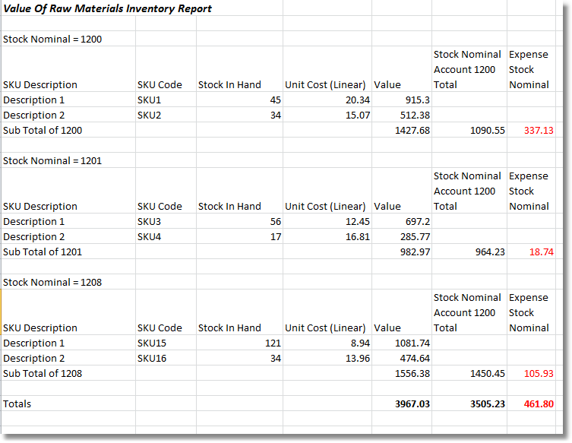

The Unit Cost (Linear) is the unit cost price (base) from the stock record. The stock nominal is the balance figure in the stock nominal account code. The stock nominal code transactions have been updated in the following way.

So this is: the stock nominal transactions entered when the purchase invoice is posted less the stock nominal transactions posted when the blind is made (theoretical BOM value) less the component detail line stock nominal transaction when the blind is made.

3507. Invoice – Bespoke 10

The invoice text from Company Details > Invoice Text is now printed on this report.

3508. Blind Types > Link Options

There is now a square metre / square foot field in here as a new condition. If ‘Use Imperial’ = false, then the figure will be square metres, if ‘Use Imperial’ = true, then the figure will be square feet. The column heading is called ‘<= Area’. If this is filled with a figure > 0, then it will be used, if 0 then the existing conditions will work the same way. The area is the man width x man drop.

3509. Order Processing > Orders > Supplier Comparison

There is a new parameter called ‘Show Supplier Comparison’, which defaults to false.

Previously if ‘Manufacture/Buy In Choice’ was switched on, it showed ‘Supplier’ in the left hand bottom of the form (which is fine) and also in the middle part. The middle part (in the red rectangle) no longer appears unless ‘Show Supplier Comparison’ = true.

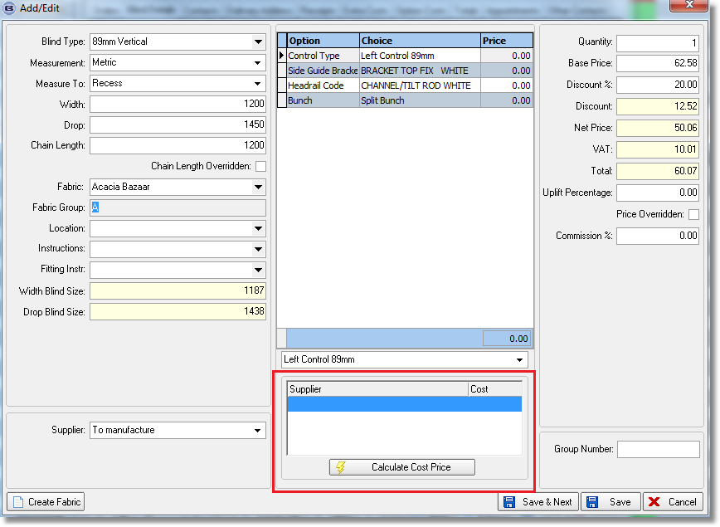

3511. Lakeview Accounting

There is one customer company that uses Lakeview Accounting and they are going to switch to using Blindata Accounting. Their financial year end is 30 April, and they want to do a parallel run until then, so this means we need to update both systems for four months.

Therefore if Parameters > Accounts System is set to ‘Lakeview’, it is now also possible to switch on ‘Blindata’ as well. If both are switched on, then both accounts systems will get updated for everything.

3512. Panel Track Calculation

There is a new button on the Formula form called ‘Panel Width’. This means that cutting sizes and BOM quantities can be calculated based on panel widths.

3513. Aeronaut File

The correct width and drop for a panel blind to Aeronaut. There is a record sent per piece of fabric ie if there are 3 panels, then it should create 3 records.

3514. Blind Types > Panel Blind

In the ‘Blind Type Amend’ window, the “Auto Calc Fabric Roll Width” option has been added for panel blinds (previously existed for rollers only)

3515. Order Processing > Orders > Component Detail Line

The component detail line entry works properly if ‘Use Imperial’ = true. This is straightforward if the ‘Unit Of Sale’ entered is the unit. Previously there were two problems with this.

- The unit cost price was not being held properly in the component detail line if the quantity entered > 1.
- The bill of materials was not calculating the correct quantity. It should always calculate the quantity as quantity entered.

It now works properly for component detail lines where the ‘Unit Of Sale’ is not the unit. Let’s take the example of a unit of sale called ‘Roll of 20 Yards’. The ‘Measurement Unit’ for this stock item is ‘Yards’ so if a quantity of 10 is entered, the unit quantity will be 200. The BOM for this component detail line will be 200.

The bill of materials for a component detail line will always be calculated as the unit quantity in the detail line, and will never need to look at the ‘Calculator’ field in the stock record.

