Blindata Release Note 6.7.3 

14 January 2014

Bug Fixes and Enhancements

4477. Stock Control > Stock Transaction Entry

When an issue transaction is entered for a batch fabric, when the batch number is entered, it now updates the stock in hand figure correctly.

4478. Administration > Import From Excel > Audit Transactions

If PI transactions were imported, the debits and credits were the wrong way round. Fixed.

4479. Company > Nominal Ledger > Journals

This did not save properly if a large number of records were entered for the journal. It started to display 0.00C or 0.00D in the balance. Also it now shows a running total for debits and credits at the bottom of the form.

4483. Order Processing > Orders

If ‘Chain Length’ record is set up in tab in Blind Types and an imperial detail line is entered, it did not convert the chain length to inches. Fixed.

4484. Stock Control > Reports > Stock Usage Report

This report did not produce any data. Fixed.

4485. Stock Control > Stock Items

If the selling price is updated, it now updates the ‘Unit Of Sale’ unit selling price as well.

4488. Works Order – Bespoke 34A

The status of an order now changes to ‘Order Printed’ after this report is printed.

4489. Order Processing > Orders

There was a problem with the wholesale carriage charge where it was sometimes not charging – fixed.

4490. Production Process By Employee

This was producing numbers that were far too high. Fixed.

4491. Order Enquiry > Start/Stop Manufacture

When the scan is done to start/stop, it now only updates the order detail line, not all the order detail lines in the order.

4492. Gross Profit By Order Report

On the Gross Profit By Order Report in Financial Reports some of the columns didn’t sub-total correctly. Any that work out the percentage (Variance/Margin), it nows works out a percentage rather than adding them up.

Also the column headings now appear at the top of each page.

4494. Invoice Batch Print > Invoice – Bespoke 34 (pdf only)

The VAT number from Administration > Company Details was not showing on the pdf if this invoice email is done from ‘Invoice Batch Print’. Fixed.

4500. System Tables > Dimension Codes

If you created a new dimension code, the validation was rounded to a whole number. Fixed.

New Work and Customer Requests

3519. Works Order – Bespoke 41

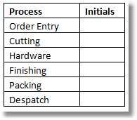
The above has been fitted in to the header on this report. The box with the text ‘This order includes the following blinds’ has been moved left by 10mm and made narrower so the above box can be fitted in.

3520. Archive Enquiry

The Contact Record column has been added to the Archive Enquiry form.

3521. Invoice – Bespoke 28

- The subtotal line can we now include 2 more lines. The top one is RRP – the figure this represents is the Actual Selling Price + the figure input in the Support Call No box. The line below is Less Discount and the figure is the amount inputted in the Support Call No: box. If the Support Call No: box is empty then these lines are hidden.
- This will now print a Discount Type drop down box which will change the “Less Discount” text to whatever is in the box. This will actually print what has been selected in the ‘Guarantee Text’ look up in the Totals tab of the order.
- The £’s & pence have been split into to the relevant columns.

3524. Stock Control > Stock Items

It is now possible to do a stock transaction entry from the context menu.

3525. Order Processing > Orders

There is a new parameter called ‘Display Fabric From Stock Flag’.

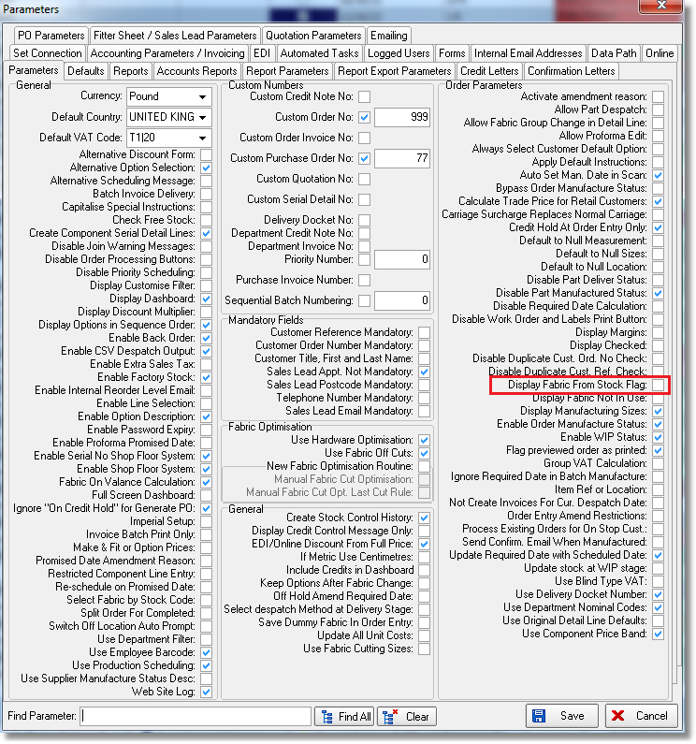
If this is set to true, then a new flag will be held against the order detail line called ‘Fabric From Stock’. This field will also be a column in ‘window Blind Amend’ and in ‘Order Enquiry’.

It will not appear for a component detail line.

3526. Stock Control > Reports

There is a new report that shows Customer, Order No, Order Date, fabric description, quantity for orders between dates for either true or false for ‘Fabric From Stock’.

The report is grouped by order number (also showing customer, order date), then within the order number, it should show order detail id, fabric description, no of blinds(quantity), fabric quantity (from BOM).

The report is called ‘Fabric From Stock by Order’ and is held in Stock Control > reports.

3527. Label Print – Bespoke 22

For blind identifier = Curtain, there are now up to 4 cutting sizes printed on the label.

3528. Works Order – Bespoke 22

The total quantity of fabric now appear on the works order. If the blind identifier = Curtain.

3529. Acknowledgement – Bespoke 34

Carriage Type is now printed on the right hand side of the report header.

3530. Delivery Docket – Bespoke 34

Carriage Type is now printed on the right hand side of the report header.

3531. Order Processing > Orders > Order Amend Enquiry

There is now a column choice for Carriage Type

3533. Archive Enquiry

The processes are now viewed in exactly the same way as they are viewed in Order Enquiry > View Process Transactions.

3534. Order Amend Enquiry

It is now possible to view processes from ‘View Serial Detail Lines’ in the context menu. This shows the process transactions in the same way as they are shown in Order Enquiry > View Process Transactions.

