Blindata Release Note 6.7.1 

13 December 2013

Bug Fixes and Enhancements

4450. Peachtree Integration

For Peachtree sales invoice posting, the codes for nominal should be taken from the following places:

Post Invoice For Order with Blind Detail Lines

Administration > Parameters > Use Customer Nominal For Posting = false

The sales nominal code is taken from the sales nominal code in the blind type record. The debtor control nominal code is taken from the ‘Debtors Control’ in System Tables > Nominal Control Codes.

Administration > Parameters > Use Customer Nominal For Posting = true

The sales nominal code is taken from the customer record. The debtor control nominal code is taken from the ‘Debtors Control’ in System Tables > Nominal Control Codes.

Post Invoice For Order with Component Detail Lines

Administration > Parameters > Use Customer Nominal For Posting = false

The sales nominal code is taken from the sales nominal code in the stock record. The debtor control nominal code is taken from the ‘Debtors Control’ in System Tables > Nominal Control Codes.

Administration > Parameters > Use Customer Nominal For Posting = true

The sales nominal code is taken from the customer record. The debtor control nominal code is taken from the ‘Debtors Control’ in System Tables > Nominal Control Codes.

4451. Order Enquiry > Processes

The cutting sizes are now rounded to the nearest 1/8 or 1/16 of an inch if ‘Use Imperial’ = true.

4452. Order Processing > Orders

There is now more space to display the fabric description. Here is an example of a fabric description that will not fit:

G75 FIBERGLASS BASKETWEAVE 10% P05-WHITE/PLATINUM 63

4456. Reports > System Reports > Man Process Type Barcodes

These barcodes are now grouped by blind identifier.

New Work and Customer Requests

3486. Hardware Cutting Sheet

This report now prints in the same order as the film cutting sheet if the products are the same.
Previously this report was ordered by ‘Tube Diam’.

3493. Stock Items

There is now a ‘Measurement Unit’ for Inches. At the moment there is Metres, Yards, Feet, Quantity.

3494. Works Order A4 Individual

Email address and mobile number now appear on this report.

Also room has been made for two columns of options. The existing column has been moved slightly left and the space between option name and option choice has been reduced slightly.

3496. Label Print – Bespoke 46

There is a new label layout called ‘Label Print – Bespoke 46. This is identical to ‘Label Print – Bespoke 8’ (prior to the current change).

The Customer Reference now prints on the small labels.

3497. Start Manufacture Scan

There is a new ‘Advanced Permission’ flag called ‘Start/Stop Manufacture’. If this is set to true, then a user can start or stop the manufacture of a blind by scanning the bar code on a label.

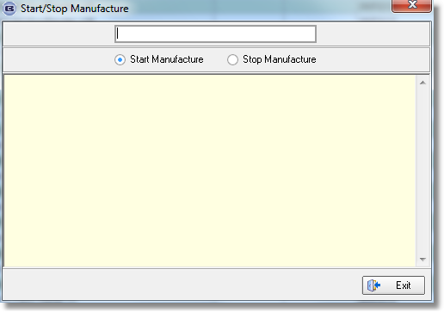

It will only be possible to start or stop a blind for manufacture if the order status is ‘Work In Progress’ or ‘Order Printed’ (if work in progress is disabled).

There is now a column choice for Start/Stop Manufacture’ in ‘Order Amend Enquiry’ and ‘Order Enquiry’.

If this flag is used, then an order history record is created.

3498. Label Print – Bespoke 8

The small top right label is now used for printing the logo from Company Details, and the company name and address from Company Details

