Blindata Release Note 6.6.8 

25 November 2013

Bug Fixes and Enhancements

4194. Cutting Options

There was a problem with multiplying in the formula for cutting options if ‘Imperial Setup’ was set to true. Fixed.

4419. System Tables > Dimension Codes

If you created a new dimension code and use ‘Control in the formula, it did not validate properly if the database is set up to be ‘Imperial Setup’ = true. Fixed (in ‘Cutting Sizes’ as well).

4424. Administration > Archiving

An error occurred when you tried to archive records. Fixed.

4425. Purchase Order Enquiry > Update

When a purchase invoice was being created for a detail line with a non unit ‘Unit Of Sale’, the prices were being multiplied incorrectly. Fixed.

4426. Order Enquiry > Processes

Previously, the batch number field could be left blank when changing a process to Complete. It no longer allows a blank batch number if the stock item in question has a batch number.

4427. Works Order – Bespoke 42

If an order is flagged as a repair and there is only a detail line with the blind type = miscellaneous, the works order now prints.

4429. Sales Files > Customers

It is now possible to only enter a nominal code that is a ‘Sales Code’.

4430. Stock Take Import

If stock take records are imported with batch numbers, and ‘Sequential Batch Numbering’ is switched on, the sequential batch number field is now updated as well.

4431. Blind Types > Blind Type Setup > Label Control

It was possible to enter label control records with a null field set, which meant not being able to see the record in ‘Label Control’ and then far too many labels printed out. Fixed.

4432. Label Print – 3 ½ x 1 Standard

The number of vanes and fabric metreage is now in the same font and size as the width and drop fields. This applies where blind identifier = Vertical or Vanes Only or Headrail Only.

4433. Order Enquiry > Processes

When a batch number is being selected, it now only displays the batch numbers that relate to that fabric.

4436. Order Processing > Delivery Docket Batch Print > Delivery Run Report

This report no longer includes orders that are on credit hold, on customer hold or are flagged as OOS (out of stock).

New Work and Customer Requests

3440. Appointments to Outlook

It is now possible to update an appointment from the Blindata diary to Outlook, and also from Outlook to Blindata. There is an option in the context menu against the appointment.

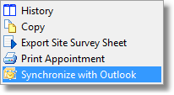
When this is selected, the following window will appear.

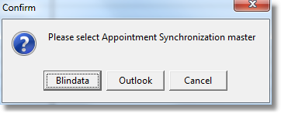
Appointments will be stored as customised categories in Outlook. If they are not already in Outlook, they will be created as follows: (FS, SL, SR, SC). Uncategorised appointments will be held as general appointments.

There is also a ‘Synchronise All With outlook’ option on the main diary form. This will synchronise all appointments for the selected employee for the selected date.

3446. Invoice Laser Print (Letterhead Logo)

This report will now print the fabric description from the ‘Customer Descriptions’ tab of the stock record instead of the normal fabric description.

The stock record has also been amended so a record can be saved in the ‘Customer Descriptions’ tab without a customer – this means the description will apply to all customers.

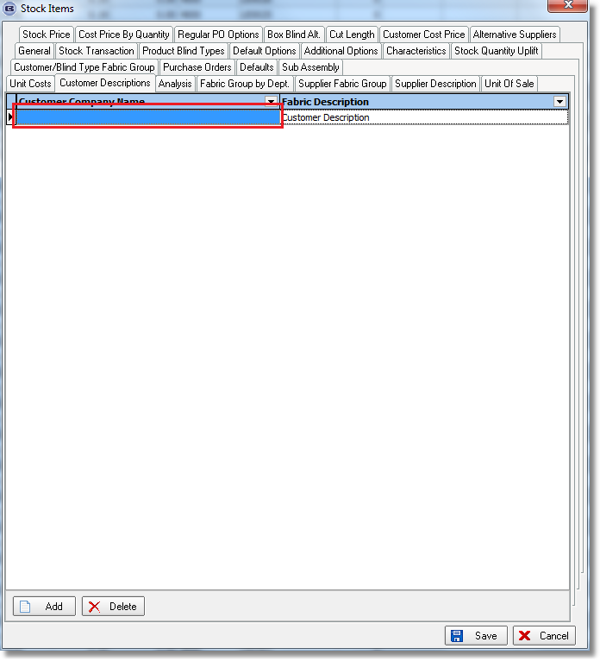

3450. Purchase Order Regular – Bespoke 42

There is a new PO report. It is the same as Purchase Order Regular - Bespoke 28 but prints in the order it is shown on the PO Enquiry form. The detail lines are not grouped.

3451. Acknowledgement – Bespoke 42

The logo from the department now prints in the top middle of the header. This has been done in the print and pdf version.

3452. Order Processing > Orders

If an order is for a customer that has the flag ‘Use EDI Import prices’ set to true, then it is no longer possible to untick ‘Price Overridden’ in a detail line price in an order.

3453. Order Processing > Cancelled Orders

More fields have added to the column choice – Cust Ord No, Cust Ref, account Code, Net Total, File Name.

3454. Acknowledgement – Bespoke 37

If the option is set as a ‘Non Print Item’ then it does not appear on the report.

This print previews in landscape on the screen but prints portrait (on certain printers). Fixed subject to onsite test.

3455. Order Processing > Orders

When typing a location, the first letter now appears up in the field. Previously the first keystroke only initiated the pop-up window for saved locations, but it now puts the first letter into the lookup field instead of having to type it again.

3456. Order Processing > Orders

When making changes to instructions, changes made in the field are now reflected in pop-up textbox.

3457. Order Processing > Orders

When entering orders with multiple tube sizes, a warning appeared after saving each blind. The warning now only appears once at the end of each order.

3458. Order Processing > Orders > Print Bill Of Materials

- The document is now set for our 8 ½ x 11 page if the country is set as USa or Canada.
- The ‘Unit of Measure’ column has been added beside the ‘Quantity’ column.

3459. Invoice – Bespoke 37

The invoice layout has been significantly altered, according to requirements, and utilises the new logo.

3460. Picking List 37

There is a new picking list layout called ‘Picking List 37’. This can be set up in Administration > Parameters > Reports.

3461. Despatch Docket – Bespoke 37

This delivery docket has been redesigned to incorporate the new logo.

