Blindata Release Note 6.6.9 

2 December 2013

Bug Fixes and Enhancements

4428. Acknowledgement – Bespoke 20

There are now more detail lines printed per page. This has been achieved by moving the addresses further up the page.

The registered office fields were not required at the bottom of the footer because they are actually in the logo that is in the footer.

Also the currency sign has been moved to beside the numbers.

The same changes have been made to ‘Quotation – Bespoke 20’, ‘Delivery Docket – Bespoke 20’ and ‘Invoice – Bespoke 20’.

4437. Pricing > Cost Price Table Calculation

This was giving timeout errors sometimes. Fixed.

4438. Label Print – Bespoke 33A

If a very long location was entered, it wrapped round on this report. It now only prints on one line and will be cut off if necessary.

4439. Order Processing > Orders

The chain length was calculated incorrectly if was set up in Blind Types > Chain Length, and (Imperial Setup = true). Fixed.

New Work and Customer Requests

3448. Consignment Note Number

When consignment number comes back into Blindata from TNT, it is now possible to trigger an email and possibly a text message, which goes to the email address or mobile number held against the order.

However this should only happen for certain customers, so there is a new field in the customer record called ‘Email After Consignment No Update’ and ‘SMS After Consignment No Update’. These flags are held in the ‘Email Fields’ tab in the customer record.

In Company Details > ‘Email Texts’ and ‘SMS Texts’ there is now a field choice for Consignment Note No like this: [Consignment No].

When the email or SMS is sent, it uses the text that is held in ‘Email Delivery Text’ and ‘SMS Delivery Text’ respectively.

A file can be generated by the carrier system that will contain the order number and the consignment number. It will be stored in a specific location that can now be recorded in Blindata. This is a new field in Parameters called ‘Carrier System Output Folder’. There is also another folder called ‘Carrier System Output Archive Folder’ which will be where the files will be placed after the consignment note number has been updated to the order.

The import file will be either a csv file or a xls file and will only have two fields: order number and consignment note number.

There is a new automated task to import the consignment note numbers from this folder.

3462. Sales Files > Customers > Product Discounts

The ‘Unit of Sale’ field has been added to the Sales Files > Customers > Product Discount tab. We also have ‘Quantity’ as a new field, with ‘Unit Quantity’ replacing the existing ‘Quantity’.

It is also possible to import product discounts with a unit of sale. ‘Unit Of Sale’ has been added to the ‘Customer Stock Discount’ import spreadsheet. If it is left blank, it will be assumed it is ‘Unit’.

3464. Purchase Order Regular – Bespoke 37

The report header has been amended to include a bigger logo and borders round some fields.

3465. Invoice – Bespoke 37

There is now an option choice for this report in ‘Report Export Parameters’.

3466. Purchase Order Enquiry > Amend

If sequential batch numbering is switched on, there is now an alternative way to assign batch numbers. Previously it would only assign a batch number for the whole detail line, but there is now an option create a batch number for each roll.

Therefore there is a new parameter called ‘Sequential Batch Number Per Roll’. This will only be active if ‘Sequential Batch Numbering’ = true.

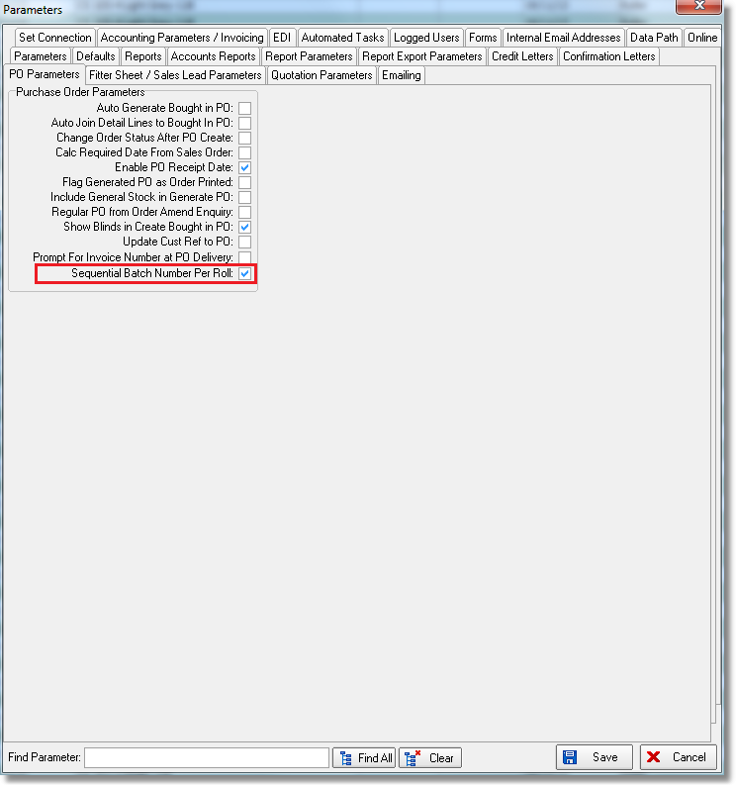

Let’s take the following example. There are 30 yards in a roll and a PO is created for 4 rolls. Therefore the quantity entered is 4 (unit of sale = roll of 30 yards) and the unit quantity will be 120.

At the moment when the PO is delivered and ‘Sequential Batch Numbering’ is switched on, one batch number is assigned per detail line delivered (if the stock record has ‘Batch Numbering’ set to true). If ‘Sequential Batch Number Per Roll’ is switched on, then four batch numbers will be created, one for each roll.

3467. Customers > Sales Tax Code

In Canada the sales tax code is dependent on where the order is being sent to, and is not related only to the customer account.

Therefore the sales tax code can now be held against the delivery address.

The sales tax code will now be taken from the delivery address record for the order. If there is no sales tax code set against the delivery address it will be taken from the customer (as it currently is).

3470. Purchase Order Enquiry > Amend

There is now a parameter so it does not ask for the purchase invoice number when delivering a purchase order,

This parameter is called ‘Prompt For Invoice Number at PO Delivery’ and defaults to false.

3471. Order Enquiry > Processes

If ‘Imperial Setup’ switched on, there is now an extra column called ‘Amount Used (Inches)’ where the number of inches can be entered. It will then fill the ‘Amount Used’ column by doing the necessary conversion (after checking the ‘Unit Of Sale’)

There is now a context menu on this form so the user can choose the columns they want to see. This contains column choices for all the existing fields and the new one.

3474. Invoice – Bespoke 15

The VAT rate from the customer record is now printed, so instead of ‘VAT’ it should say ‘VAT (@ 20%)’.

