Blindata Release Note 6.6.7 

18 November 2013

Bug Fixes and Enhancements

4420. Purchase Order Enquiry > Generate Regular PO

There was a possible conflict between numbers when saving regular POs and bought in PO (Create PO in order amend enquiry) at the same time. A change has been made to the way the sequential PO number is saved.

4421. Purchase Order Enquiry

There were too many decimal places on new column ‘Free Stock ex PO’. Fixed.

4422. Aeronaut File

When the aeronaut file is created, if there are more than 50 records, they are put in a second file (so there is a limit of 50 records per file). The second and subsequent files now also have column headers – previously only the first file did.

4423. Aeronaut File

The xls file now prompts to be saved in the same folder as the csv file. The location defaults to the one set up in Parameters > Export Path.

New Work and Customer Requests

2847. Suppliers > Contact Management

It is now possible to add/amend contact management records to suppliers and purchase orders in the same way as we do for sales orders and customers.

These records in the same tables as they are held in the existing contact management, but we now distinguish between customer and supplier codes. This is required because we want to see contacts by employee – and these could be contact records that apply to customers/sales orders or suppliers/purchase orders.

There is now a ‘Contact Management’ button in the ‘Suppliers Enquiry’ form and also one on the ‘Purchase Order Enquiry’ form.

At the moment only customer contact records will appear in reports – this will be done for suppliers at a later stage.

3424. Financials > Invoice Batch Print

There is now a ‘Sort By’ choice for ‘Account Code’.

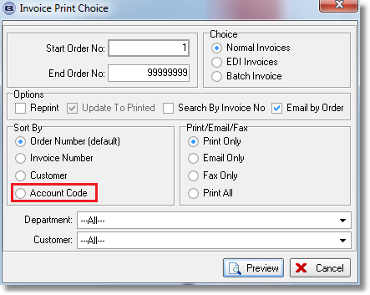

3436. Omnis CSV Export Files

The department from the customer record is now exported to the export files SALINV_blindata, and INTERNAL in column L. The records are exported in department order. The ‘Branch Description’ from the department record that goes into column L.

The department from the customer account has also been added in column M of the CUS_blindata export file, and the customer email address in column N.

3437. Administration > Import From Excel > Option Discounts

There is a new choice to import option discounts. The spreadsheet should contain customer account code, blind type code, option stock code, discount %. This option is called ‘Option Discounts’.

3439. Order Processing > Orders

The ‘Number of Vanes’ now appears as a column choice in Window Blind Amend.

3442. Import From Excel > Blind Type Fabric Groups

Previously this import just added records. However this means we can end up with a lot of unnecessary records here, so if the blind type already exists and option = false, then it now overwrites the existing record.

3444. Sales Files > Customers

We now hold a ‘Location’ field against the delivery address in the ‘Del Address’ tab. This is 16 characters long.

3445. EDI Invoice

If ‘Send Electronic Invoice’ is switched on in the customer record, an EDI invoice file is sent (see layout below). We have made two changes to the EDI invoice file.

In field 4 of the HEAD record, we now hold the Location field, which is taken from the delivery addresss record of the order (see dev 3444). If this is blank, then it remains as it is.

In field 2 of the DTL record we now hold the ‘Bought In Blind No’ from the blind type record in the detail line. Previously this did not have anything in it.

COMMADDMMYYYY HHMM HEAD DTL VAT TLR
HEAD,ABC001,JLEWIS,01,253,01082013,,01082013,1616,01082013,1616,01082013,,,01082013,0,Unit 6,Blackwater Close,Marsh Way,RM13 8UA
DTL,,,1,,,1,1,,181,0,0,,1,181,,N,
DTL,,,1,,,1,1,,10,0,0,,1,10,,N,
VAT,1,2,191,,0,38.2
TLR,191,,,,,38.2,0

3447. EDI Import – Carriage Type / Stock Item

There is a new field called ‘Carriage Type’ against the stock record. When the EDI import is done, if there is a carriage type held in that new field, then it will be applied to the carriage type in the order.

