Blindata Release Note 6.6.6 

12 November 2013

Bug Fixes and Enhancements

4319. Order Processing > Orders On Hold

If you take an order off hold, it did not seem to save the ‘Taken Off Hold’ flag properly, but did work on subsequent attempts. Fixed.

4392. Aeronaut File

The Quantity in the Aeronaut File is now always set to 1.

The Line Number is now always the same as the line number on the label.

The first list in the aeronaut file has been changed from:
START## (TAB) HOLLAND BLIND
to:
START##(SPACE)HOLLAND BLIND(TAB)

4408. Stock Control > Reports > Fabric Requirement Report

The fabric quantity was being rounded down – it is now rounded up.

4413. Order Processing > Production Documentation

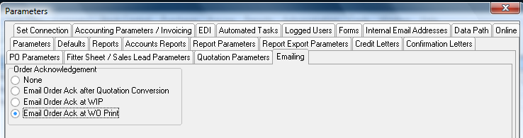

Emailing at the ‘Order Ack WO Print’ stage now only email to those customers set up with order ack delivery = email.

4414. Contact Management

The ‘Further Details’ text field has been increased from 500 to 1000 characters. It is not possible to enter over 1000 characters.

4415. Blind Types > Product Blind Type

When adding a product blind type record, ‘Option’ now defaults to false.

4416. Acknowledgement – Bespoke 37

The fax number for the customer now prints below the tel number.

4417. Archive Enquiry > Serial Detail Lines > View Processes

The processes can now be seen. The flags are now inactive – we just show the processes that relate to this serial detail line.

4418. Calculator ‘Quantity Per Blind Type’

If the calculator ‘Quantity Per Blind Type’ is used in the bill of materials, then the quantity is only calculated per blind type in the order. If the quantity is set to 1 and there are four blinds of the same blind type in an order, then the quantity is 1 for the order, and not 4.

New Work and Customer Requests

3417. Sales Files > Customers

There is now a default delivery address flag in the customer delivery address record.

Also it is now possible to edit all fields in the delivery address.

When an order is entered, it will fill the delivery address with the default record (if there is one).

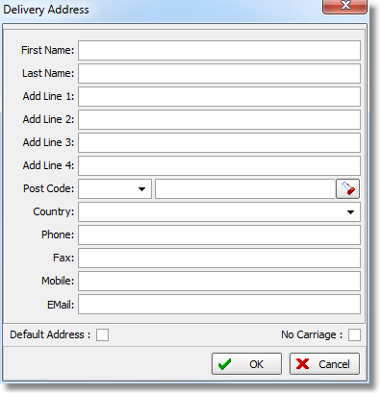

3434. Administration > Maintenance

There is now a clean up routine for stock transactions. Here is an example of what gets cleared up. In both boxes 1 and 2 there are transactions that should not be there. In the case of 1 they will be removed completely. In the case of 2 the program checks the PO transactions. If they do not exist, then these transactions are removed.

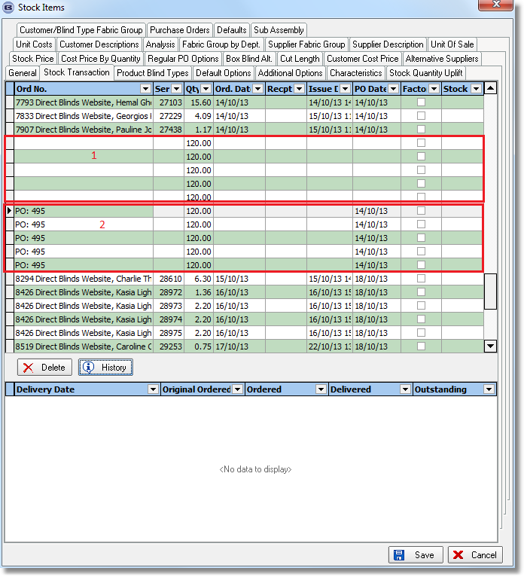
There is a new option on the Maintenance form called ‘Stock Transaction Clean Up’.

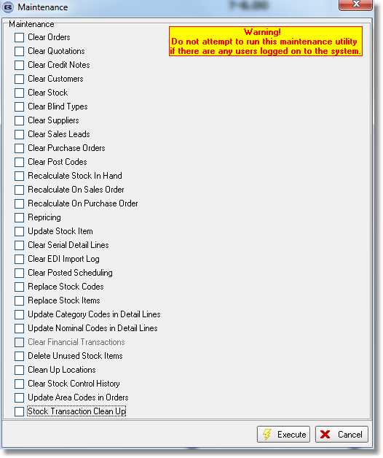

3435. Solar Solve Marine Reports

Quotation Print

The bottom rail size now always appears, regardless of blind type or shape of blind.

Technical Data Sheet

The fabric bottom width now always prints.

Film Cutting Sheet

The fabric bottom width now always prints.

Item Listing

The bottom width now always prints.

